VISUAL SHOW DIRECTOR 8.3.3

Table of contents (Ctrl-click to follow link)
VISUAL SHOW DIRECTOR 8 Getting Started 4
Introduction 7
How to use this guide 10
Other Resources 13
Upgrading to version 8 from previous versions 16
Language Settings 23
Show Director Overview 26
The Toolbars 30
Toolbars Interaction 34
Toolbars Customization 37
Script and Effects Managers Common Tools 40
Visual Applications 43
FX-Generator 46
Producer 49
3D Position Editor 53
Viewer 56
Interface 59
Options 63
Grid Formatting Layouts 67
Grid Formatting by Columns 70
Hide / Show Columns 73
Repositioning Columns 76
Custom Views 79
Layouts 82
The Creation Process 85
Software User Folders Structure 88
The Project 91
Create a New Project 94
Open an Existing project 98
Save a Project 101
Close a Project 104
The Project Library 107
The Wave file 111
The Visual Files 116
The Script File 119
Create a New Script File 124
Open an existing Script File 127
Save Copies of the Script File 130
Import a Script File from other Firing Systems 133
Export a Script to other systems 136
Auto Restore - Undo 142
Scripting for DMX 145
Scripting Commands and Syntax of Visual Columns 152
QTY 155
PAN & TILT 158
CAMERA 161
VISUAL REFERENCE 164
BEAM 167
WORLD 170
OBJECT 173
VIDEO LINK & PICTURE LINK 176
Working with Cues 179
Save / Clear New Cues 182
Copy, Cut, Paste and Duplicate Cues 185
Insert Cues 188
Insert Effects 192
Create Effects 195
Update Effects 198
Create Macro 202
Capture Cues/Automatic Beat Detection 205
Renumber Cues 209
Renumber Addresses 212
Validate Addresses 216
Reset Addresses 219
Offset Time 222
Refresh Grid 225
Column Fill Down 228
Cues Invert 231
Cues Auto Complete 234
Locate 237
Import / Export Cues 240
Import Beat 243
Export .Chr (Visual Script File) 246
The Script Filter File 249
Script filter File Operations 254
The Script Sort File 257
Script Sort File Operations 261
Script Views 264
The Effects Manager 267
Create a New Effects File 272
Open an existing Effects File 275
Open and Save Effects Managers in .csv .xls .efx 278
Working with Effects 281
Refresh Grid 284
Duplicate Effects 287
Column Fill Down 290
Locate Effect Ref# 293
Total Effect 296
Total All Effects 299
Update Effect Total 302
Import / Export Effects 305
Effects Merge 308
The Effects Filter File 311
Effects Filter File Operations 316
The Effects Sort File 319
Effects Sort File Operations 322
Effects Views 325
Grid Printing and Formatting 328
Direct Print 331
Reports 334
Reports: Overview 337
Reports: Export and send by email 340
Custom Reports (SD Tools Plug in) 343
Reports: Direct Printing 346
Script Reports 349
Effects Reports 352
Configuration 355
Configure TimeCode 358
Configure Wave Display 362
Firing Tables Manager 365
Visual Show Director Manual Mode 369

VISUAL SHOW DIRECTOR 8 Getting Started

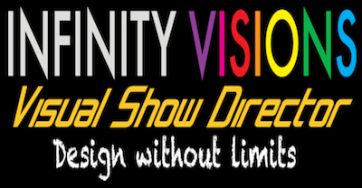

THIS GUIDE IS FOR "SHOW DIRECTOR" (NON VISUAL) AND "VISUAL SHOW DIRECTOR"
REFRESH YOUR BROWSER TO GET THE LATEST UPDATES OF THE USER'S GUIDE (Version 8.3.0)
When you receive the installation package and install the applications follow the Registration procedure.
For help on this procedure see:
http://www.infinityvisions.com/showdirector/ivActivationHelp.asp
Familiarize yourself with the Visual Show Director User's Guide. You will find here answers to your questions.

Watch our Video Tutorials on various topics of the software.
Download this user guide in Word format.
Download this user guide PDF format
Download this user guide in HTML format

Introduction
This guide is designed to introduce you to the use of "Show Director" and "Visual Show Director".
Show Director is a professional tool for designing pyrotechnic pyromusical shows for a variety of firing systems.
.
Visual Show Director provides you with additional Visual Applications, for 3D visualization of fireworks. lasers, lights, image projections and objects animation to enhance your creative experience.
In the following guide we will use only the name "Visual Show Director". For "Show Director" users disregard references to visualization.

WATCH VIDEO INTRODUCTION

How to use this guide

The guide is divided into several chapters. You can read the chapters in order, or you can read the rest of this Introduction and then start with the chapter that best suits your interest and experience. Within each chapter, we recommend following the instructions in order.

Other Resources
Visual Show Director includes a variety of resources to help you learn the program quickly and become proficient in creating your own effects and libraries. These resources include the following:

- A Demo Project
Included in the installation package there is a Demo Project to start practicing with.
- Visual Show Director's Online Help
Includes comprehensive information about using all aspects of Visual Show Director, as well as an HTML version online and video tutorials.www.infinityvisions.net/software/documentation

- Visual Show Director in program Help is located in the installation folder as vsd.chm.
In addition, you may find updated versions of this help and video tutorials on our website.

WATCH VIDEO INTRODUCTION
Upgrading to version 8 from previous versions

If you are a new user or are upgrading to version 8 from previous versions here are all the new features.
For Importing Previous versions Projects see Video Tutorial here.

WHAT IS NEW IN VERSION 8.3?

Read Release Notes
WATCH VIDEO

BACKWARDS COMPATIBLE

- Project Import in the "Project Library". Will import older projects, versions 5,6,7 and will export a copy of a VSD8 project. It will make a copy of all the older files selected and a new .pyr.
Export will export to versions 5, 6 , 7 or make a copy of version 8 projects and selected files.
- Direct open/import from the "File menu" of "Scripts", "Effects Manager"s, Sorts and Filters from versions 5,6, and 7.
Copies of original version files will be saved as "samename". "file extension".bak in the same folder.
Older projects can not be opened directly from the File Menu, they need to be imported with Project Library.
- Project Save As… Makes a copy of the existing .grx and .atb files and copies them to the new project before it saves. This fixes the missing column colors/formatting in the new project if the script windows was closed.4. Automatic version update notifications.5. You can now associate ShowDirector8 to .pyr project files. This allows you to double click a .pyr project file and have ShowDirector open with that project loaded.
AUTO-RESTORE (UNDO)
- New Auto Restore for Scripts and Effects Managers. This new function will keep a backup of your most recent Scripts or Effects Managers making a copy of the files every 5 minutes within 1 hour. There will be 12 copies that you can restore at any point on time. The feature is only active with a project open. The backup files are stored in a folder inside the directory where the project is saved.The function can be manually deactivated by changing On to Off in the file sd.ini in C:/Users/username/Appdata/Roaming/ShowDirector. You will never lose more than 5 minutes of work.
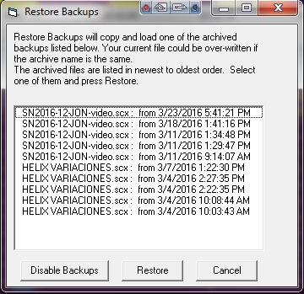 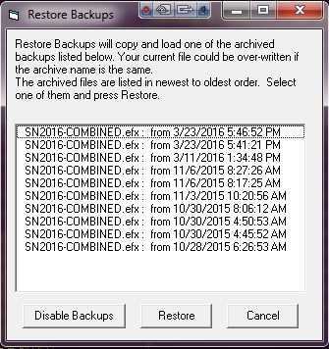
MORE COLUMNS
- Added new Script columns; MS (MILLISECONDS),MACRO,GROUP,TABLE,MODE, CONTROLLER, MODULE, PIN, CUSTOM 3>8, LOCK1 > LOCK 8 columns added to Script. Included in Filter and Sort. This supports different firing system functionalities. The new columns are initially hidden and you can show them with the show/hide tool in the format toolbar.
- Added new columns to Effects Manager grid: Custom3-5. The columns from Effects Manager overwrite the values in Script Manager. Script Manager. also got three additional Custom (6-8) that do not get overwritten as they don't exist in effects. All new columns are shown. REF column widened from 16 to 50 characters.
- All ShowDirector Managers Grids now support Column Cut and Paste. It is limited to columns on the same grid and of the similar data types. Some data types can't be copied between columns (for example, while you can put a CUE number into a text field such as CUSTOM3, you can't put that CUSTOM3 value back into the CUE).
To copy a column or a section of it: select the cell to start, press Shift and select the last row, press Shift-F4 or the icon tool in the Sort/Filter toolbar, click in the cell you want to start the paste and press Shift+F5 or icon tool.
MULTI-FIRING SYSTEM SCRIPTING
- Script Import and Export for: FireOne (.fir) , Galaxis, PyroLeda, Explo, Cobra...
- The Script Open and Save As and have been expanded to include the new columns. Script Open from .xls, or .csv and older scripts (VSD 5,6,7) that do not have the new columns. The new columns will be blank.
Columns in Excel have to be named with the same characters and format as VSD.
Excel with one workbook has to be named as "Sheet1".
The Effects Manager export and import has .csv and Excel (.xls) format.
MULTI FIRING SYSTEM AUTO-ADDRESSING
- New Renumber Address dialog for ADDR and Module/Pin will dynamically display the Script Sort you have (up to 10 columns) that can be selected to cause the Renumber to increment to the next Module when that value in that column changes. It also allows you to specify if you want the pin addresses to increment or decrement (default). Once a module is full, we increment to the next module. The Reset Address also has a new dialog that allows you to specify either
ADDR or MODULE/PIN
- The Validate Addresses form has now a Module Report function that will display a count of Total Firing Modules and available pins not used.
- Reset Address, Renumber Address and Validate Address now work on both ADDR column and the new MODULE/PIN columns. When you run the menu items, it works on both the ADDR and MODULE/PIN.
- Module and Pin AutoComplete. You can AutoComplete incrementing or decrementing by any amount. Currently the maximum pin value is 100. To AutoComplete select first cell and shift last row and press CTRL+F9
NEW TIME FORMATS AND DIRECT EDIT AND SEQUENCING IN THE TIME COLUMNS
- Cue Time (HH MM SS FF) remain in frame rate. We have added a MS (milliseconds) column that contains the Cue Time represented in total milliseconds. If you change any of the Cue Time values, the MS column will update. If you change the MS column, the Cue Time values will update.
- The Next column has been changed to allow edits. This makes the interval between two cues as settable. If you change the value of in the Next column, the Cue Time and MS will update. If other Next values exist, then all following Cue Times will also update with their intervals. Thus, if you change a Next time interval, you slide the entire show by that much time. How this effects the show can be manipulated by the filters and selections you have in place at the time of the edit to the Next value. Copy Down and AutoComplete also works for the Next column allowing you to generate linear and curved interval sequences. A valid Next edit can be as a number from 1 on up as milliseconds or in the format of mm:ss:ms (minutes, seconds, milliseconds), however the display will always show mm:ss:ms.
It is also possible to Copy parts of the NEXT column and Paste in other Cues to set the same intervals.
- Increased the precision of the PFT (Pre-Fire Time) from 1/10s of a second to milliseconds. You can enter any number from 1 (millisecond) to 9999. Zero is still valid and indicates no pre-fire time. This change should be reflected in both the Script and the Effects files. When exporting to previous versions it will reformat the PFT as 1/10 sec. When importing from older versions it will convert 1/10 sec into milliseconds. When creating the Firing Table .tab for the PD Field Controller it will export as 1/10sec.
- Configure Timecode form now allows to change the Frames format of the open Script. If you are in 30fps and select 25fps the Script will change to that format.
FIND-REPLACE & ADDITIVE FILTERS
- Added universal Find/Replace in all the Managers. Shift+F3.
- Script and Effects Quick Filter are additive now. If you have a filter in place and select a new Quick Filter, it will add to the end of the existing filter. This continues until you select Reset Filter.
USER INTERFACE ADAPTABILITY
- Added Major Version number (8) to the .grx and .atb filenames. This will help facilitate the organization and addition of new columns and tools to ShowDirector.
The default toolbar (.atb in appdata/roaming/ShowDirector) when it opens does not show all the toolbars possible. To Open other toolbars, right click in the grey area and select them from the menu or from Customize.
- The default grid (.grx in appdata/roaming/ShowDirector) has a new order of columns and doesn't show all the columns possible. If you want to reorganize this default grid, show more columns or hide other and in different order, do the following. Reopen ShowDirector, do not open a project, Open a new script, show/hide and reorder, do the same with toolbars shown/hidden and distribution. Close the script. Restart Show Director. The new default layout will be displayed. Colors for colors are only part of a Project. If you want to use a particular project layout, make a template and every time you make a new project open the template first and save the new project with new name.
- ToolbarLayout (.atb) and GridLayout (.grx) files gained the Minor version number. This means if a menu changes or a grid column changes, we will advance the product Minor version and refuse to load the old, out-of-date layout files. A side effect is that any custom formatting in the old version is lost to the new version. Default .atb and .grx files in the users/AppData/Roaming/ShowDirector folder have been made Read-Only to preserve them against possible corruption by loading out of date script or effect files when no project has been loaded.
Here is a list of what was new in version 7
- Toolbars
- Complete overhaul of menu system to modern, XP style, breakaway toolbars. Toolbars are grouped according to function and may be placed anywhere - top, bottom, left, or right side or desktop.
- All major functions are easily accessible with a single click.
- User has control over which toolbars are visible and icons shown.
- One click formatting of all grid columns - font, font size, font style, alignment, and colors.
- Different toolbar layouts are supported for each named project.
- Different grid layouts and formatting supported for each named project.
- Select available windows from the new Window List.
Script and Effect Manager
- Columns can be re-ordered to your preference, simply by selecting the header and dragging to desired location.
- 32 named "Views" are supported for each Manager. A View is a Filter, a Sort, or a combination of both.
- View, Filter, and Sort selection toolbars provide rapid access.
- Unlimited number of Named and Storable filters.
- Script and Effects Managers may be filtered by one or all columns.
- Unlimited number of Named and Storable sorts.
- Script and Effects Managers may be sorted by one or all columns, ascending or descending.
- Single click, column sort available on toolbar for fast access.
- Single click, Sort by Time for Script Manager, available on toolbar.
- Single click, quick Filter by cell value available on toolbar.
- Single Click, Unfiltered Cues.
- Sort grid displays dynamically arranges columns by sort order.
- Import and export Show Scripts, Cues and Effects easily.
- Export effects from Script to new Effect Manager files.
- Paste, Import Cues works now in multiple cue selection.
- Copy-Cut-Paste text within cells.
- Offset Cues, works now in Cues selections.
Firing Tables Manager
- New, integrated Firing Table Manager supports multiple Field Controllers.
- Integrated Firing Table Manager consolidates all functions to create and download tables to Pyrodigital Field Controller on a single screen.
WAVE Display
- Improved control of WAV playback. Double-click to start playing. Single click left button to seek, single click right button to stop and seek.
File Interface
- Project Library. In this new menu you can see, select and copy all the project files to a new folder for filing or sending to another user. The project configurations , settings and file paths are saved.
- Improved Script and Effect import and export to CSV format support.
- Recent Project File list aids quickly opening up 5 most recent projects.
- File open remembers your last directory.
- Print all grids in WYSIWYG format, as displayed on screen.
- File support and Plug-In ready for "Visual Show Director" fireworks simulation software.
Upgrading from 4.0: What was new in Show Director 5.0.5
Visual Show Director includes all the features of Show Director 5.0.5. Here is a list of what was new in version 5.0.5
- Toolbars
- Complete overhaul of menu system to modern, XP style, breakaway toolbars. Toolbars are grouped according to function and may be placed anywhere – top, bottom, left, or right side or desktop.
- All major functions are easily accessible with a single click.
- User has control over which toolbars are visible and icons shown.
- One click formatting of all grid columns – font, font size, font style, alignment, and colors.
- Different toolbar layouts are supported for each named project.
- Different grid layouts and formatting supported for each named project.
- Select available windows from the new Window List.
Script and Effect Manager
- Columns can be re-ordered to your preference, simply by selecting the header and dragging to desired location.
- 32 named “Views” are supported for each Manager. A View is a Filter, a Sort, or a combination of both.
- View, Filter, and Sort selection toolbars provide rapid access.
- Unlimited number of Named and Storable filters.
- Script and Effects Managers may be filtered by one or all columns.
- Unlimited number of Named and Storable sorts.
- Script and Effects Managers may be sorted by one or all columns, ascending or descending.
- Single click, column sort available on toolbar for fast access.
- Single click, Sort by Time for Script Manager, available on toolbar.
- Single click, quick Filter by cell value available on toolbar.
- Single Click, Unfiltered Cues.
- Sort grid displays dynamically arranges columns by sort order.
- Import and export Show Scripts, Cues and Effects easily.
- Export effects from Script to new Effect Manager files.
- Paste, Import Cues works now in multiple cue selection.
- Copy-Cut-Paste text within cells.
- Offset Cues, works now in Cues selections.
Firing Tables Manager
- New, integrated Firing Table Manager supports multiple Field Controllers.
- Integrated Firing Table Manager consolidates all functions to create and download tables to Pyrodigital Field Controller on a single screen.
WAVE Display
- Improved control of WAV playback. Double-click to start playing. Single click left button to seek, single click right button to stop and seek.
File Interface
- Project Library. In this new menu you can see, select and copy all the project files to a new folder for filing or sending to another user. The project configurations , settings and file paths are saved.
- Improved Script and Effect import and export to CSV format support.
- Recent Project File list aids uickly opening up 5 most recent projects.
- File open remembers your last directory.
- Print all grids in WYSIWYG format, as displayed on screen.
- File support and Plug-In ready for “Visual Show Director” fireworks simulation software.
Dongle Key
- New USB and Parallel Port protection key, upgrade remotely. Demo version available.

Language Settings
All the Visual Applications of Visual Show Director, are available in different languages.
To select the language in use, please use the Language Selection Tool, available in the Visual Show Director folder as shown in the following illustration.
The tool interface is very simple and it is enough to select a language from the ones available and press the [APPLY] button.
The next time the visual tools are run, they will be in the desired language.
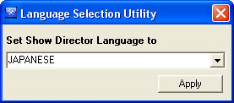
Currently available languages: English, Spanish,Japanese,French. Korean, Chinese Simplified, Chinese Traditional.

The text maps of language correspondences are located in:C:\Program Files (x86)\ShowDirector8\Visual\Resources\Messages
If you are interested in correcting or translating Visual Show Director in your language, make any changes in the .txt files and send an email to vsd@infinityvisions.com

Show Director Overview
Visual Show Director Overview
This is an overview of the files system structure of Visual Show Director
It shows how all files are related and tied together in the Project.
Download the Visual Show Director Files structure Map

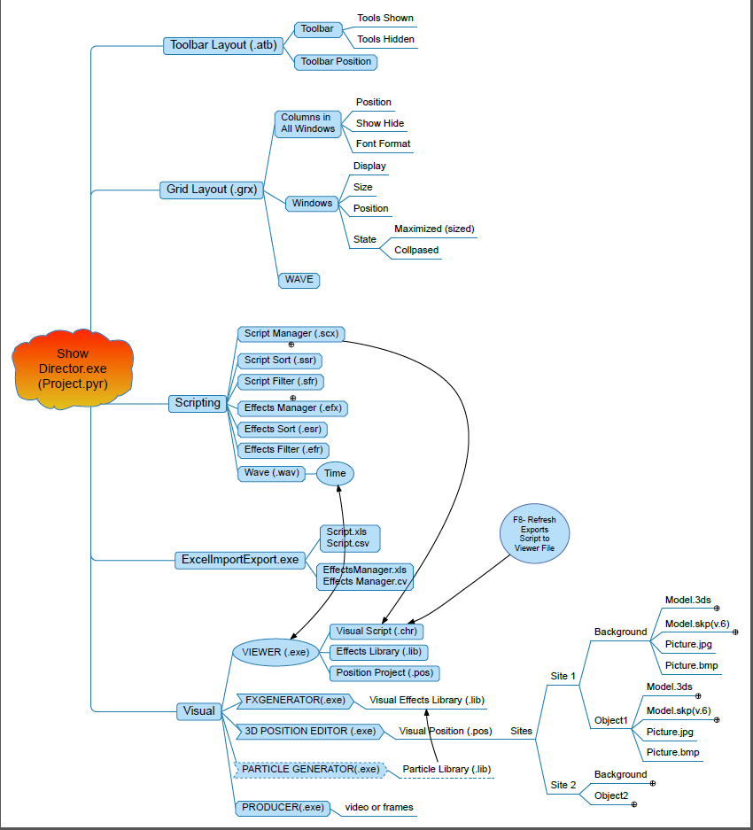

Visual Applications

- FX Generator
Is the application used for the creation of the effects and Libraries.
click here for more information
- 3D Position Editor
Is the application used for the creation of the effects and Libraries.
click here for more information
- Producer
Is the application used for the creation of the effects and Libraries.
click here for more information
- Viewer
Is the application used for the creation of the effects and Libraries.
click here for more information

The Toolbars
The tool bars let's you have all the commands conveniently accessible. They are fully customizable.
The tool bars offer you quick access to the VSD functions and commands. It is VERY IMPORTANT that you take the time to go with your mouse over them to see what each one does. Click and try them.
They are saved with the project. In this way when you reopen, everything will be in the exact place that you left it
- Tool bar Features:
  - Can be placed anywhere in the Show Director window or in the Desktop.
click here for more information on how to relocate toolbars
  - Can be customized: Add or Remove Icons, Add Name tag to Icon, Icon size.
click here for more information on how to customize toolbars
  - Function of the Icon is displayed when the mouse is over the icon.
A tool tip always shows a description of the command
  - The tool bars position in the user interface are saved in the .atb file. Each project can have a specific tool bar layout or arrangement.
If you want to use a tool bar layout as the default, copy the file "myproject.ToolBarLayout.atb" in the project folder where you made it and place it in C:/Users/"your username"/Appdata/Roaming/ShowDirector folder and rename it as "ToolBarLayout82.atb". After that in any new project it will be the default layout.
  - All the tools can be accessed from the Menus, so in order to save space in the screen you want to use only the most frequently used. This is the default original layout in the application.
The available Toolbars

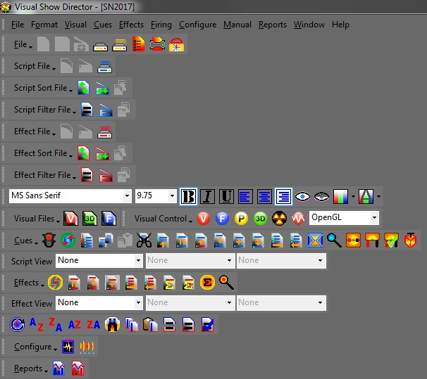
- Tool bar Features:
- Can be placed anywhere in the Show Director window or in the Desktop.
click here for more information on how to relocate tool bars
- Can be customized: Add or Remove Icons, Add Name tag to Icon, Icon size.
click here for more information on how to customize tool bars
- Function of the Icon is displayed when the mouse is over the icon.
A tool-tip always shows a description of the command

Toolbars Interaction
Any Tool bar can be moved, docked in another place or left floating in the screen.
- To move a tool bar, Drag & Drop it using the Handle shown in the next illustration
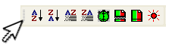
- To close a floating tool bar, click on the X as shown in the next illustration
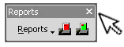

Toolbars Customization
Any Toolbar can be customized with custom tools and it is also possible to create new custom toolbars to suit your needs.
To show/hide a toolbar, right click with the mouse on an empty space of the toolbar and select from the popup menu shown in the next illustration the toolbar to show/hide. | 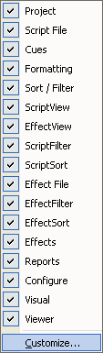
To customize toolbars,choose customize from the toolbars context menu. A new window with all the custom tools will popup.
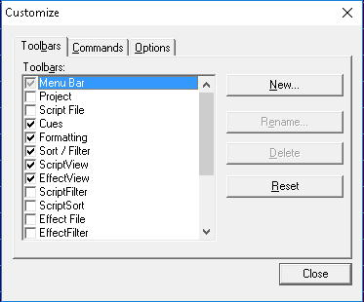

Script and Effects Managers Common Tools

The Script and Effects Manager share these common tools.

Fonts Format tools

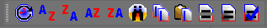

Ordered from left to right:

Sort Script by Time (Ctrl-T) Sorts the script by time.

Sort Ascending

Sort Descending

Sort Selection Ascending

Sort Selection Descending

Find Replace
Universal Find/Replace in all the Managers. Shift+F3

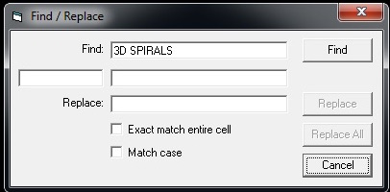

All ShowDirector Managers Grids now support Column Copy, Cut and Paste. It is limited to columns on the same grid and of the similar data types. Some data types can't be copied between columns (for example, while you can put a CUE number into a text field such as CUSTOM3, you can't put that CUSTOM3 value back into the CUE).

Copy Column Copies a selection in a Column. Select first cell and press Shift to select the last row of the selection. Click the icon of the tool. Copies data.

Paste Column. Pastes copied data of the same format into another column. Select the cell to insert copied data and press the icon tool.

Quick Filter - Reset Filter - Unfiltered Rows
Script and Effects QuickFilter are additive now. If you have a filter in place and select a new QuickFilter, it will add to the end of the existing filter. This continues until you select Reset Filter.

Visual Applications
Visual Show Director integrates a set of applications that allow three dimensional creation and visualization of fireworks, special effects, lights and laser beams, image projections and movement of objects in a 3 Dimensional environment.
Visual Show Director Multimedia Version is a complete fireworks and multimedia show authoring application that includes all of the above features not available in ShowDirector.
- Visual Applications
FX Generator
This application is used for the creation of the Effects and Libraries.
click here for more information
3D Position Editor
This application is used for the creation of Sites, Positions, Objects and Light Beams Keyframing animation .
click here for more information
Producer
This application is used to publish your show in a variety of picture and video formats, including stereoscopic images, and create VSDPlayer files
click here for more information
Viewer
This application is used to visualize your show in real time.
click here for more information
WATCH WHAT IS POSSIBLE

FX-Generator
The FX Generator is the application used for the creation of the effects and Libraries of effects.
With the FXGenerator you will produce Visual Reference codes that are associated with the effects in the Effect Manager and translated to the Visual Reference field in the Script Manager.
This allows the Viewer to interpret and animate the effects.
For complete details on the FX Generator , please refer to its User's Guide
A Typical FX GENERATOR layout
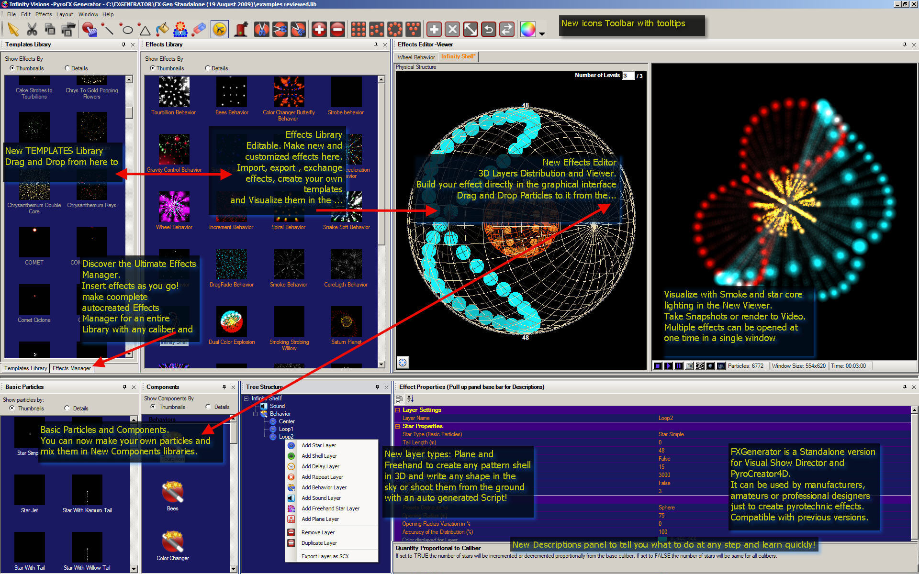

Producer
The producer contains the functions to create snapshots, video and frames starting from a project file. The producer can generate media of any type from a script that can play 2D or 3D shows, plus the option to create stereo or auto-stereo frames.

The quality of the video is set by the Video Codec that you use and installed in your system. There are many packages of Video Codecs for download in the Internet. Choose a reliable one.
For encoding the Audio in your system you need to run this Encoder. ( An error will appear if you do not have permissions to encode mp3)
- Snapshots: the parameters are:
- type of image file (.jpg, .pcx, .bmp, .tga);
- destination filename;
- Image quality and parameters (gamma correction, jpeg quality, etc etc.);
- snapshot time;
- flag for stereo or autostereo;
- path in meters for the camera;
- flag for alpha bitmaps;

- Video: the parameters are:
- Type of video files (.avi, .mpg, .wmv, etc etc.)
- Destination filename;
- Codec to use and codec options;
- Sound flag;
- Starting frame;
- Ending frame;
- "Take all the show" flag;

- Frames: the parameters are:
- Type of image file (.jpg, .pcx, .bmp, .tga);
- Destination filename;
- Image quality and parameters (gamma correction, jpeg quality, etc etc.);
- Flag for stereo or auto-stereo;
- Path in meters for the camera;
- Flag for alpha bitmaps;
- Starting frame;
- Ending frame;
- "Take all the show" flag;
- Executable: the parameters are:
- destination filename;
- flag for playing the show in stereo mode;
- path in meters for the camera;
- starting frame;
- ending frame;
- take all the show" flag;
For complete details on the PRODUCER , please refer to its User's Guide
The PRODUCER interface
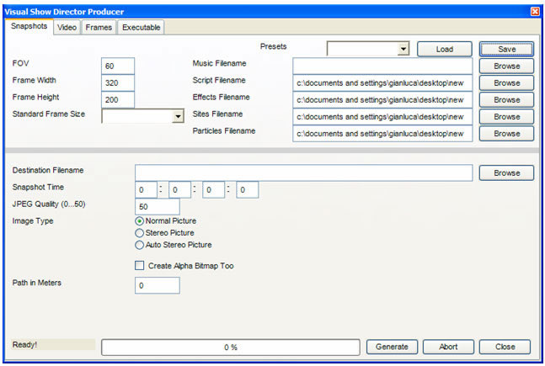

3D Position Editor
The application is used to create position sites, generate light beam animation effects and animate 3dimensional objects.
Library: shows the content of a position library; a library consists of a collection of sites; each site consist of a background filename (3d model: .3ds or bitmap file: .bmp, .jpg, or .tga), stage size and square size factor, sky and terrain bitmap filenames, etc.
Object Hierarchy: this panel shows the object hierarchy tree, i.e. a tree that shows the relationship between the several objects inside a site.
Position Grids: this panel shows, for each site, the positions like a database, so the user can modify positions coordinates and attributes by typing in this grids.
Key-framing: this panel shows a time line that can be used to establish an animation for a beam or for an object.
Tool Options: this panel shows all the options relative to a particular tool;
Groups and Selections: this panel shows the tools relative to group of positions.
If you are using Visual and don't want to have all the positions listed you can create a group of positions in the 3D Position Editor. Then use @groupname in the cue. It will fire from all the positions in the group. Obviously for the addressing and set up you have to paste all the positions in that @ cue. If you made an empty script with all the positions in the groups, use Import Cues to paste them, and then fill down the parameters of the cue and the REF for inserting same effects.
For complete details in the 3D POSITION EDITOR , please refer to its User's Guide
A Typical 3D POSITION EDITOR layout
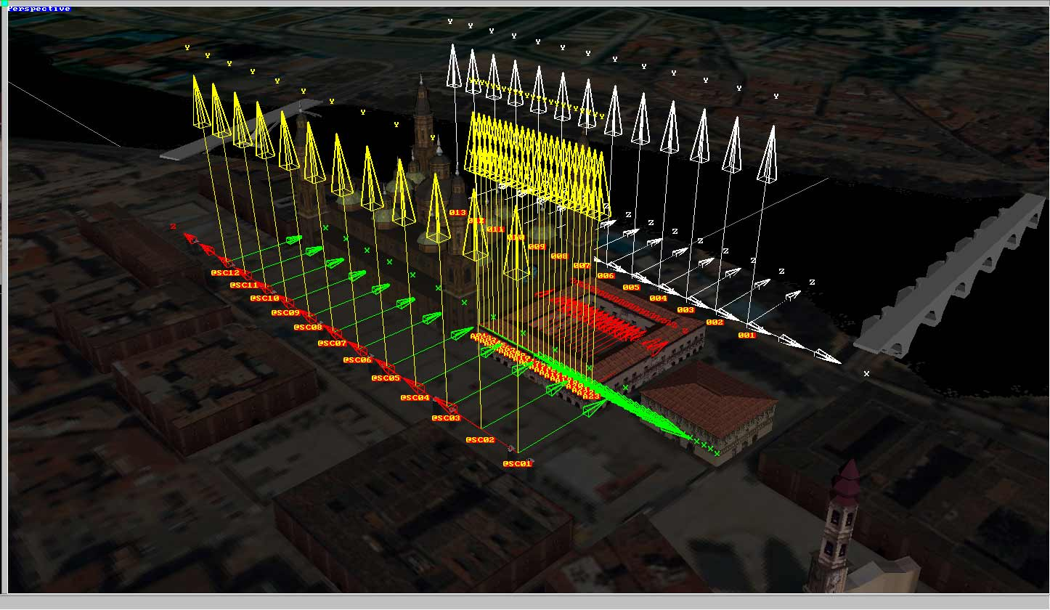

Viewer
The Viewer is the component that visually plays a show. The component works in window mode.
Window mode: the component runs in a window, and the controls (play, stop, etc.) are outside the Viewer and shared with Show Director.
The options are customizable.
The Viewer application automatically recognizes any change of time in the wave file while in play and it is automatically synchronized.
IF AND ONLY IF YOU ARE USING EXTERNAL TIMECODE, INSTEAD OF A WAVE FILE, YOU NEED TO PRESS THE BUTTON ON THE VIEWER TOOLBAR TO INITIALIZE THE VIEWER WITH THE ACTUAL TIMECODE.
Notes about the Viewer Interaction with external time-code
When using an external time-code source, such as Pyrodigital Modem, the Viewer waits for the time-code Sync button and then keeps going using an internal clock to save resources.
Only if you change your time-code (i.e. using FFW or REW), then you need to press the Sync button once again to tell the application the new time it have to reinitialize the internal clock.

Interface
The Viewer main interface looks like this:
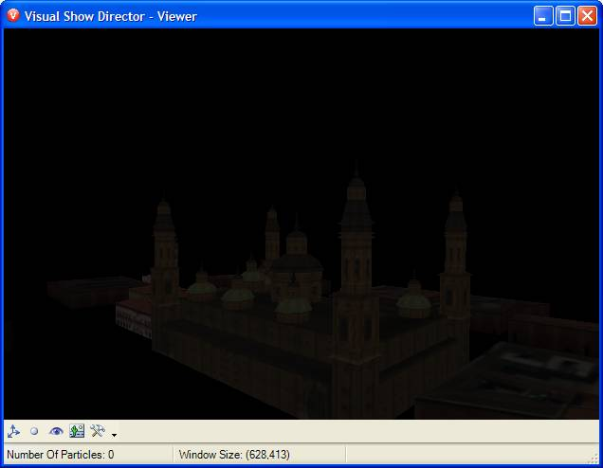
The main window features a main display area, plus a toolbar to customize options and a status bar to display information about the application.
The Viewer Keyboard controls
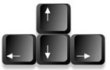 | Camera Movement
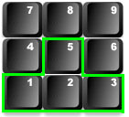 | Camera Zoom
 | Camera Rotation
The Toolbars

The tool bar contains the commands to change camera position and orientation and the rendering options.
- Available Tools
- Show/Hide position dots:
this tool toggles the visibility of position markers, displayed as green dots on the screen;
- Show/Hide burst rise:
this tool toggles the visibility of the burst rise; the burst rise is the dot that appears when a shell is shot from a position;
- Reset Camera:
this tool resets the camera to the default position and orientation;
- Make Snapshot:
this tool captures a snapshot of the actual view-port and saves it on file;
- Options:
this tool brings up the Option window where advanced customization is possible.
The Status Bar

The Status Bar displays information about the number of particles used to display the actual scene and information about the windows size (useful when taking snapshots).
- Notes about the Number of Particles The number of particles panels displays a counter indicating how many particles are active on the screen.
The higher the number of particles, the more system resources are used. Please keep in mind this equation when designing effects in the FX Generator.
The number of particles depends on the way each star type has been built (a star with tail is made by several particles).

Options
VIEWER OPTIONS
The Viewer Option Window looks like the following illustration:
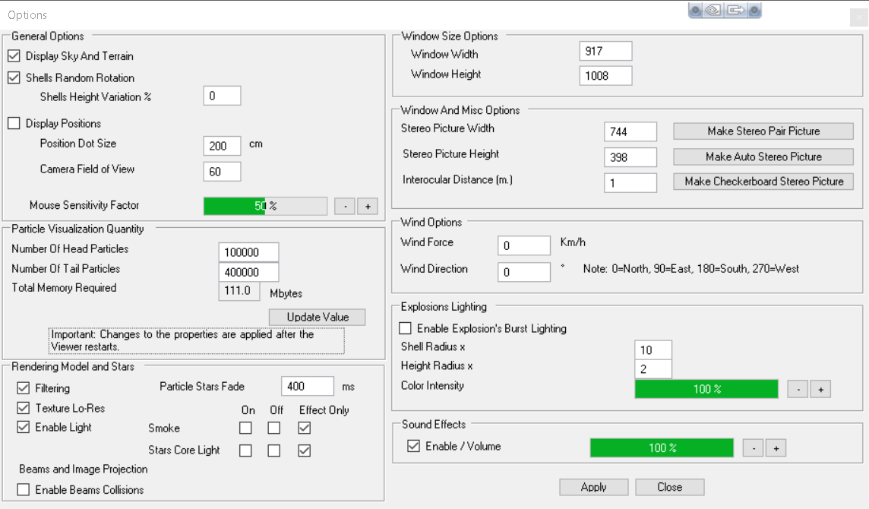
This window is organized in sections for an intuitive navigation
- General Options
The General Options section panel includes the common options used to show/hide objects like positions, sky and terrain that are related to each site.
The option also includes the random rotation for shells, which makes the shells rotation random as in the real world.
- Rendering
The Rendering Options section is related to the actual render used and includes:
- Filtering: this option makes the pictures applied to polygons more smooth; if you disable this option, the pictures will be more sharp; disabling this option results in a faster rendering.
- Mip-mapping: this option reduces pictures size depending on the distance from camera; disabling this option results in a faster rendering.
- Enable light: this option enables lighting on the environment; when disabled, the engine renders all the polygons with the same light; disabling this option result in a faster rendering
- Position dot size: this option sets the size for the dot used to display the positions on screen; the size is expressed in centimeters.
- Sound Effects: The Sound Effects options section includes a check-box to toggle sounds on/off. Sound volume can be adjusted using the +/- buttons
- Interface: the Interface section includes the FOV (Field Of View), expressed in degrees, and the height variation used to add that little touch of inaccuracy typical of the real world displays.
This section includes also the mouse sensitivity factor, adjustable using the +/- buttons which establishes the relation between mouse movements and camera: the higher this is set, the faster the camera movement (for very accurate movements, set this value to a low number).
- Wind options: The wind options includes the wind force and angle; the angle establishes the wind direction, in a clockwise convention
- Window and Misc options: The Window and Misc options includes the actual window size and the parameters related to stereographic pictures.
With the “Stereo Picture Width and “Stereo Picture Height, it is possible to set the size for the stereo picture;
with the “Path in Meters it is possible to set the distance from the two cameras used to produce a stereographic image.
At this point, it is possible to create a standard stereo picture using the “Make Stereo Picture button or to create an auto stereo picture with the “Make Auto Stereo Picture button.
The stereo picture will contain two pictures: one of them represents a snapshot from the actual position of the camera minus the (path in meters)/2, and the other represents a snapshot from the actual position of the camera plus the (path in meters)/2.
The auto stereo picture will contain 9 pictures: the 9 pictures are placed in a 3x3 grid, and each of them represents a snapshot from the actual position of the camera that stands on the path.
- Particle Engine Properties: The Particle Engine Properties panel contains options to customize the maximum number of head and tail particles that the engine will use to draw particles.
This option shows the memory size consumption for the selected particles; to update this value use the "Update Value" button.

Grid Formatting Layouts
It is possible to customize the grids appearance for each project using the [FORMAT] menu and tool-bar.
All the changes to the grid are saved in the project folder with the filename [projectname.gridlayout.grx] and are automatically restored on project opening.
The Format Menu and the Formatting tool-bar

WATCH VIDEO Configure your own User Interface: Windows Tiling and Layouts.
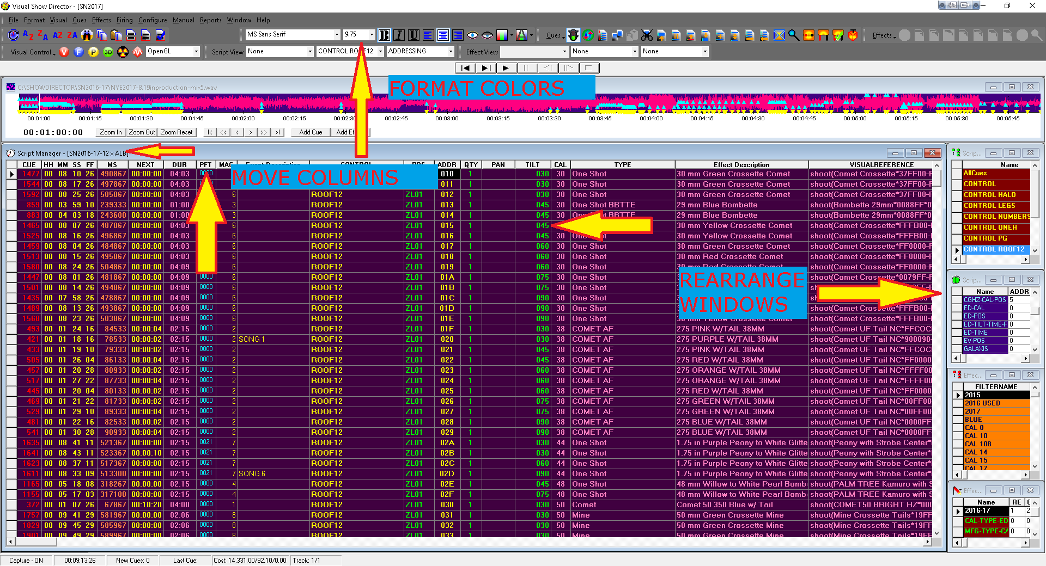
Grid Formatting by Columns
To assign a certain format property to a column:

- Select the column/s clicking on the column/s header
- Change the format option from the Format Menu or from the Formatting Toolbar.

If you want to change the name of a column,right click in the tag of the column and a dialog will prompt you to change the names.

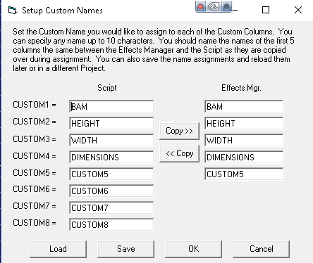
Hide / Show Columns
Any column can be hidden or un hidden in a grid layout.
With this feature, Show Director allows the user to work with a subset of the columns for a better organization
To Hide one or more columns
- Select the columns using the columns headers
- click on the closed eyes icon in the [FORMATTING] toolbar
or select from the [FORMAT] menu
To Show one or more columns
- Select the columns using the columns headers
- click on the closed eyes icon in the [FORMATTING] toolbar
or select from the [FORMAT] menu
- Select the columns you want to show again in the dialog that pops up (see next illustration)

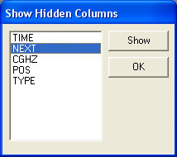
Repositioning Columns
Columns positions are customizable in Show Director
To change the position of a column in the grid layout
- Select the column using the columns headers
- Drag it to the desired position. A RED marker shows the insert point while dragging
- Drop it in the new position

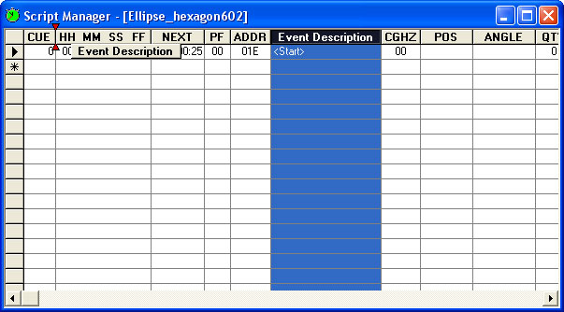
All the changes are displayed immediately and saved with the grid layout file.

Custom Views
( Show Director Tools Plug in)

From 8.2.14, Show Director Tools includes Custom Report and Views.

We have added the ability to save a named Custom View that includes the Visible Script Columns and their order plus whatever filters or sorts you may have in place.

These Custom Views can be used in any project without having to load the original Script Filter or Sort files.

In addition to loading a Custom View, you have the ability to Print or Save the Script using that View.
Saving uses the Microsoft Excel format (.xls) and only saves the visible columns in order with the filter and sort.

This differs from normal Script Save as Excel which saves ALL columns and data.
Use this feature to create Custom Reports that can be applied to any Project.

A few commonly requested Custom Report Views have been included to get you started.

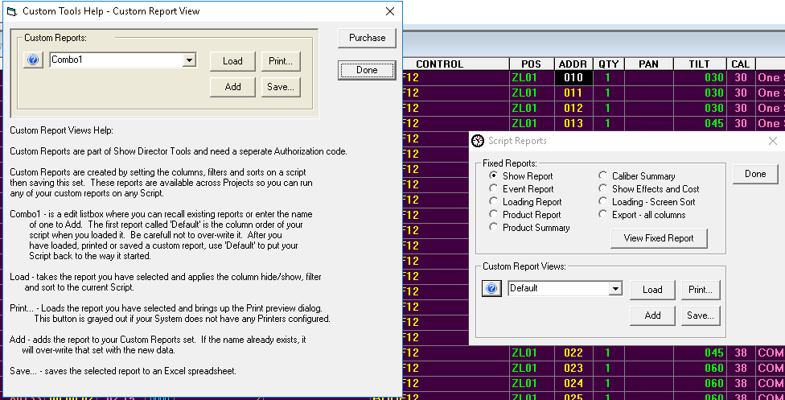

Layouts

The Layouts are the best way to customize the user's visual interface to any firing system.

Saving and Loading of the layout files is done from a new Grid Options dialog.

Make any changes in the view of the grid: Rearrange columns, hide or show columns, change fonts and backgrounds.

To save or load a grid layout, select the grid and press F11.

Saving your grid layout will save:
- The foreground and background colors
- Fonts
- Columns shown (Hide/show)
- Column order and column width

Loading will restore these values. Each type of grid (Script manager, Script Filter manager, etc.) has its own layout file format and its file extension will be that of its grid + 'l'.

For example, the Script manger's extension is '.scx' and its layout file extension is '.scxl'.

Each layout file contains the layout for only one grid type.

Layout files are not Project specific so you can load your layouts on any grid in any project.

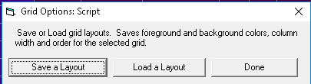

Option to save or load all grid layouts at once. Select from the menu Window->Window Layouts. The Layouts dialog will appear where you can select what loaded grids to configure and either Save or Load those layout files.

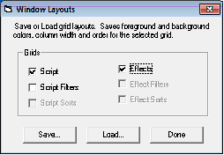

The Creation Process
The Creation Process
The Project
The creation of a Project (.pyr) is the first step to design a show.
The Project contains:
Two files for the appearance and display of the Grid and Tool bars.
- (.GRX) The Grid Preferences set for field colors, fonts, column display and position,
- (.ATB) The Toolbars settings for their display or not and position in the window
These files are created automatically when the project is saved according to the configuration that the user has made.
The files can be renamed in another project with the new project name and this will adopt the configuration that they contain.
The Project contains and associates a group of files necessary to display a show: The following files must be created or selected in this order to use the software.
- Wave File (.WAV)
Contains the music of the show to synchronize with cues.
- Script Manager (.SCX)
Contains the Cues and associated Effects characteristics, Positions, Worlds, Firing addresses.
- Visual Script (.CHR)
Contains a exported version of the Script used by the Viewer to run the simulation of the show.
- Effects Manager (.EFX)
Contains the Effects with all the parameters necessary to be inserted in the cues of the Script Manager.
- Position File (.POS)
Contains the Site positions. Created with the 3D Position Editor application.
- Library (.LIB)
Contains the Library of effects. Created with the FX Generator application.
The Project can also contain optional files not necessary to display a show but useful for the operation of the Script Manager and Effects Manager:
- Script Filters (.SFR)
Contains a table of custom filters set by the user, to filter the Script in different ways and to split the Script into various down-loadable tables to the Field Controller, and to Export the cues according to the Filter selected.
- Script Sorts (.SSR)
Contains a table of custom Sorts set by the user, to sort the Script in different ways.
- Effects Filters (.EFR)
Contains a table of custom filters set by the user, to filter the Effects Manager in different ways.
- Effects Sorts (.ESR)
Contains a table of custom sorts set by the user, to sort the Effects Manager in different ways and to Export the cues according to the Filter selected.
Script and Effects Filters and Sorts can be associated in the Script or Effect View tool bar to create a view that combines a filtered Script Manager or Effect Manager sorted in a specific way.
For complete details in the VISUAL APPLICATIONS , please refer to their own User's Guide

Software User Folders Structure

It is recommended to create and maintain a logical folder structure that can be shared with other users within a company and to store orderly the production show files.

You can start by using the same root drive C: or D:

In C: or any drive, create a root folder for the Visual Show Director software files.
The following is just an example. You decide what kind of order is best for you.

Example:

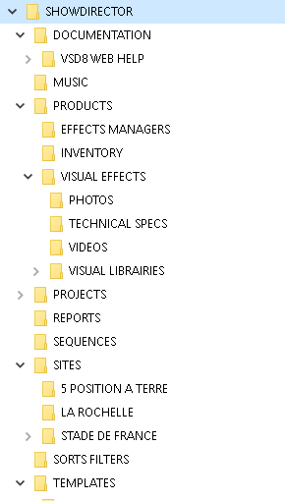

There will be common files used in every project: Effects Manager, Visual Libraries, Sorts and Filters, Custom Reports,Layouts, Sites, Music, that can be located in dedicated folders as common shared resources.

If you create a Template project that will always open these common files, you will need to add only Script and Wave, most likely.

In each specific project there will be files corresponding more exclusively to the project like: Scripts,Sites, Reports...

The Project
The Project File
The Project File
Show Director stores all information in Project files (.pyr). Project files linking the group of files necessary to conduct the operation of show scripting and downloading to the Field Controllers.
You must always start by creating a Project, with the command New Project. If you choose to not create a Project, you won't be able to save settings and layouts and will be forced to open every time the group of files again.

Download the Visual Show Director Files structure Map

Create a New Project
(.pyr)
Start by creating a Project, with the command File Menu> New Project or press (Ctrl+N).
By creating a Project(.pyr) all of the necessary files for show design will be grouped together and opened automatically each time the project is opened. If you choose not to create a Project, you won't be able to save settings and will be forced to open the group of files individually.
Once the Project is created you have to continue opening existing or creating new files in order for them to be grouped:
From the File Menu Create New:
Script Manager (.scx).
This is the window for scripting, containing the time-line and all the information of the show. (create new, or open existing)
Effects Manager (.efx).
This is the window that contains your Database of Effects. You will insert effects or drag them from this window into the Script. With this file it is NOT necessary to re-type effects in the Script Manager every time you make an entry, if they are previously stored with all their characteristics in the Effects Manager. You can have as many Effects Manager databases as you want.
Wave Display (.wav).
This is the window that displays your music in the form of a PCM WAV file. You will navigate through the Script and Music clicking on this display.
You will be able to insert cues or effects directly from here, and see a display of marks of them in the wave display. The resolution of the display is adjustable. WITHOUT a .wav file, cuing in times using cue function will not be possible as there is no reference of time without the WAV.
Sorts & Filters: Files that you create to change the view, organize, or arrange a Script Manager(.scx) or Effects Manager(.efr) file. The purpose of using Sorts & Filters is to quickly access and organize the vast amount of information contained in your show files. Create a Filter and then enter in what parameters it will use to search, arrange, show or hide certain data.
Script Filter Manager (.sfr).
this window contains all possible Filter combinations for all columns that you create. This file can be opened in multiple Projects, saving once in order to use your preferred filters at any time. This window or control panel serves to create the Table files that will be downloaded to the Field Controller. You can assign to each filter a Field Controller ID (serial number) and a Firing Table ID. There is a Function to see the Unfiltered Cue, to avoid miss-download of firing data.

Script Sort Manager (.ssr). It contains allows you to create all possible combinations to arrange the columns and rows. This file can be opened in multiple Projects, saving once in order to use your preferred Sorts at any time. For example, arrange by Position, Effect, Duration, Caliber. etc
Effects Filter Manager (.efr).
This window contains all possible Effect Filter combinations for all columns that you create. This file can be opened in multiple Projects, saving once in order to use your preferred Filters at any time
Effects Sort Manager (.esr).
This window contains all possible Effect Sort combinations for all columns that you create. This file can be opened in multiple Projects, saving once in order to use your preferred Sorts at any time.

Visual Script File (.chr)
Creates with a predetermined (given) name, normally the same as the Script Manager. This is an exported version of the Script in .chr format used by the Viewer to run the simulation of the show. The Export can be done by pressing the Icon with the yellow and black nuclear sign on it.

Visual Position File (.pos)
Selects the Site positions. This file must be previously created with the 3D Position Editor application accessed from the Tool bar.

Visual Library File (.lib)
Selects the Library of effects. The file must be previously created with the FX Generator application accessed from the Tool bar.
If one or more of these files are missing, it will be impossible to start the viewer and the system will warn you of the missing files.
Two new files that are created automatically in every Project are added to the group of files in the Project. You should not delete or move these files:
- GRIDLAYOUT (.grx)
This file stores the configurations that you give to the Grids. In Show Director you can move and swap the order of the columns and hide them.
- TOOLBARLAYOUT (.atb).
This file stores the layout of the new toolbars configuration and position in the window.
Every project can have different layout and configuration. Show Director will create a specific GRIDLAYOUT (.grx) and TOOLBARLAYOUT (.atb), for every project. In the case that you do not choose to work within a project, Show Director will create two default files.

Download the Visual Show Director Files structure Map
Open an Existing project

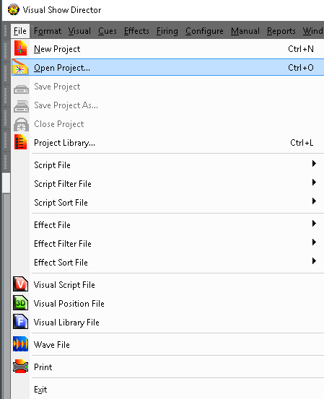
It is only possible to have one project open at a time. If you open another project the current one on screen will close. Changes are automatically saved. If you want to compare Projects or Scripts you can launch the application as many times as necessary (conditioned to RAM capacity) , multiple Show Director windows can be open at one time.
When Show Director starts and you open a New Project, it will open with the default configuration: all columns, black foreground and white background, MS Sans Serif 8 font. If you open a new project with another one already open, the new project will adopt the screen configuration of the existing one and will replace it.
The Script and Effects Manager files will be the same as the previous project. Filters, sort and download configuration will be the same. To open a project use the File Menu as shown in the following illustration or the predefined shortcut CTRL-O.

Save a Project
There are two ways to save a project.

Save Project: saves the Project and settings for the Grid and Toolbars and links to associated files.

Save As: saves the project with a different name, it is useful when you want to create a new project with the same settings as the original.
You may want to close and open new Script or other files.

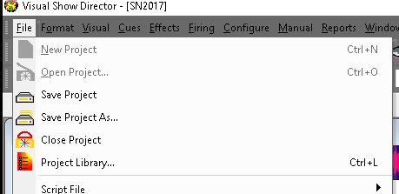

Close a Project
File Menu > Close Project

This command closes the Project and associated files. It frees the memory to open a new Project without having the configuration of the previous Project.

The Project Library
File Menu > Project Library (Ctrl+L)

This command opens a new window, where you can see all the files associated with the Project, and their relative paths.
You can Export these files packed, to a new Project, into a different directory or folder of the original project.
This folder can be exchanged and when the exported Project opens in a different computer it will keep the same layout configuration and file paths.
To export a Project the Project must be closed in order to be able to read and write new files. Close the Project and Browse for it and then proceed to export.
For visual projects, exporting from the project library also exports textures and data for 3D models as needed.
In some cases the exporting of Sketchup models needs to be done manually copying from the model folder. If you get an error message, uncheck the Visual Positions and proceed manually.
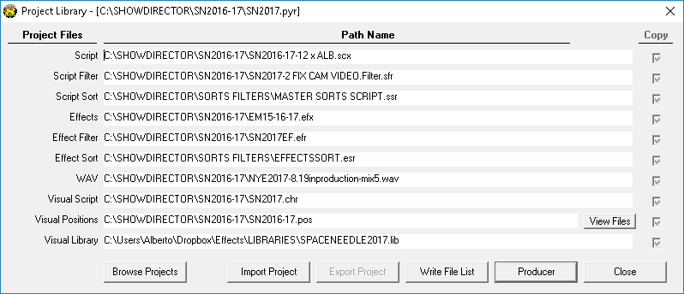
- Import Project
Will import a previous version project into version 8 in a different new folder.
- "Write File List"
Will create a .txt document in the same folder of the project (.pyr), with the list of files and paths. You can use this file to create a printed record of the Project files.
- "Export Project"
Will export a project with all its files in a specified folder. This function is useful to share projects and to have portable copies.Will export a project in Show Director previous versions file formats.

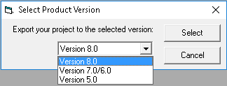
- "Producer"
Will launch the Producer to render the visual project to a movie or picture format

The Wave file
The Wave Display Window is the preferred way to script a show. You should be able to create your soundtrack with a number of sound editors available on the market. Show Director plays 16bit wave format. Wave Files made at 32 bit will need to be converted to 16bit.
If you play the soundtrack from a .wav file, you will need to include time code in synchronization with the wave clock. You can record time code from the Pyrodigital CD, the time code starts at 00:00:00:00. If you are importing audio time code from the PD CD, do not delete the tone at the beginning; it is part of the Time Code sequence.
From the .wav file with music and Time Code you can record your final show tape or vice versa.
- The ability to display and script to the music's waveform image is now provided using the WAV file display window. This display overlays the cues onto the WAV display, and indicates each cue's caliber graphically with higher caliber being taller on the WAV display.

- The user has the ability to position the time cursor and add cues and effects using the WAV display, in addition to the normal "space bar"” capture.

- The display appearance can be user defined under the Configure Menu- Wave Display.
You can select a .wav file to script.
File Menu > Wave File
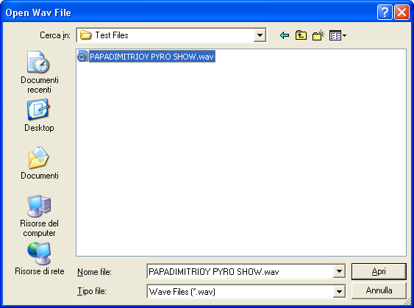
Before you open a wave file and want to see the graphics, make sure that you have WAV Plot Display Enabled in the Configure Menu: Wave Display
Working Sequence:
- Open Wave File Menu, select a wave file to play. Click Open in the Menu
- The Process WAVE file window will be displayed. You can select left or right channel, if you have a channel in your wave with the Time Code.

It is possible to increase the definition of the graphic display reducing the file size factor. The graphic plot file size is by default 500 KB. The factor is set automatically to create a plot file of this size. Bigger sizes of graphic plot file, will give more definition and also may slow the display. Same size of Plot and Wave File is factor 1.
Channel selector allows selecting Left or right channels of your wave file. This is necessary when you have a wave file that also has Time Code in one channel. To not plot the Time Code Channel you will have to select the Music channel. The computer will play a wave file as is, in stereo. To not hear the Time Code you will have to disable the channel with the Windows audio settings for balance.

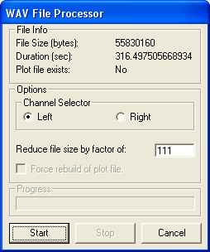
Once the process of building the plot file is finished the new Wave Window will pop up and will be synchronized with the Script.
The cues and caliber will also be plotted over the wave graphic.
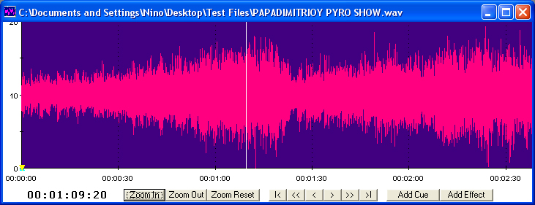
The commands in the Wave display window allow you to:

- Zoom In and Zoom Out (16 magnification steps) Small Scroll Left and Right Large Scroll Left and Right Add a Cue pressing the Add Cue button or depressing the Space Bar Add a Cue with a selected effect or effects in the Effects Manager while capturing. Visualize Marked cues and caliber of effects Double click in any part of the wave graphic starts playing the sound and re-locates the cue in the Script Manager Select a Cue or row in the Script Manager places the Wave Cursor in the corresponding time position.
- To PLAY the music you can double click anywhere and the Script will locate the cue and start playing and displaying the Events.
- If you are searching for a beat in the music, after locating it, you can use the right button of the mouse to start play and stop in the same position.

Multi-Select using Shift-Click on the Wave Plot will Select multiple cues.
When the Wave Plot is in Capture mode (i.e. "Green Light"), if you click on the wave plot it selects the next nearest cue.
Now if you Shift+Click further along the wave plot, it will multi-select all the cues between the two clicks.

The Visual Files
In order to play a show in the Viewer, Visual Show Director needs to have a set of 3 files.
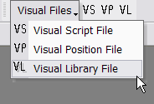
- A Visual Script File (.chr)
Creates with a given name, normally the same as the Script, an exported version of the Script in .chr format used by the Viewer to run the simulation of the show. The file needs to be Exported by pressing the Icon with the yellow and black nuclear sign on it.

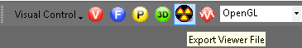
- A Visual Position File (.pos)
Selects the Site positions. The file must be previously created with the 3D Position Editor application.
- A Visual Library File (.lib)
Selects the Library of effects. The file must be previously created with the FX Generator application.
If one or more of these files are missing, it will be impossible to start the Viewer and the system will warn you of the missing files.

The Script File
The Script File (.scx) is where you create your show cues and contains all the information for the show.
The functions that apply to the Script are in the Cues Menu. See the chapter Working with Cues
The Script window has the following columns names and characteristics:
* This is not a representation of the script, but a LIST of the variables in the Script.
You can reorder the position of the columns and have them visible or hidden from the interface.
Columns names can be changed in the Columns: Locks 1 to 8 and Custom6,7 and 8.

Data Field Formats

* When importing from .xls or .csv the number of characters will be trimmed to match Show Director maximums.

Column | Column Name | Column Data Type | Comment
1 | CUE | Number(5) | Unique id for a script row.
2 | MACRO | Number(5) | A number that links shots together for a single firing sequence. Event in Fireone.
3 | GROUP | Text(48) | Name of a group of effects.
4 | TABLE | Text(32) | Description to split the script into subscripts.
5 | MODE | Text(32) | MANUAL, MUSIC, AUTO or GPS.
6 | TIME | Number(8) | Long value for PCM time.
7 | HH | Number(2) | Integer value for cue hours.
8 | MM | Number(2) | Integer value for cue minutes.
9 | SS | Number(2) | Integer value for cue seconds.
10 | FF | Number(2) | Integer value for cue frames (default 0-29)
11 | MS | Number(7) | Long value for total number of milliseconds represented by cue time.
12 | NEXT | Text(8) | MM:SS:FF until the next cue.
13 | Event Description | Text(128) | Open description of the event in the cue.
14 | PFT | Number(5) | Pre-fire time in milliseconds.
15 | ADDR | Number(3) | Hex value for the Pyrodigital HEX address.
16 | CONTROL | Text(32) | Name of the field controller or system for this cue.
17 | MODULE | Number(4) | Integer address for a module (0-9999)
18 | PIN | Number(4) | Integer address for the pin on the module (0-9999)
19 | CGHZ | Number(2) | Integer 1-99 for Caliber hazard groups.
20 | LOCK1 | Text(10) | Open lock description string. Character "X" activates lock.
21 | LOCK2 | Text(10) | Open lock description string. Character "X" activates lock.
22 | LOCK3 | Text(10) | Open lock description string. Character "X" activates lock.
23 | LOCK4 | Text(10) | Open lock description string. Character "X" activates lock.
24 | LOCK5 | Text(10) | Open lock description string. Character "X" activates lock.
25 | LOCK6 | Text(10) | Open lock description string. Character "X" activates lock.
26 | LOCK7 | Text(10) | Open lock description string. Character "X" activates lock.
27 | LOCK8 | Text(10) | Open lock description string. Character "X" activates lock.
28 | POS | Text(10) | Firing position. Alphanumeric.
29 | ANGLE | Text(64) | Angle is open text and may include numbers and \|/.
30 | QTY | Number(4) | Integer for number of effects on this cue.
31 | CAL | Number(3) | Integer value for the caliber of these effects in mm.
32 | TYPE | Text(36) | Text description of the kind or family of effect being fired.
33 | DUR | Number(4) | Integer effect duration in (0-99) seconds and (0-29) frames (00:15 = 1/2 sec).
34 | Effect Description | Text(128) | Description of the effect. Color, etc.
35 | REF | Text(50) | Reference number for the effect.
36 | MFG | Text(64) | Manufacturer of the effect.
37 | MAGAZINE | Text(6) | Inventory Quantities. Inventory-tracking.
38 | PRICE1 | Number(8) | Price of this effect.
39 | PRICE2 | Number(8) | Price of this effect.
40 | PRICE3 | Number(8) | Price of this effect.
41 | CUSTOM1 | Text(128) | Open text field for effects data. Header right click to change.
42 | CUSTOM2 | Text(128) | Open text field for effects data. Header right click to change.
43 | CUSTOM3 | Text(128) | Open text field for effects data. Header right click to change.
44 | CUSTOM4 | Text(128) | Open text field for effects data. Header right click to change.
45 | CUSTOM5 | Text(128) | Open text field for effects data. Header right click to change.
46 | CUSTOM6 | Text(128) | Open text field for script data. Header right click to change.
47 | CUSTOM7 | Text(128) | Open text field for script data. Header right click to change.
48 | CUSTOM8 | Text(128) | Open text field for script data. Header right click to change.
49 | PAN | Number(255) | Angle number value to describe PAN direction of trajectory .Multiple separated by " - "
50 | TILT | Number(255) | Angle number value to describe TILT direction of trajectory .Multiple separated by " - "
51 | CAMERA | Text(255) | Text field to describe the camera FOV. Captured from Viewer. "c" key.
52 | VISUALREFERENCE | Text(255) | Text field to describe the code of the particle effect. Fx Generator.
53 | BEAM | Text(255) | Keyframing string for animation of lights and lasers. 3D POS EDITOR.
54 | WORLD | Text(64) | Text name of a site in the .pos project environment.3D POS EDITOR.
55 | OBJECT | Text(255) | Keyframing string for animation of an object in the 3d environment.
56 | PICTURELINK | Text(255) | Text link to PLAY a web or disk based picture.
57 | VIDEOLINK | Text(255) | Text link to PLAY a web or disk based video.

Version 8:
The Columns CUSTOM 1-2-3-4-5 and LOCKS 1-2-3-4-5-6-7-8 can be renamed with your own names.
Right Click in the Header of the column and do it the Form to Change name. Different names templates can be saved and applied to new projects.

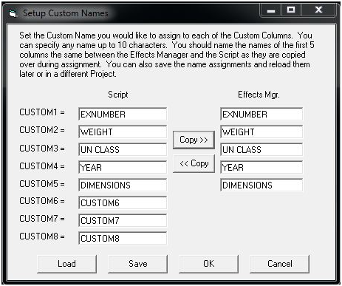

Create a New Script File
File Menu > Script File > New
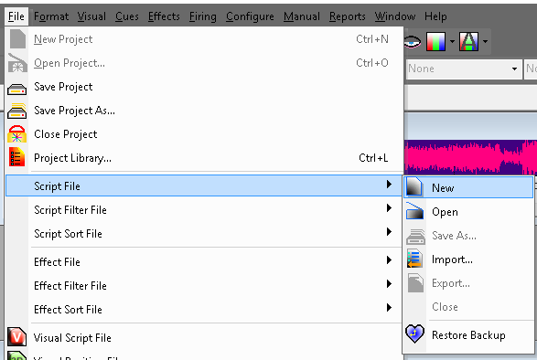
Creates a new Script file.
The user is prompted for a valid filename and, if the selected filename corresponds to an existing file, the software warns the user and prompts for overwrite.
It is safe to press [NO] if the user doesn't want to overwrite the existing file.
Open an existing Script File
File Menu > Script File > Open
Opens an existing Script file.
If the file that is being opened is from a previous version of Show Director, the software will warn the user and will prompt for a filename for the imported version.
It auto-updates the file format.

Save Copies of the Script File

Saves a copy of the open File.
It is useful to frequently save backups of your file.
The current Script will close momentarily while saving and reopen.

Save the current Script File as an Effects Manager

You can create an Effects Manager from all the effects present in the Script. Just select Effects Manager File in the Save As form.

Note: There is no [SAVE] command on Script as this is saved constantly every time a change is made

Import a Script File from other Firing Systems

Imports a file from Fireone (*.fir), Galaxis (*.gs2), Pyroleda (*.shw), Explo(*.shw), Cobra and fireTEK (* .csv)
The column order and configuration is the same as in Show Director Script.
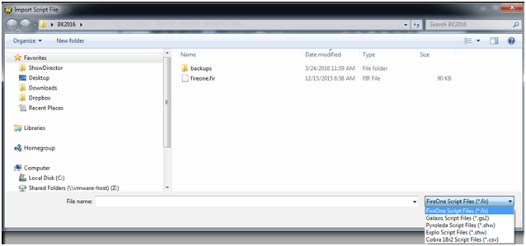

Export a Script to other systems
Exports a file to Fireone (*.fir), Galaxis (*.gs2), Pyroleda (*.shw), Explo(*.shw), Cobra, FIREMASTER, fireTEK (* .csv), Piromac.
The column order and configuration is the same as in Show Director Script.
If you want to export All Columns, you need to use the File Menu function "Save As> Excel. xls, or .csv"
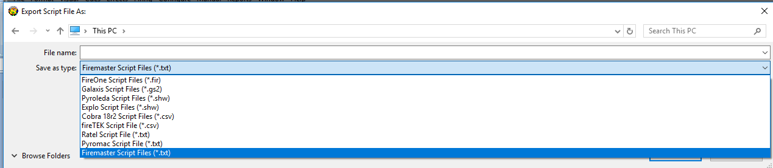

FireOne Columns Correspondence (.xls)

FireOne | F1 Type | VSD Column | Comment
ID | AutoIncrementing |  | AutoIncrementing - NOT CUE, CUE IS LOST
ScriptTime | float
Position | Char(10) | POS | DATA LOSS 64 -> 10
Qty | small int | QTY
BreakTime | float
Duration | float | DUR
Priority | small int | CGHZ | Defaults to '1' else CGHZ
Cost | BCD | PRICE1
Location | Char(8) | POS | DATA LOSS 64 -> 8
Comment | Char(60) | Event Description | DATA LOSS 128 -> 60
LaunchTime | float
Description | Char(80) | Effect Description | DATA LOSS 128 -> 80
ProductNumber | Char(20) | REF | DATA LOSS 50 -> 20
Size | Char(12) | CAL | DATA CONVERSION Int -> string
Color | Char(14)
VendorNumber | Char(20) | MFG | DATA LOSS 64 -> 20
Type | Char(15) | TYPE | DATA LOSS 36 -> 15
ScriptTimeMS | int | MS
LaunchTimeMS | int | MS - PFT
DelayTimeMS | int |  | Hardcoded to '0'
ScriptTimeText | Char(14) | MS
LaunchTimeText | Char(14) | MS - PFT
DelayTimeText | Char(14) |  | Hardcoded to "00:00:00.00"
Effects | Char(6) | ANGLE | DATA LOSS 64 -> 6
Event | small int | MACRO
Slat | int | MODULE
Cue | int | PIN
Length | Int
SayWhen | int
SayWhenText | Char(14)
SayWhat | Char(50)
Conflict | Char(10)
PyroSlat | Char(4)
PyroCue | Char(2)

GALAXIS

Galaxis Columns Correspondence (.xls)

field - Version 2 | Galaxis Name | your interpretation | Prefered Galaxis Name | VSD Column | Comment | Value | Sample | Sample | Sample | Sample | Description
(Field #0) | Ignition time count | 0 | Cue | CUE | starting with 1 | 1 - 999 |  |  |  |  | Cue 1 starts normally at 00:00:00, if the ignition time is the same we have the same cue number
(Field #1) | Dt | 1 | dt | NEXT | as an integer representation of 1/100 seconds | 0 - 99990 | 0,91s = 91 | 2,10s = 210
(Field #2) | Ignition time | 2 | Fire Time | MS - PFT | as an integer representation of 1/100 seconds | 0 - | 3:55:49 = 35594 | 2:53:04 = 25304 | 9:57:75 = 95775 | 10:03:88 = 100388 | the whole script is sorted by ignition time
(Field #3) | Effect time | 3 | Effect Time | MS - PFT | as an integer representation of 1/100 seconds | 0 - | same as ignition time
(Field #4) | Prefire duration | 4 | PFT | PFT | in the format 0,00 | 0.00 - | 1.55 = 1.55 | 2.20 = 2.20
 |  | 5 | Duration 1 | DUR | in the format 0,00 | 0.00 - | 1.20 |  |  |  | If you have a three times color changing effect = duration of effect 1
 |  | 6 | Duration 2 |  | in the format 0,00 | 0.00 - | 2.10 |  |  |  | If you have a three times color changing effect = duration of effect 2
 |  | 7 | Duration 3 |  | in the format 0,00 | 0.00 - | 1.25 |  |  |  | If you have a three times color changing effect = duration of effect 3
(Field #8) | Step cue | 8 | S Cue |  | if two cues are to close together like < 0.30 s we have to use the step cue and step delay | 1 - 999
(Field #9) | Step delay | 9 | S Delay |  | as an integer representation of 1/100 seconds | 0.01 - 99.99 | 229.96 = 22996 | 431.46 = 43146
(Field #10) | Category | 10 | Category |  | as a string |  |  |  |  |  | not really used
(Field #12) | Effect Name | 11 | Item | TYPE | as a string
 |  | 12 | Description | EFFECT DESC | as a string |  | Peony color changing |  |  |  | free text for the user
(Field #13) | Caliber | 13 | Size | CAL | as a string from VSD float | 5 or 125 | 5 as inch or 125 as mm |  |  |  | free value for the user
 |  | 14 | Effect 1 | CUSTOM8 | as a string |  | Peony color changing |  |  |  | free text for the user
 |  | 15 | Color 1 |  | as a string |  | red |  |  |  | free text for the user
 |  | 16 | Effect 2 |  | as a string |  | Peony color changing |  |  |  | free text for the user
 |  | 17 | Color 2 |  | as a string |  | blue |  |  |  | free text for the user
 |  | 18 | Effect 3 |  | as a string |  | Peony color changing |  |  |  | free text for the user
 |  | 19 | Color 3 |  | as a string |  | green |  |  |  | free text for the user
 |  | 20 | Shots |  | as an integer |  | 16 |  |  |  | Shots from a cake box
 |  | 21 | Pcs | QTY | as an integer |  |  |  |  |  | if you shoot more then one simultaneously
(Field #22) | Launch Position | 22 | Position | POS | as a string |  | left; center; right |  |  |  | Firing position
(Field #23) | Angle | 23 | Angle | ANGLE | Angle in degrees, followed by symbol font arrow characters dG, dF, and dH, e.g., up = 0dG , left = 0dF, right = 0dH |  |  |  |  |  | with the PyrotecComposer.ttf font you can see an arrow in the right direction and the value in degrees
 |  | 24 | Fan Type |  | as a string |  |  |  |  |  | free text for the user
 |  | 25 | Fan Name |  | as a string |  |  |  |  |  | free text for the user
 |  | 26 | Tube No. |  | as a string |  |  |  |  |  | free text for the user
 |  | 27 | Igniter |  | as a string |  |  |  |  |  | free text for the user
(Field #28) | Device number | 28 | Device ID # | MODULE | ID number of the receiver, receiver 1 to 999 | 1 - 999
(Field #29) | Output number | 29 | Output # | PIN | depends on the device and extension module like Matrix Module 50 or 100 Output | 1 - 100 (1 - 50)
(Field #30) | SC-ID | 30 | SC-ID | AutoCreated | unique incrementing value + 10000 | 10001 -
 |  | 31 | DB-ID |  | unique ID number of the database effect
 |  | 32 | Rising Height |  | as a string |  |  |  |  |  | free text for the user
 |  | 33 | Diameter |  | as a string |  |  |  |  |  | free text for the user
 |  | 34 | BAM Number | CUSTOM1 | as a string |  |  |  |  |  | free text for the user
 |  | 35 | ADR Class. |  | as a string |  |  |  |  |  | free text for the user
 |  | 36 | UN Number | CUSTOM2 | as a string |  |  |  |  |  | free text for the user
 |  | 37 | Chipher |  | as a string |  |  |  |  |  | free text for the user
 |  | 38 | Net weight | CUSTOM3 | in the format 0,00 |  |  |  |  |  | free value for the user
 |  | 39 | Gross weight | CUSTOM4 | in the format 0,00 |  |  |  |  |  | free value for the user
 |  | 40 | S.D. horizontal |  | in the format 0,00 |  |  |  |  |  | free value for the user
 |  | 41 | S.D. vertical |  | in the format 0,00 |  |  |  |  |  | free value for the user
(Field #42) | Product ID | 42 | Item No. | REF | as a string |  |  |  |  |  | free text for the user
 |  | 43 | Supplier | MFG | as a string |  |  |  |  |  | free text for the user
 |  | 44 | Producer |  | as a string |  |  |  |  |  | free text for the user
 |  | 45 | Price | PRICE1 | in the format 0,00 | 0.00 | 23.50 |  |  |  | free value for the user
 |  | 46 | Calc. Factor | PRICE2 | in the format 0,00 | 0.00 | 1.40 |  |  |  | we calculate Price (CP): 1.00 x 1.40 (Calc. Factor) = SP
 |  | 47 | Description | CUSTOM6 | as a string |  |  |  |  |  | free text for the user
 |  | 48 | Information | CUSTOM7 | as a string |  | nice effect |  |  |  | free text for the user
 |  | 49 | Image (Path) | PICTURELINK | as a string |  |  |  |  |  | free text for the user
 |  | 50 | Video (Path) | VIDEOLINK | as a string |  |  |  |  |  | free text for the user
 |  | 51 | Indoor |  | 0 or 1 |  |  |  |  |  | free value for the user
 |  | 52 | Outdoor |  | 0 or 1 |  |  |  |  |  | free value for the user
 |  | 53 | C1 |  | 32 bit color value of Color 1 | 0 - 16777215 | 0 = black | 255 = red | 65280 = green | 16711935 = magenta
 |  | 54 | C2 |  | 32 bit color value of Color 2 | 0 - 16777215 | 16777215 = white
 |  | 55 | C3 |  | 32 bit color value of Color 3 | 0 - 16777215
 |  | 56 | Infotext Z1 | TYPE | max. 16 characters of ASCII Characters |  | gerb step run |  |  |  | Shows the PFC Advanced controller during firing
 |  | 57 | Infotext Z2 | EFFECT DESC | max. 16 characters of ASCII Characters |  | middle of stage |  |  |  | Shows the PFC Advanced controller during firing
 |  | 58 | Class | CUSTOM5 | as a string
 |  | 59 | Stock Place | MAG | as a string
 |  | 60 | ShowSim Effect ID | VISUALREF | ShowSim Effect ID
 |  | 61 | Part List
 |  | 62 | F | MACRO | empty or F |  |  |  |  |  | To separate the script; if the controller reads a "F" -> the controller stops and wait till anybody press the fire button. Is sometimes used with life music
 |  | 63 | Layer |  | as a string
 |  | 64 | Group | GROUP | as a string |  |  |  |  |  | the same name belongs to one group; just for editing
 |  | 65 | PAN Angle |  | same as angle
 |  | 66 | Tilt Angle ShowSim | TILT | translated values for ShowSim from Angle
 |  | 67 | Pan Angle ShowSim | PAN | translated values for ShowSim from Pan Angle

FIREMASTER

Field | Firemaster Name | VSD Column | Comment
1 | Cue | Cue
2 | Seq | Macro
3 | Rif | Group
4 | Start | Cue Time | Start + Delay = Cue Time, but Delay is not stored seperately
5 | Delay | (See Cue Time Comment)
6 | Address | Module / Pin | If Unit/Term is provided it is used otherwise Address is split into Module/Pin
7 | Unit | Module
8 | Term | Pin
9 | Group | Cghz
10 | Note | Effect Description | Up to 127 characters
11 | 11 - 17 UNUSED

EXPLO

Field | Explo Name | VSD Column | Comment
0 | Box/Nr | MODULE / PIN | The module (box) and pin (post) number of the shot.
1 | Explozeit | MS | The break time of the shot, in the format 00:00.00. (MM:SS.MS)
2 | Abstand Zündzeit | NEXT | The delay to the next firing row, in the format 00:00.00. (MM:SS.MS)
3 | Effektbezeichnung | Effect Desc | The effect description.
4 | Stz. | PFT | The prefire time, in the format 0,0 (comma decimal point).
5 | Efz. | DUR | The duration of the effect. Written as whole number of seconds
6 | Efg. | TYPE | The effect category.
7 | Stop
8 | Stk. | QTY | Quantity. total number of devices represented by the firing row.
9 | Beschreibung | ANGLE | Comment. indicating the angles of the shots, such as ///.
10 | Position |  | "Position"
11 | Steighöhe |  | "Rising Height"
12 | Größe | CAL | "Size"
13 | Etk. | CUSTOM8 | Label text
14 | Effekttop |  | "Effect Top"
15 | Gruppe | GROUP | "Group"
16 | Bereich |  | "Area"
17 | Winkel | TILT | Angle.
18 | Pos. | POS | Launch position.
19 | (no name) | REF
20 | blank |  | Just to have an trailing TAB on each line

PYROLEDA

PyroLEDA | Show Director | Notes
“@” |  | instruction line start character. GEH NOTE will skip all other lines
“cue” |  | (integer >0) cue id number. GEH NOTE Autoincrements. if cue is zero then we add a row with 0 time and this whole line in Event Desc and the MACRO is zero
“time” | MS - PFT | (integer >= 0) time in millisecond.
“trigger” | MODE | trigger source can be: MAN, AUTO, SLV
“group” | CGHZ | (integer >= 0 and <= 8) group id. GEH NOTE all values 8-16 will be mapped to 8
“seq” | MODULE | (integer > 0) sequencer id.
“fire” | PIN | integer > 0 (1-32) to turn on fire line, integer <0 to turn it off . GEH NOTE We can't do negitive pin numbers, see [length]
“fire comment” | Event Desc | text string (can be null).
[“lenght”] | Custom7 | optional (can be omitted), integer>0 in milliseconds, duration of pulse. Special value 32768 = infinite (line must be turned off explicitly). GEH NOTE: Stored in Custom7 as "LINE ON XX" or "LINE OFF" if pin was negative
[“voltage”] | Custom8 | optional (can be omitted), integer>0 in Volt, if included, MUST BE Forwarded by the preceding length field GEH NOTE stored in Custom8

FIRETEK

Field | FireTek Name | VSD Column | Comment
1 | Module Address | CONTROL
2 | Slot Address | MODULE
3 | Pin Address | PIN
4 | IgnitionTime | MS-PFT | in milliseconds (Prefire Time, MS - PFT)

Auto Restore - Undo

- New Auto Restore for Scripts and Effects Managers. This new function will keep a back up of your most recent Scripts or Effects Managers making a copy of the files every 5 minutes within 1 hour. There will be 12 copies that you can restore at any point on time.
- The feature is only active with a project open. The backup files are stored in a folder inside the directory where the project is saved.The function can be manually deactivated by changing On to Off in the file sd.ini in C:/Users/username/Appdata/Roaming/ShowDirector. You will never loose more than 5 minutes of work.
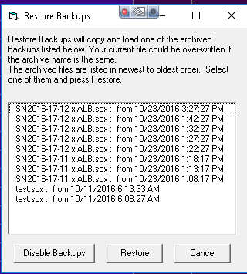

Scripting for DMX

How to program different DMX devices from Show Director

Show Director supports DMX devices in two ways. First by providing a simple way to address a DMX controller, channel and value for that channel. The second is by providing specific devices where multiple channels are used. Below we will provide example of how each can be used.
Show Director allows for DMX devices to be added to any show script. Different actions can be specified using the existing columns in your script. One requirement for the DMX devices is that the TYPE column in your script must be exactly one of the supported DMX types. For example, the SimpleDMX type must be specified in the TYPE column as "SimpleDMX". Case and spelling do count. Other columns will contain the additional information based on the DMX command.

SimpleDMX
The most basic of the DMX commands is a generic simple command. This will set one of the 512 channels to a specified value. We allow for CUSTOM1 column to be used to over-ride the PIN column. This is so that you can create Effects Manager entries to control the intensity value set to the PIN column. If you put a numerical value in CUSTOM1, it will over-ride the value in PIN. Otherwise, use the PIN column.

SD Column Name | DMX | Note
TYPE |  | Must be "SimpleDMX"
CONTROL | Controller | One DMX controller universe per serial USB connection
MODULE | Channel | Values 1 to 512 are allowed
DUR | The duration that this channel will have this value before returning to zero | If duration is zero (00:00) then the channel is set to value permanently, otherwise max duration is 99 seconds
PIN or CUSTOM1 | Value to place on the Channel | Values 0 to 255 are allowed.

Here is an example of what a SD script might look like using SimpleDMX commands:
CUE | HH MM SS FF | TYPE | CONTROL | MODULE | DUR | PIN | Event Description
1 | 00 00 00 00 | SimpleDMX | C1 | 12 | 01:15 | 255 | Turn channel 12 on for 1 and a half sec
2 | 00 00 05 00 | SimpleDMX | C1 | 7 | 00:00 | 127 | Set channel 7 to 127
3 | 00 00 10 15 | SimpleDMX | C1 | 7 | 00:00 | 0 | Set channel 7 to 0

When the DUR column is zero, then the value place on the channel is permanent until changed again by another cue. However, if a duration is provided, then the channel is set to the value in the PIN column for the specified time and then the channel is returned to zero. The limit on duration is 99 seconds.

Galaxis G-Flame Flame Box
One of the specifically supported DMX devices is the G-Flame by Galaxis. Like most flame boxes, the G-Flame has a safety channel as well as a trigger channel. In order for the G-Flame to operate, the safety channel must first be turned on and later, for safety, must be turned off. The G-Flame therefore has three command: GFlameSafetyOn, GFlameTrigger and GFlameSafetyOff. These can be called multiple times during the show as long as the safety channel is on before any event triggers. Note that multiple G-Flame devices can share a single safety channel. Here are the SD columns and an example script:

SD Column Name | DMX | Note
TYPE |  | One of the GFlame commands listed below
CONTROL | Controller | One DMX controller universe per serial USB connection
MODULE | Channel | Values 1 to 512 are allowed
DUR | The duration of this flame | Must be a value between 00:01 and 25:00 (maximum duration)

Assuming two G-Flame boxes are configured with safety channel 33 and trigger channel 2 and 17 respectively:
CUE | HH MM SS FF | TYPE | CONTROL | MODULE | DUR | Event Description
1 | 00 00 00 00 | GFlameSafetyOn | G2 | 33 | 00:00 | Set channel 33 to GFlame safety value
2 | 00 00 05 00 | GFlameTrigger | G2 | 2 | 00:15 | Flame on device 2 for half sec
3 | 00 00 05 00 | GFlameTrigger | G2 | 17 | 00:15 | Also start device 17 for same
4 | 00 01 00 00 | GFlameTrigger | G2 | 2 | 05:00 | Flame on device 2 for 5 sec
5 | 00 05 00 00 | GFlameSafetyOff | G2 | 33 | 00:00 | Disable both 2 and 17

You should always turn the G-Flame safety on for at least 1 second before any trigger events in order to give the flame box time to get activated.

Le Maitre Salamander Flame Box
The Salamander Flame Box is a specifically supported DMX device. Like all flame boxes it has a safety channel and a trigger channel. In order for the flame box to operate, the safety channel must be turned on before any trigger commands will activate. For safety reasons we must also turn the safety channel back off at the end of the script. The safety and triggers may be turned on or off any number of times as long as the safety is on before any trigger cues are executed. The Salamander has three commands for this: SalamanderSafetyOn, SalamanderTrigger and SalamanderSafetyOff. Note that multiple Salamander devices may use the same safety channel.

SD Column Name | DMX | Note
TYPE |  | One of the Salamander commands listed below
CONTROL | Controller | One DMX controller universe per serial USB connection
MODULE | Channel | Values 1 to 512 are allowed
DUR | The duration of this flame | Must be a value between 00:01 and 25:00 (maximum duration)

Here is an example SD script using two Salamander flame boxes with separate safety channels. One has the safety channel on 1 and trigger on 2, the other safety is 3 and trigger 4.

CUE | HH MM SS FF | TYPE | CONTROL | MODULE | DUR | Event Description
1 | 00 00 00 00 | SalamanderSafetyOn | C1 | 1 | 00:00 | Set channel 1 to Salamander safety value for device 2
2 | 00 00 00 00 | SalamanderSafetyOn | C1 | 3 | 00:00 | Set channel 3 to Salamander safety value for device 4
3 | 00 00 10 00 | SalamanderTrigger | C1 | 2 | 00:15 | Flame on device 2 for half sec
4 | 00 00 10 00 | SalamanderTrigger | C1 | 4 | 00:15 | Also start device 4 for same
5 | 00 01 00 00 | SalamanderTrigger | C1 | 2 | 05:00 | Flame on device 2 for 5 sec
6 | 00 05 00 00 | SalamanderSafetyOff | C1 | 1 | 00:00 | Disable channel 1 for 2
7 | 00 05 00 00 | SalamanderSafetyOff | C1 | 3 | 00:00 | Disable channel 3 for 4

You should always allow for 10 seconds after turning the Salamander safety channel on before any trigger events.

Explo X2 Wave Flame Box
The Explo X2 Wave flame box is specifically supported by SD. This DMX device sports a moving flame head and is a little more complex the some other flame boxes. SD takes care of this complexity through four commands: X2WaveSafetyOn, X2WaveTrigger, X2WaveSeq and S2WaveSafetyOff. The X2 Wave device has a safety channel for each device and they cannot be shared. A unique feature of the X2 Wave is that you only need to set the first channel of the device. All other features are an offset from that first channel and therefore not required to be specified in the SD script. There are 6 channels in use, so the base addresses for any other device must be 6 greater than the base address of the X2 Wave. If the base channel of a X2 Wave flame box is 6, then the next DMX device on the controller must be set to 12 or higher otherwise you will have channel conflicts and errors.

SD Column Name | DMX | Note
TYPE |  | One of the GFlame commands listed below
CONTROL | Controller | One DMX controller universe per serial USB connection
MODULE | Channel | Values 1 to 512 are allowed
DUR | The duration of this flame | Must be a value between 00:01 and 02:15 (maximum duration)
TILT | Angle of the flame head | 0 degrees is horizontal right, 90 is up and 180 is horizontal left. Negative values may be used between 0 and -180 to represent down (-90 is down).  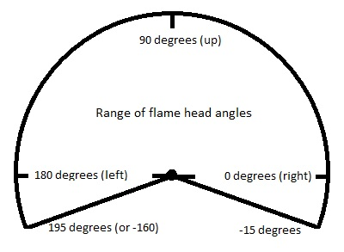
CUSTOM2 | Speed of flame head | When the flame head changes positions, the speed at which if moves may be specified. 0 is stationary, 1 (slowest) to 255 (fastest). Default movement is fastest.
REF | Built-in X2 Wave sequences | There are 70 built in sequences programmed into the X2 Wave. See the X2 Wave user's manual for a full explanation of these sequences.

Here is an example SD script using the X2 Wave. Assume we have two devices set to base channel 10 and 16 respectively.

CUE | HH MM SS FF | TYPE | CONTROL | MODULE | DUR | REF | TILT | CUSTOM2 | Event Description
1 | 00 00 00 00 | X2WaveSafetyOn | DD1 | 10 | 00:00 |  |  |  | Set safety on for device 10
2 | 00 00 00 00 | X2WaveSafetyOn | DD1 | 16 | 00:00 |  |  |  | Set safety on for device 16
3 | 00 00 10 00 | X2WaveTrigger | DD1 | 10 | 00:15 |  |  |  | Flame on device 10 for half sec
4 | 00 00 10 00 | X2WaveTrigger | DD1 | 16 | 00:15 |  |  |  | Also start device 16 for same
5 | 00 01 00 00 | X2WaveTrigger | DD1 | 10 | 02:00 |  |  |  | Flame on device 10 for 2 sec
6 | 00 01 30 00 | X2WaveTrigger | DD1 | 10 | 00:00 |  | 135 | 255 | Flame off, move head to 45 left
7 | 00 01 00 00 | X2WaveTrigger | DD1 | 10 | 02:15 |  | 45 | 127 | Flame on med wave to 45 right
8 | 00 01 00 00 | X2WaveTrigger | DD1 | 10 | 00:00 |  | 90 | 255 | Flame off move to up
9 | 00 01 00 00 | X2WaveTrigger | DD1 | 10 | 02:00 |  |  |  | Flame on device 10 for 2 sec
10 | 00 01 00 00 | X2WaveSeq | DD1 | 10 | 00:00 | 51 |  |  | Seq med wave 45 left to 45 right
11 | 00 01 00 00 | X2WaveSeq | DD1 | 16 | 00:00 | 52 |  |  | Seq med wave 45 right to 45 left
12 | 00 05 00 00 | X2WaveSafetyOn | DD1 | 10 | 00:00 |  |  |  | Disable device 10
13 | 00 05 00 00 | X2WaveSafetyOn | DD1 | 16 | 00:00 |  |  |  | Disable device 16

The build in sequences in the X2 Wave are nice in that cue 10 does the same thing as cues 6,7 and the duration of the flame is regulated by the sequence, not by the script writers estimation.

SafeX Flame Jet Flame Box
The SafeX Flame Jet flame box is another SD supported DMX device. Like all flame boxes it has a safety channel and a trigger channel. In order for the flame box to operate, the safety channel must be turned on before any trigger commands will activate. For safety reasons we must also turn the safety channel back off at the end of the script. The safety and triggers may be turned on or off any number of times as long as the safety is on before any trigger cues are executed. The Flame Jet has three commands for this: FlameJetSafetyOn, FlameJetTrigger and FlameJetSafetyOff. Note that multiple Flame Jet devices may use the same safety channel.

SD Column Name | DMX | Note
TYPE |  | One of the Flame Jet commands listed below
CONTROL | Controller | One DMX controller universe per serial USB connection
MODULE | Channel | Values 1 to 512 are allowed
DUR | The duration of this flame | Must be a value between 00:01 and 10:00 (maximum duration)

Assuming two Flame Jet boxes are configured with safety channel 33 and trigger channel 2 and 17 respectively:

CUE | HH MM SS FF | TYPE | CONTROL | MODULE | DUR | Event Description
1 | 00 00 00 00 | FlameJetSafetyOn | G2 | 33 | 00:00 | Set channel 33 to FlameJet safety
2 | 00 00 05 00 | FlameJetTrigger | G2 | 2 | 00:15 | Flame on device 2 for half sec
3 | 00 00 05 00 | FlameJetTrigger | G2 | 17 | 00:15 | Also start device 17 for same
4 | 00 01 00 00 | FlameJetTrigger | G2 | 2 | 05:00 | Flame on device 2 for 5 sec
5 | 00 05 00 00 | FlameJetSafetyOff | G2 | 33 | 00:00 | Disable both 2 and 17

You should always turn the Flame Jet safety on for at least 1 second before any trigger events in order to give the flame box time to get activated.

CRGBLight
A very common DMX controlled light is one with four channels that does Red, Green and Blue colors. Show Director Control has provided a TYPE for this light. The Control for the light is in the PIN (or CUSTOM1) column and is light specific as to how values control the light. Typically 0 turns the light off and 255 will use the values of Red, Green and Blue to set color and intensity. Your lamp may have other features that are controlled using the PIN column. Consult your manual. To specify a color, you need to have the start of the Effect Description have a '#RRGGBB' hexadecimal value. These values are two hex characters each for red, green and blue. So, for example, #FF0000 would be full red. #00FF00 would be full Blue, etc. #7F0000 would be half intensity red. #00FFFF would be bright cyan. If you provide a duration, the light will turn on for than amount of time and then turn itself off.

SD Column Name | DMX | Note
TYPE |  | Must be "CRGBLight"
CONTROL | Controller | One DMX controller universe per serial USB connection
MODULE | Channel | Values 1 to 512 are allowed. Each CRGBLight uses 4 contiguous channels. Next device must be 4 higher than the value used here.
DUR | The duration that this channel will have this value before returning to zero | If duration is zero (00:00) then the channel is set to value permanently, otherwise max duration is 99 seconds
PIN or CUSTOM1 | Control value to place on the Channel | Values 0 to 255 are allowed. Typically 0 is off and 255 uses the color and intensity provided. Other values are light specific features like blinking and fade.
Effect Description | Color and Intensity of the light | Values #000000 to #FFFFFF are allowed

Here is an example of what a SD script might look like using CRGBLight commands:
CUE | HH MM SS FF | TYPE | CONTROL | MODULE | DUR | PIN | Event Description
1 | 00 00 00 00 | CRGBLight | C1 | 1 | 01:15 | 255 | #FFFFFF bright white for 1.5 seconds
2 | 00 00 05 00 | CRGBLight | C1 | 1 | 00:00 | 255 | #FF0000 full red on
3 | 00 00 10 15 | CRGBLight | C1 | 1 | 00:00 | 255 | #A5184C switch to custom color
4 | 00 00 12 15 | CRGBLight | C1 | 1 | 00:00 | 0 | Turn light off

PanTiltWRGBCYMLight
Another common DMX controlled light is one with 10 channels that does Pan, Tilt, colors. Show Director Control has provided a TYPE for this light. In this light, the color is determined by an internal color wheel that has 7 colors: White, Red, Green, Blue, Cyan, Yellow and Magenta. To specify a color, you need to have the start of the Effect Description have a '#RRGGBB' hexadecimal value. These values are two hex characters each for red, green and blue. So, for example, #FF0000 would be full red. #00FF00 would be full Blue, #00FFFF would be bright cyan, etc. If you provide a duration, the light will turn on for than amount of time and then turn itself off. In addition the light has a swivel head and can be panned or tilted. You can pan through 360 degrees and tilt from 0 to 180. The light can be pan/tilted while the light is off or on.

SD Column Name | DMX | Note
TYPE |  | Must be "PanTiltWRGBCYMLight"
CONTROL | Controller | One DMX controller universe per serial USB connection
MODULE | Channel | Values 1 to 512 are allowed. Each PanTiltWRGBCYMLight uses 8 contiguous channels. Next device must be 8 higher than the value used here.
DUR | The duration that this channel will have this value before returning to zero | If duration is zero (00:00) then the channel is set to value permanently, otherwise max duration is 99 seconds
PIN or CUSTOM1 | The intensity of the light | Values 0 to 255 are allowed. 0 is off through 255 being full intensity.
Effect Description | Color of the light | Values #000000 to #FFFFFF are allowed.
PAN | Pan angle of the light | Values 0-360.
TILT | Tilt angle of the light | Values 0-180.
CUSTOM2 | Speed of the pan and tilt | Values 1-255. 1 is slow, 255 is fast. Zero or blank is fast.

Here is an example of what a SD script might look like using PanTiltWRGBCYMLight commands:

CUE | HH MM SS FF | TYPE | CONTROL | MOD | DUR | PIN | PAN | TILT | CUSTOM2 | Event Description
1 | 00 00 00 00 | PanTiltWRGBCYMLight | C1 | 7 | 01:15 | 255 |  |  |  | #FFFFFF bright white for 1.5 seconds
2 | 00 00 05 00 | PanTiltWRGBCYMLight | C1 | 7 | 00:00 | 255 | 90 | 45 | 127 | #FF0000 full red on, pan 90 and tilt up 45, medium speed
3 | 00 00 10 15 | PanTiltWRGBCYMLight | C1 | 7 | 00:00 | 255 |  | 135 | 255 | #A5184C switch to custom color and tilt over to 135, fast speed
3 | 00 00 12 15 | PanTiltWRGBCYMLight | C1 | 7 | 00:00 | 0 | 0 | 0 |  | Turn light off and return to center pan and tilt, fast speed

Scripting Commands and Syntax of Visual Columns
There are special syntax for each of the following Column fields:

QTY

PAN & TILT

CAMERA

VISUAL REFERENCE

BEAM

WORLD

OBJECT

VIDEO LINK & PICTURE LINK

QTY
Script Commands and Syntax: QTY FIELD
This field contains an integer that can be 0 or not. If 0 is the value no effects will be displayed. To shoot the effects 1 must be at least present. 0 will not fire.
The number of effects shot in the engine is not determined by the QTY value but by the number of angles present in the PAN and TILT fields whatever is greater. (for example, if three angels 60-90-120 is entered into the TILT Column, three shots will be fired) 3 must be entered into QTY solely for inventory purposes. The QTY field should always reflect the total number of effects for inventory purposes.
Other fields: PAN & TILT - CAMERA - VISUAL REFERENCE - BEAM - WORLD - OBJECT - VIDEO LINK & PICTURE LINK

PAN & TILT
Script Commands and Syntax: PAN & TILT
PAN AND TILT
This fields contain integer values separated by the - character. Their number determines the number of effects to shoot and the angles.
If PAN angles are not used, the field can be left empty. Only TILT angles will be taken into consideration.
PAN is the rotation around Y axis (orientation), and TILT is the rotation around Z axis (inclination).
Normally the X axis is pointing to the right of the audience view and it represents 0 degrees. Angles are set counter clockwise 180__|90|__0
The previous versions ANGLE field is not used to fire the effects but only as a reference. It admits also symbolic characters like \|/.
Examples:
Example I:
PAN | TILT
45-90 | 90
It specifies 2 effects to be shot; the three effects will have the following pair of angles for shooting:
First effect: PAN=45, TILT=90
Second effect:PAN=90, TILT=90

Example II:
PAN | TILT
0 | 45-90
It specifies 2 effects to be shot; the two effects will have the following pair of angles for shooting:
First effect:PAN=0, TILT=45
Second effect:PAN=0, TILT=90

Example III:
PAN | TILT
0-45 | 0-45-90
It specifies 3 effects to be shot; the three effects will have the following pair of angles for shooting:
First effect:PAN=0, TILT=0
Second effect:PAN=45, TILT=45
Third effect:PAN=45, TILT=90

Example IV:
PAN | TILT
0-45-90 | 45-60-75
It specifies 3 effects to be shot; the three effects will have the following pair of angles for shooting:
First effect: PAN=0, TILT=45
Second effect:PAN=45, TILT=60
Third effect:PAN=90, TILT=75
Other fields: QTY - CAMERA - VISUAL REFERENCE - BEAM - WORLD - OBJECT - VIDEO LINK & PICTURE LINK

CAMERA
Script Commands and Syntax: CAMERA
CAMERA
The camera reference is obtained by pressing the letter “c” in the keyboard while window focus is in the Viewer and then pasting it into the Visual Reference field of the Script with the mouse right button menu, Paste Selection.
The Camera contains the following string:
camera(-25.500000*1744.199707*-4560.000000*358.980011*3.060000*0.000000*60*1)
camera(x*y*z*rx*ry*rz*fov*time) FOV:Field of View ( lens angle)
Where:
- x,y and z are the coordinates of the new positions of the camera.
- rx,ry and rz are the rotation angles of the camera.
- fov is the field of view angle, in this case 60 degrees opening. Human Eye FOV is 120.
- time is the transition time, in milliseconds, for the camera movement. The minimum value is 1.
- Cameras can be copied and pasted as regular cues.
- To set a camera transition from one point of View to another, two camera codes are necessary. The first code will be the origin point and the second the destination.
- The transition start time is determined in a cue following at least 1 frame of script time from where the origin code was pasted. This new line will contain the new destination code.The duration of the transition is set in the second (or destination code) at the last digit for time.
- The sign # in front of the camera code cancels a camera action, so it is not necessary to delete the code, while rehearsing a position.
# camera(-25.500000*1744.199707*-4560.000000*358.980011*3.060000*0.000000*60*1)
Other fields: QTY - PAN & TILT - VISUAL REFERENCE - BEAM - WORLD - OBJECT - VIDEO LINK & PICTURE LINK

VISUAL REFERENCE
Script Commands and Syntax: VISUAL REFERENCE
VISUAL REFERENCE
The Visual reference code is obtained with the VSD FXGenerator, it contains the name of the effect and its variations in color, size and height. It is a necessary field to display the effect.
This field has the following syntax:
shoot(Chrysanthemum*0000FF-FFFFFF-FFFFFF*0*0)
shoot(effect name *color string *opening radius*height)
Where:
- Effect name is the name of the effect to be shot.
- Color string is the color string for the effects; it must be written with the following Hexadecimal color syntax:
RRGGBB-RRGGBB-RRGGBB
where R, G or B is any hexadecimal digit from 0 to F corresponding to the decimal value of the color.
Example:
White = FFFFFF,
Black = 000000,
Red = FF0000,
Green= 00FF00
Blue=0000FF

To understand Hex colors Read This
The color string can be modified directly, without the use of the FXGenerator, if a set of colors and hexadecimal values are known.
- Opening and height are the alternative opening radius and height for the effects. Opening is only relevant for the Shell effect types, not for Ground effects.
Other fields: QTY - PAN & TILT - CAMERA - BEAM - WORLD - OBJECT - VIDEO LINK & PICTURE LINK

BEAM
Script Commands and Syntax: BEAM
BEAM ( lighting & lasers and image projections)
The beam reference is built inside the VsdPos3D and can be exported (copied to the clipboard) from inside the VsdPos3D by right-clicking and selecting Export key-framing string.
The string code has the following syntax:

beam(300*1*Z90*1*0*300*Y0*1*0*300*X0*1*0*300*CFFFF80*1*FFFF80*300*O1*1*1*300*D5*1*5*300*L150*1*150*300*B100*1*100*300)
beam(duration*number of repeats*initial z angle*number of angles*angle1*time1*...*angleN*timeN*initial y angle*number of angles*angle1*time1*...*angleN*timeN*initial x angle*number of angles*angle1*time1*...*angleN*timeN*initial color*number of colors*color1*time1*...*colorN*timeN*initial start diameter*number of start diameters*start diam.1*time1*...*start diam.N*timeN*initial final diameter*number of final diameters*final diam.1*time1*...*final diam.N*timeN*initial length*number of lengths*length1*time1*...*length N*timeN*initial brightness*number of brightnesses*brightness 1*time1*...*brightness N*timeN)
The values of the string are based in the Modifiers values set in the VSDPOS. An initial cue can have a complete number of modifiers and a following one can just have one modifier.
Due to the length and complexity of the strings it is better to modify the values in the VSDPOS and export the string.
If you want you can also make modifications directly in the string. Here is an example:
beam(300*1*Z90*1*0*300*Y0*1*0*300*X0*1*0*300*CFFFF80*1*FFFF80*300*O1*1*1*300*D5*1*5*300*L150*1*150*300*B100*1*100*300)
Beam (duration (300)*repetition count (1)*Z90*1*0*300 stands for: Z initial is 90, there is 1 change, 0 is the next Z value, 300 is the transition time*and so on for the others... *C is color *O is start diameter*D is final diameter*L is length*B is brightness)
The letter represents the beam property... Z,Y and X are the beam angles... B is the brightness, O and, L is length, and...
After the letter, there is always the initial value so Z90 means that the initial Z value is 90, and so on for the other letters
The number after the * is the number of transitions
Then, after this number, there are couples of numbers *N*T where N is the new value of the beam property and T is the transition time
for example: CFFFF80*1*FFFF80*300 means that the initial color is FFFF80... then the color changes one time, in particular the new color will be FFFF80 in 3 seconds
Lengths of the beam can be adjusted
L150*1*150*300 means that the initial length is 150, then the length changes one time, in particular the new length will be 150 in 3 seconds
Other fields: QTY - PAN & TILT - CAMERA - VISUAL REFERENCE - WORLD - OBJECT - VIDEO LINK & PICTURE LINK

WORLD
Script Commands and Syntax: WORLD
WORLD
The position file project (.pos) can have multiple Sites with different models or pictures. In this case the WORLD field must contain the name of the Site to display. It is possible to change in a cue from one WORLD or Site to another by changing the Site name in the WORLD column. The Script will change to that WORLD when the cue is shot.
When there is only one Site. The Viewer by default will open that site only. No input in the WORLD field is necessary. As soon as there is another site in the Position File, input of specific sites is necessary.
Other fields: QTY - PAN & TILT - CAMERA - VISUAL REFERENCE - BEAM - OBJECT - VIDEO LINK & PICTURE LINK

OBJECT
Script Commands and Syntax: OBJECT
OBJECT
The Object field is used to control the animation of the objects inside the models or the sites. An object with an attached effect can rotate around itself, like a Saxon, or it can move across the site, like a boat.
The Object reference is built inside the VsdPos3D and can be exported (copied to the clipboard) from inside the VsdPos3D by right-clicking and selecting Export key-framing string.
The syntax is the following:
object(Ellipse_4x_I1*1*1*2000*0*1*0*0*720*0)
object(name of the object*1*1*time*0*1*0*0*total rotation angle*0)
The string code can be copied and pasted and the Object manually renamed to do the same operation for similar objects.
The Duration time in milliseconds can be adjusted. In this case is 2000 or 2 seconds, but the value can be altered to increase or decrease the duration of the movement.
The Total rotation angle can be increased or decreased or change the direction by inserting a negative number. Positive number is clockwise direction, and negative (-720) is counter clockwise.
If we change as:
object(Ellipse_4x_I2*1*1*10000*0*1*0*0*-1440*0)
In this case the object is a similar one, number I2 ,will rotate during 10 seconds and 4 times around itself (4x360=1440).
Other fields: QTY - PAN & TILT - CAMERA - VISUAL REFERENCE - BEAM - WORLD - VIDEO LINK & PICTURE LINK

VIDEO LINK & PICTURE LINK
Script Commands and Syntax: VIDEO LINK & PICTURE LINK
PICTURE LINK
This field is used to link pictures to the effects. Normally these are set in the Effects Manger.
The pictures will be used to render a synchronized to cues slide show with the PRODUCER option.
The pictures are not displayed in the Viewer, only in the final rendered movie.
VIDEO LINK
This field is used to link video clips to the effects. Normally these are set in the Effects Manager.
The video clips will be used to render a synchronized to cues slide show with the PRODUCER option.
The video clips are not displayed in the Viewer, only in the final rendered movie.
Other fields: QTY - PAN & TILT - CAMERA - VISUAL REFERENCE - BEAM - WORLD - OBJECT

Working with Cues
Show Director offers a wide number of functions, options and choices that work with the Script Manager.
From the [CUES] menu the following functions are available:

- Save New Cues  - Clear New Cues  - Copy Cues  - Cut Cues  - Paste Cues  - Duplicate Cues  - Insert Cues  - Insert Effects  - Create Effects  - Update Effects  - Create Macro  - Capture Cues  - Renumber Cues  - Renumber Addresses  - Validate Addresses  - Reset Addresses  - Offset Time  - Refresh Grid  - Column Fill Down  - Cues Invert  - Cues Auto Complete  - Locate  - Import Cues  - Export Cues  - Import Beat  - Export .chr | 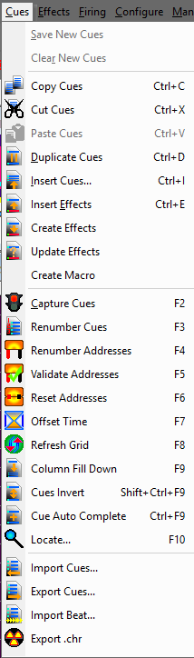

Save / Clear New Cues
While capturing cues in play mode , if you want to keep the cues, you can save them instantly before stopping, or clear them if you do not want to keep them.
This command is active only when Play is running. Once you stop playing the cues are automatically inserted in the Script.

Copy, Cut, Paste and Duplicate Cues
You can copy or cut any selection on the Script and paste it in any other cue or selection of cues with automatic time reset to the inserted cue.
With Visual Show Director you can Copy selections of cues at different times and Paste them in different cues or selections of cues at different times.
First: make a Selection.
If you don't know how to select multiple cues, please refer to Selection Strategies
To Copy | Press Ctrl+C, select command from Menu or click the related Icon in the toolbar
To Cut | Press Ctrl+X, select command from Cues Menu or click the related Icon in the toolbar. Cut will take off the cues from the Script and store them temporarily in the Clipboard
To Paste | Make first a selection of one or Multiple Cues. Press Ctrl+V, select command from Cues Menu or click the related Icon in the toolbar.
to Duplicate | Press Ctrl+D, select command from Cues Menu or click the related Icon in the toolbar.  When you are duplicating more than one time, a cue that is part of a group of cues with the same time, make sure that after duplicating it, the cursor always moves back to the first cue, which may be a different effect than the one you want to duplicate. To avoid this problem:  - Use Copy Paste commands, or  - Create a sort named “Duplicating” with Time as value 1 and Cue as value –2 (descending). The last cue duplicated will go up and be selected, and you will be able to continue with the duplicate operation.
You can now also Copy, Cut and Paste text within cells or from other application. Highlight the text string and, clicking on it with the right button of the mouse, opens the edit Menu.

Insert Cues
This is a powerful Show Director feature that you can use with great flexibility. It is a real time saver.
At the same time it is a calculator of cue intervals, numbers, within time sequences.

How to use Insert Cues
- Go to Cues Menu and select Insert Cues, or just type Ctrl+I
- The Insert/Edit cues window will open.
You can use this window to Insert any number of cues, with a selected effect, address, position and Interval of firing.
Time/Duration
- Set the time in in Frames or Milliseconds.
- If after Apply you wan to continue insert cues at the last cue entered, select Update. The Script will scroll to the last row and you can create a new sequence.
There are 3 methods of operation.
- Compute # of Cues: You can select a Time in and a Timeout for the effect and interval. Show Director will calculate the number of cues necessary.
- Compute Interval: You can select a Time in and a Time-Out and the number of cues. Show Director will calculate the interval in-between cues.
- Compute Duration: You can select a Time in, the number of cues and the interval. Show Director will calculate the Time Out.

To any of these methods you can assign:

The selected effect or effects in Effects Manager. Or type a REF and the effect will be automatically selected.
A position. If you want to create a sequence of position incremental (In) or decremental (Dec) check the corresponding box.
A Quantity.
A Description for Event DEscription column.
An angle Tilt and Pan
A Macro Number or Event (Fireone)
Caliber Group Hazard number, and an Event Description.
Correlative or offset addresses, in HEX and DEC ( module and Pin)

To select multiple effects in the Effects Manager, press the Shift key for adjacent effects in the list or the Ctrl key for non-adjacent and descending effects selected. The multiple effects selected will be inserted with the same time, and as many times as the number of cues at the selected intervals. After filling the values on the form, you can press the Compute button to see the results, and adjust if necessary any of the values. Clicking Apply or OK buttons inserts the cues in the Script window.

How to Insert One Single empty line

Just press the Ins key in your keyboard below the cue time you want to insert.

WATCH VIDEO TUTORIAL
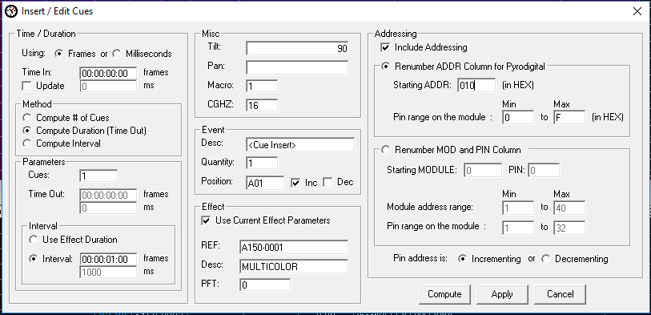

Insert Effects
(See also Duplicate Cues)
The same functions as Duplicate cues apply for Insert Current effect.
In the Effect Manager, select a single effect, subsequent effects, or a nonadjacent selection of effects (See also Selection Strategies).
You can also select multiple cues, and insert the effect or effects in each cue of the multiple selections.
Select contiguous rows with the Shift key.
Select alternate roes with the Ctrl key.

In the Script Window:

- Select the row(s) at the time(s) where you want to insert the selection,
Select contiguous rows with the Shift key.
Select alternate roes with the Ctrl key.
- Press Ctrl-E, select command from Cues menu or click in the Icon.

- All the effects selected will be inserted with the same time.
In the script window you can type a reference number or the first digits of it in the Script window Reference field and you will see how it is located in the Effects Manager, and also inserted in the Script.

- Once you have the desired effect.
Press Ctrl+E and the effect(s) will be inserted at the selected cue(s).
If you want to work within a specific category of effects, apply a filter to the Effects Manager, and the same functions will apply.

Create Effects
You can create a new effect entry in the Effects Manager by selecting the effects in the Script and selecting Create Effect from the Cues Menu.

A window will pop up with the following message:

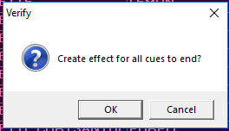

New effect lines will be created in the Effects Manager fro all the effects not already present.

It is necessary to have a distinct reference number for each effect. REF.

This function is particularly useful when you have a Script that was created without and Effects Manger, by typing each effect manually.

Update Effects

All or a selection of Cues Effects data in a script can be updated from a new the loaded Effects Manager.
If you have updated your Effects Manager with new information, you can quickly update your Script by REF number with the new data.
Make a selection of Cues (or no selection for the full script) and select from the menus Cues->Update Effects.

Add Script Effect to Effects Manager
If a Cues REF number is not in the current Effect Manager, it can be automatically added with all the provided effect data by selecting the cue and selecting from the menus Cues->Create Effects

Create Macro

Select a cue with a CGHZ value other than zero and select from the menus Cues->Create Macro.

For the current script view, all cues with the matching CGHZ value will be tallied and their Cue Time will be set to the value of the highest value.

However, all of the PFT values will be set so that the original cue time is kept.

That is to say that a macro with the correct fire times will be created based on PFT and the highest cue time.

Macros are limited to a total of ten minutes time. After that you will need to break them down into separate macros.

Capture Cues/Automatic Beat Detection
To start capturing cues the Capture Cues function must be on.
You can do that from the Cues Menu, pressing F2 or clicking in the Streetlight Icon.
When the streetlight icon is on “Green” and in the bottom bar it says “Capture On”, you are ready to capture Cues.
The CD and WAV file players have been enhanced to allow the "seek to" operation.
The user may seek both forward and backward in increments of 5 seconds. Also, by selecting a row in the event grid and pressing the Play key the music will seek to that time and begin playing. This greatly enhances the ability to quickly review firing sequences.
The Clock on the second left box at the bottom of the screen displays a HH: MM: SS: FF clock in sync with the Time Code.
> Press Space-bar, or Click Add Cues on the Wave Display button.
You can also insert selected effects at the same time that you capture cues pressing the Button Add Effects. The Effects Manager needs to be open to have this function enabled.
Each time you press, the New Cues box displays the total of cues entered, and the Last Cue pan the time of the last cue. You can see that the Script window displays the new cues with the <CAPTURE> sign in the Event Description column. The columns HH: MM: SS: FF display the exact time of the cues.
> Stop playing the music.
The Script Window will update and save automatically the cues entered. You can also save the cues at any moment during capture by going to the Cue menu and clicking on Save Cues. To review the cue markers in the wave Display you need to PressF8
> Rewind, and Play again. Capture must be ON to play the cues.
The Next cue on the time sequence will be highlighted in blue, and as the cues time match the Time Code running clock they will highlighted as well. The Blue highlight is programmed to be stable at the center of your window. Therefore at the beginning of the script it will scroll down to find the center position of the screen, and at the end will move down until the last cue is highlighted.
500 cues may be safely captured before being saved.
If you want to enter a modification or adjustment in the time HH: MM: SS: FF, you can do it by selecting the cell and typing a new number. Press Tab to go to the next cell. It is also possible to increase or decrease the time value by Pressing (Shift +) to increase, or, (-) to decrease (no Shift).

Music Beat Detection and Cue Insertion

  - Often you need to insert a large set of cues that are on the beat of the music. Show Director now includes Beat Detection for doing this. With a wave file loaded and the Capture mode off (i.e. "Red Light") , click where you want the capture to start and Shift+Click where you want the capture to stop. If you don't set a starting and/or ending point it will use the beginning and end of the wave plot. Select from the menus Cues->Import Beat... This will bring up the Beat Detection dialog:

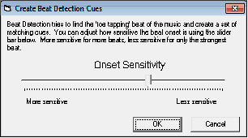

  - Onset Sensitivity is how sensitive the detection is. If you have more sensitivity you get more cues, possible including false beats or back beats. Less sensitive you might miss a few beats ins quiet sections or if the beat gets too complex. Play with this setting to get the level you want.

NOTE: Some .wav files, like those converted from .mp3, may not be able to be beat detected due to not having the correct PCM internal format. We will work on this for a future update.

Watch Video Tutorial

Renumber Cues (F3)
Selecting Renumber Cues in the Cues menu or pressing F3 will renumber the cues in the entire script or filtered script.
Warning: There is no Undo for this function. Use Restore Backups.

Renumber Addresses (F4)
Show Director allows you to address your script with an important degree of automation and verification.You won't need to type every single address.
It is possible to address for multiple firing systems. Pyrodigital uses the ADDR column based on hexadecimal address from 000 to 7FF.
Other systems use Module and Pin. Module from 000 to 999 and Pin from 0 to 100. Control can be used for systems that use a Controller or a module with also multiple Slats and Pins.
You need to know the Sort, Filter, and Selection strategies, to use the Renumber Address function to its full potential.
Normally to address a script you will do it with a Sort by positions, then by caliber, then by quantities, then by Tilt (angle), then by time or product type.
If you want your show to be progressively fired by time and fire your racks in a spatial sequence, you will sort by time (this way you add a safety factor, as in the case of having to go to the launching site during firing, you know where there are no shells to be fired). If for packing reasons you want to load by type of product you will then sort by product.
If you want to keep this Addressing Script separate from the Time Script, you can copy and save it with another name with Explore.
To start addressing then, Sort by Position (POS), then by Caliber (CAL), then by Time (HH: MM: SS: FF), and then by Type-Effect Description or Reference.
SHOW DIRECTOR can sort and filter by different categories and apply the combinations to a Script View.
Once you have your Script sorted, you can either address all of it at once, or do it by blocks based on Filters.
For all the Script:
- Select the cell where you want to start in the ADD or Module and Pin columns. Type the initial address, ex 010. or 1 and 1 and press Enter.
- Go to Cues Menu and select Renumber Address or Press F4. The form Renumber Addresses will pop up.
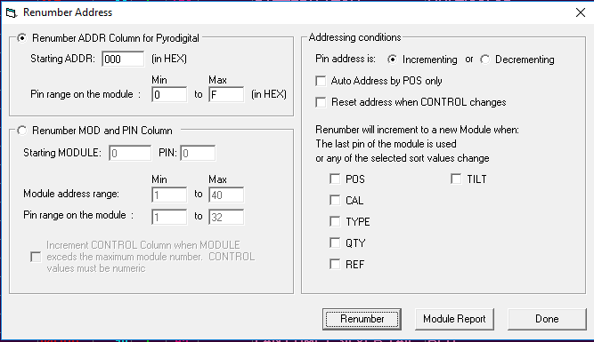

- Pin Range on the module for ADDR (in Hex)
You can set the pin range to fill the modules. If you want to leave some free addresses you can type Min 0 and Max D. In this case the moudule wlil be filed until address C. Any range between 0 and F is possible.
- Module address range and Pin range in the module( for Decimal:)
Select the star module number from 1 to 999 maximum.
Select the Pin range from 1 to 999 , or 1 to 32, or whatever the module can handle.
- Increment CONTROL:
This feature is used to address different Controllers when a limit of modules set in above parameters is exceeded.
Or to address a module that has multiple Slats and Pins per Slat. It will change the Control Module number after 4 Slats and 12 pins per slat have been used.
- Addressing Conditions. Incrementing Decrementing Pin:
You can address in any order starting a module from F to 0 or from 32 to 1, or from 100 to 1, etc.
Reset Address when CONTROL changes will restart the counting from the minimum to the maximum.
- Increment modules when a sort condition changes:
This is one of the most powerful features of this control. You can automatically change to a new module when a positions changes or when a caliber or when multiple conditions are met.

- Autonumber by POS
Tallies up all the POS values and them supplies module and pin addresses by POS. From the existing Renumber dialog (Cues->Renumber Addresses), notice the new checkbox for Auto Address by POS only.
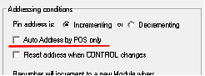

Select this option, which will disable other Addressing Conditions, and renumber.
After you have finish addressing you can see a Module Report.
In the module report you can see what pins in each module are used or not. and a total count of the modules and which modules belong to each Controller.
You can save a .xls or .txt file of this report.
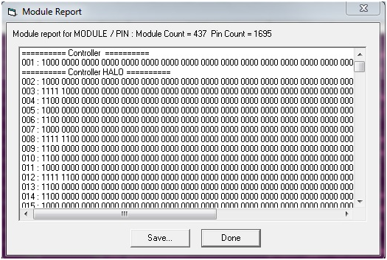

Validate Addresses (F5)
Once the script addressing is done, you can validate your Script checking for repeated addresses.
You can do it now within the application before downloading to the Field Controller.
- Go to Cues Menu
- Select Validate Addresses, or press F5.
A window for Duplicate Address Error will pop up, indicating any duplicate addresses or none (No duplicate addresses).
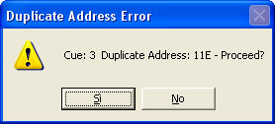 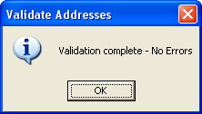
If any Address is duplicated , the message indicates the Cue number and the Address duplicated, and at the same time highlighted on the script window the row with the error.
Click OK. Go to the address cell, change it, and press Enter.
For SAFETY reasons you must validate the Script.
Addresses 000 to 00F, sometimes used for comments, are not excluded on the check.
Show Director does not allow entering any addresses over 7FF.
If you want to keep duplicated addresses:
- Click Skip button, at the error prompt

Reset Addresses (F6)
Reset addresses, changes all the addresses to HEX 000 or DEC Module 0 and Pin 0.
This is useful when importing a script from an old show that has addresses on it and needs to be re-addressed.
Instead of deleting one by one you can do it all at once.

Offset Time (F7)
The Offset feature is necessary when the Time code has changed from your original script or if you want to move a group of cues in the timeline.
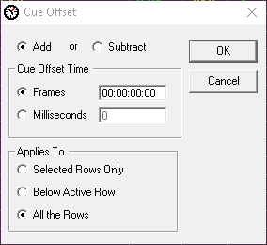

Refresh Grid (F8)
Refresh grid command sorts the script by the current options set in the Sort Menu.
By default the sort is by Time-PFT-Cue.
Refresh also computes and adds new values for the NEXT column, and updates the Price 1-2-3 sum.
It also updates the markers on the wave display, if any.
Refresh is necessary to refresh the Viewer file, when new cues with effects in the Script or Visual files have been updated.

Column Fill Down (F9)
If you want to copy, repeat a value to the following cues, you can use the Fill Down command.:
- Select the cell you want to fill down.

- While pressing the Shift key, select the last row of your fill. The selection is highlighted.
Use Ctrl key to make non contiguous selections. (for more information: Grid Selection strategies)
- Press F9, and the cell will be copied to the cells below the selection
Note: If you skip the point number 2, the cell will be copied until the end of the visible part of the script (sorted and filtered, in other words, it will fill until the end of the grid).

Cues Invert (CTRL+SHIFT+F9)
If you want to invert the values of a column or a whole set of cues, you can use the INVERT CUES command:
To Invert only the content of ONE column:

- Select the first cell you want to invert in the desired column.While pressing the Shift key, select the last row in which you want to invert the content. The selection is highlighted.
- Press CTRL+SHIFT+F9, and the selected columns content, of the selected rows, will be inverted
To Invert a whole set of rows content (all but the time):
- Select the first row you want to invert.While pressing the Shift key, select the last row in which you want to invert the content. The selection is highlighted.
- Press CTRL+SHIFT+F9, and the all the rows, except Time, are inverted.

This function really helps in creating fans and reverse sequences.
See Video Tutorial Here.

Cues Auto Complete (CTRL+F9)
This new function auto-completes sequences of positions, angles and any column you want.
AutoComplete can be used also in the Time columns HH MM SS FF MS and NEXT to create time intervals and sequences.
The logic of the auto-complete function
This function, is based on the user input. It finds the increment gap in your sequence and goes to fill the rest
- if you are using it on the Address field and the first cell is A01 and the second is B01, it will keep addressing with C01, D01 and so on
- if you are using it on the Address field and the first cell is A01 and the second is C02, it will keep addressing with E03, G04 and so on
This function is useful to create angles and addresses sequences. Note: the sequence is calculated on the first two cells of the selection.
To auto Fill a column

- Select the first cell you want to use as the base of the sequence.While pressing the Shift key, select the last row in which you want to auto Fill. The selection is highlighted and the first two cells of the selection are used to create the sequence.

- Press CTRL+F9, and the selected columns content, of the selected rows, will be filled automatically by the auto-complete function
See Video Tutorial Here.

Locate (F10)
Locate helps you to go to a certain Cue, Time or Address of the Script. When you have to make changes in the addresses of the script, you should use this command. You will be able to locate the address and change it to a new one
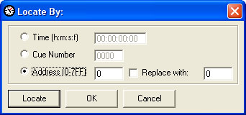
Import / Export Cues

This is one of the most powerful functions of Show Director. You can use it to create macro scripts and design sequences that you can easily add to any new script.

Import and Export cues Show Director feature works together and in conjunction with Script Filter Manager option.
A Filter is a part of the Script.
It could be a large number of cues corresponding to a song, or several cues for a particular sequence.
The filter can be more specific than only cues.
You can filter by any entry in the Script. If you want to use a song without certain positions, calibers or products, you can filter it.
EXPORT FILTERED CUES:
- First create a Filter name in the Script Filter Manager. Make the selection of values for every column.
- Select the Filter in the Drop down menu. The Script will show only the Filtered Cues.
- Select Export Cues in the Cues Menu or click in the Icon
- Follow directions in the Save Menu. A new Script file will be created for the Filtered Cues.
Once you have exported the cues or you have another script you can use and import in different projects.
IMPORT FILTERED CUES:
- Select the Cue or Cue Selection where you want your Script (filtered)
- Select Import Cues in the Cues Menu or click in the Icon
- Choose the File to Import
- The imported Script with cues will be inserted in the Cue or in every Cue of your selection.
Import Beat

Wave
- Multi-Select using Shift-Click on the Wave Plot will Select multiple cues.
  - When the Wave Plot is in Capture mode (i.e. "Green Light"), if you click on the wave plot it selects the next nearest cue. Now if you Shift+Click further along the wave plot, it will multi-select all the cues between the two clicks

- Music Beat Detection and Cue Insertion
  - Often you need to insert a large set of cues that are on the beat of the music. Show Director now includes Beat Detection for doing this. With a wave file loaded and the Capture mode off (i.e. "Red Light") , click where you want the capture to start and Shift+Click where you want the capture to stop. If you don't set a starting and/or ending point it will use the beginning and end of the wave plot. Select from the menus Cues->Import Beat... This will bring up the Beat Detection dialog:
Onset Sensitivity is how sensitive the detection is. If you have more sensitivity you get more cues, possible including false beats or back beats. Less sensitive you might miss a few beats ins quiet sections or if the beat gets too complex. Play with this setting to get the level you want.
NOTE: Some .wav files, like those converted from .mp3, may not be able to be beat detected due to not having the correct PCM internal format. We will work on this for a future update.

Export .Chr (Visual Script File)
.chr file is used by the Viewer graphic engine and it is a copy of the script.
By default it is created and exported every time you refresh the grid by pressing F8.
It is a good strategy to export it manually if you can't see the script changes reflected in the visual components.

The Script Filter File
Filtering will cause the Script file to show&hide certain data. For example, if the Script contains two field controllers FC1 & FC2 the Script can be Filtered for only one of the field controllers, in this case FC1. After being filtered, the script will only display cues to be shot by FC1 and the newly filtered Script can therefore be quickly available to load into the Controller. This way the show can be designed on One single table.
It contains all possible Filter combinations for all columns that you can create.
This file can be opened in multiple Projects, saving your preferred filters for future use. This window or selection panel serves to create the Table files that will be downloaded to the Field Controller. You can assign to every filter a Field Controller ID (serial number, labels..) and a Firing Table ID.
There is a Function to see the Unfiltered Cue, to avoid miss-download of firing data.
Steps in Creating a Filter
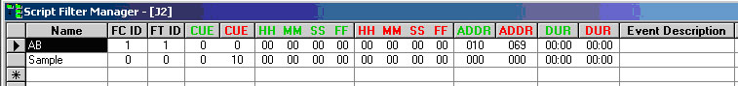

NAME: In this field you enter the name of the Filter. This will become the name of the Firing Table file (.tab), if you assign a value in the FC ID and FT ID columns. The names of the Filter will be displayed in the Drop-Down Toolbar
FC ID: (FIELD CONTROLLER IDENTIFICATION).
In this filed you enter the number of the Field Controller. It can be any number, no letters. You can put the Serial Number to identify the FC if you want. In the Download Manager (see later: Firing Tables Manager) you can select each FC with the display of the Tables assigned to it.
FT ID: (FIRING TABLE IDENTIFICATION).
In this field you put the number of the Firing table assigned to the Field Controller. The values are hexadecimal, as are in the Firing Tables. Therefore, you can enter up to 12 Tables, from 0 to B. The program won’t let you enter a value superior to B.
COLUMN FIELDS:
The Columns in Green or Red are Ranges:
- FIELD in Green corresponds to IN value.
- FIELD in Red corresponds to OUT Value.
If values remain at 0, the range is not taken into consideration.

Sorts and Filters Selection: When you select a name in the Drop-Down menu the Script will change accordingly to the settings of the Filter.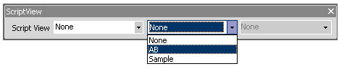
You can select the Sort and Filter directly from the Script or Effects Sort & Filter Managers. Select/highlight the row and press enter will change the view of the Script or Effects Manager, and it will be reflected in the drop down boxes where you previously had to do the selections.

Script Filter Manager AutoCreate
You can now automatically create a set of Effect Filters based on column data from Effect Manager. Select a column in Effect Manager then in Effect Filter Manager double-click the empty FilterName cell. You can also AutoCreate with two neighboring
Columns selected for a compound effect. A dialog will ask if you wish to AutoCreate the filters, select Yes.
A set of Filters will be created based on the column or columns you selected and the column data that matches at least one row in your Effect Manager.

Filter Word based.
You can create a filter based in a single word or description. Name the Filter and Shift Double Click in a cell containing the description. A dialog will ask you if you want to add that description to the filter selected. Once included in the Filter you can delete the part of the Description that you don't need and leave just the word. You can also type the word directly in a Filter column.

Partial Match on Filters
For Script and Effect Sorts, all text fields now will match case-insensitive on a partial sort. If, for example, you have a Sort for Description that is "Yellow" it will find all Descriptions with the word "Crackling" or "crackling" or “CRACKLING".

Easy Add to Script- Effect Filter Manager
When you have a row selected in Script-Effect Filter Manager and you press Shift-Double Click in a cell in the Script- Effect Manager, you will be asked if you wish to add that cell data to the selected filter. Yes will add the data into the correct cell, No will go into normal Edit for the cell.
For the Columns VISUALREFERENCE, VIDEOLINK and PICTURELINK that have links to the Test Viewer, Video Player or Website, to view the linked effects, just double click to view. Other Show Director Changes

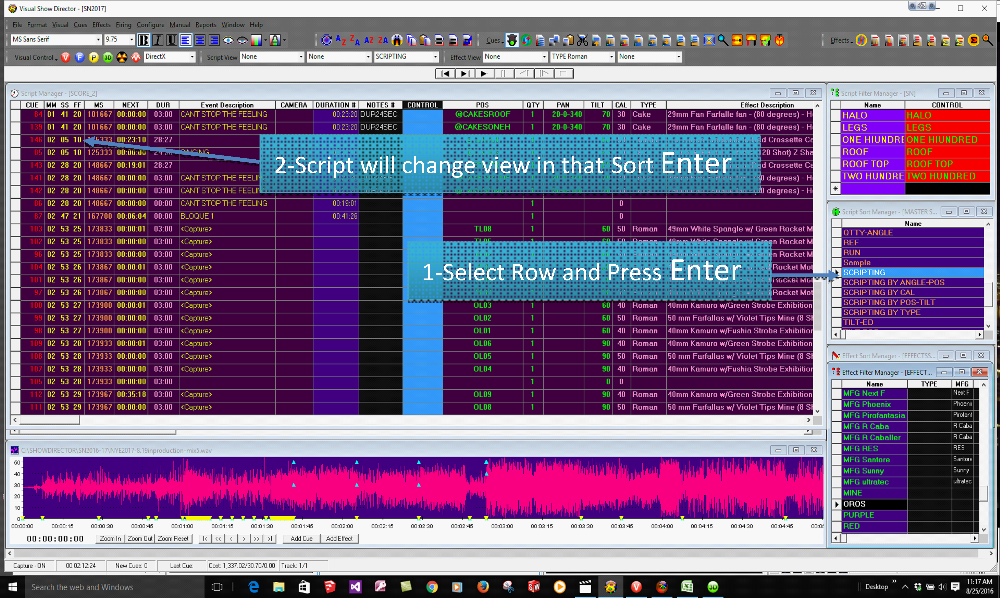

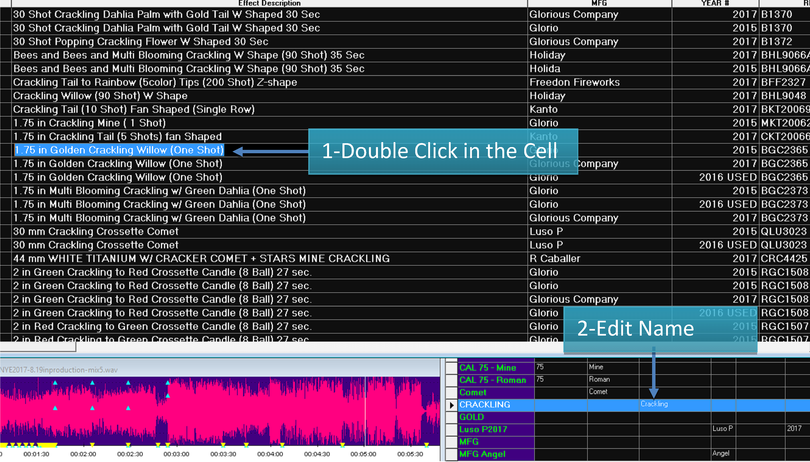

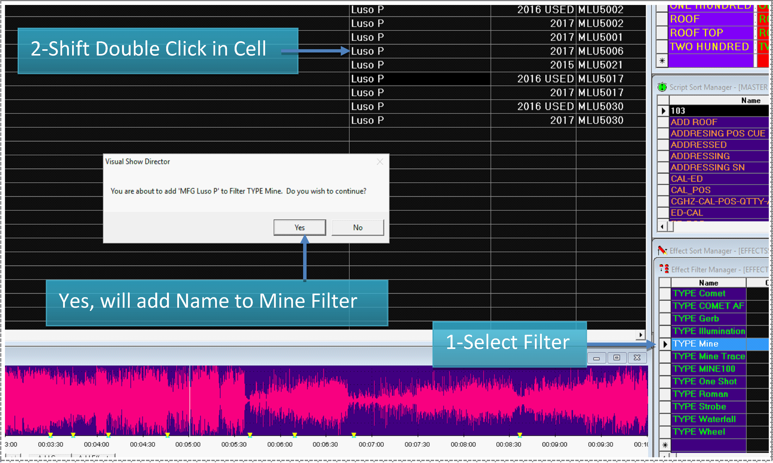

Script filter File Operations
From the File Menu, the following functions are accessible for the Script Filter File

- NEW
Creates a new file (it prompts for overwriting if the selected file exists)
- OPEN
Opens an existing file
- SAVE AS...
Saves a copy of the open File. It is useful to frequently save backups of your file.
- CLOSE
Closes the opened file

The Script Sort File
This is very important for organizing the firing Table. Normally the Script is chronological, a Sort File will help to arrange the Script based on other parameters. For example, The Script can be arranged in order of Position, Caliber, Quantity, Tilt, Reference. This allows the Script to be sorted such that Addressing of shots can be done automatically!!!
This contains all possible Sort combinations for all columns that you wan to create. This file can be opened in multiple Projects, saving once your preferred sorts for future use. All columns of the Script Manager are present in the Script Filter Manager.

You need to give a name to the Sort and then proceed to insert the values of your Sort Order.
Value 1, will be the first column sorted, and so on. Positive values sort Ascending. Negative values sort Descending.
The display order of the columns in the Script Sort Manager, will change accordingly to the sort order, to help you visualize the Sort.
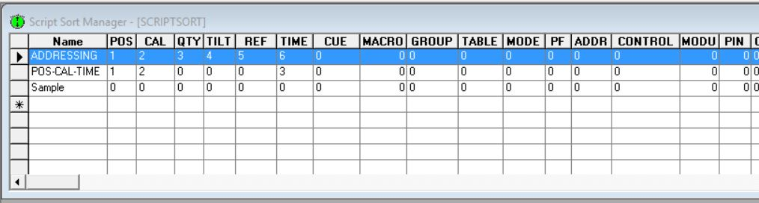
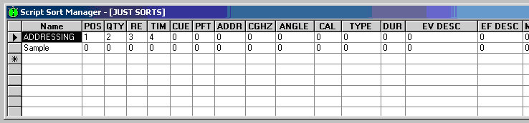
The Sort names will be displayed in the Script View Tool-bar:
When you select a name in the Drop-Down menu the Script will change accordingly to the settings of the Sort.

Sorts and Filters Selection
You can select the Sort and Filter directly from the Script or Effects Sort & Filter Managers. Select the row and press enter will change the view of the Script or Effects Manager, and it will be reflected in the drop down boxes where you previously had to do the selections.

Quick and Additive Sort

- Quick Sort by using the three new tool-bar buttons, Sort Ascending, Sort Descending and Clear Sort. Select a column that you want to be your primary sort. Press either the Sort Ascending or the Sort Descending button
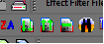
- If you select additional columns and presses either the Sort Ascending or Sort Descending buttons it will add additional levels of sorting. To clear the quick sort, press the Clear Quick Sort button.
- Apply multiple Script or Effects Filters
  - Selecting one or more Script Filters or Effects Filters and Right Clicking will apply all filters selected.

Script Sort File Operations
From the File Menu, the following functions are accessible for the Script sort File
- NEW
Creates a new file (it prompts for overwriting if the selected file exists)
- OPEN
Opens an existing file
- SAVE AS...
Saves a copy of the open File. It is useful to frequently save backups of your file.
- CLOSE
Closes the opened file

Quick Sort by using the three new Tool bar buttons, Sort Ascending, Sort Descending and Clear Sort. Select a column that you want to be your primary sort. Press either the Sort Ascending or the Sort Descending button

If you select additional columns and presses either the Sort Ascending or Sort Descending buttons it will add additional levels of sorting. To clear the quick sort, press the Clear Quick Sort button.

Apply multiple Script or Effects Filters

Selecting one or more Script Filters or Effects Filters and Right Clicking will apply all filters selected.
Script Views
A Script View is a combination of a Sort and a Filter.
You can name the View for quick access with the Drop-Down Menu in the Toolbar.
This is useful to view parts of the Script (Filters) sorted in a particular Order.
You will find many useful applications for this feature.
There is a limit of 32 names for Views in a Project.
The Effects Manager

The Effect Manager File
Effect Manager (Effect Filename.efx) is the Show Director products database.
Show Director can open simultaneously only one Effect Manager and one Script at a time.
You will be able to create as many Effect Manager databases as you want, for different products and show types, and bring them up as you need, but only one at a time.
Each Effect Manager has unlimited Filters available. (See Effect Filter later). You can have a complete database that is filtered by any category of the column Fields.
You can create an Effect Manager File, from scratch, from another Effect Manager File via Filtering and Export, or import from a .csv file created with Excel, Access or any database/spreadsheet application.
EXCEL
You will also be able to export a Show Director Effect file (. efx) to a same (.efx) file (see Effect Filter later- Export Effects) or a (.csv)(.xls) formats to be opened with your spreadsheet application for more complex editing or presentation.
To see what is the format of a .csv or .xls, Open a new Effects Manager and then save it as .csv or .xls.
Open it in Excel and use the same format of columns.
Add your data an reopen the file with Show Director
EFFECTS MANAGER FROM A SCRIPT
It is possible to create an Effects Manager from the products used in a show.
Open the Script, and Save As .efx.
An Effects Manager with the single individual effects used will be created.
Version 8
The Columns CUSTOM 1-2-3-4-5 Can be renamed with your own names. Right Click in the Header of the column and do it the Form to Change name.
Different names templates can be saved and applied to new projects.

The Effects File
Data Field Formats

* When importing from .xls or .csv the number of characters will be trimmed to match Show Director maximums.
The Script window has the following columns and characteristics:

Column | Column Name | Column Data Type | Comment
1 | CAL | Number(3) | Integer value for the calibar of these effects
2 | TYPE | Text(36) | Text description of the kind or family of effect being fired
3 | PFT | Number(5) | Pre-fire time in miliseconds
4 | Effect Description | Text(128) | Description of the effect
5 | DUR | Number(4) | Integer effect duration in frames and seconds (100 = 1 sec)
6 | REF | Text(50) | Reference number for the effect
7 | MFG | Text(64) | Manufacturer of the effect
8 | MAGAZINE | Number(6) | Inventory Quantities.
9 | PRICE1 | Number(8) | Price of this effect
10 | PRICE2 | Number(8) | Price of this effect
11 | PRICE3 | Number(8) | Price of this effect
12 | CUSTOM1 | Text(128) | Open text field for effects data
13 | CUSTOM2 | Text(128) | Open text field for effects data
14 | CUSTOM3 | Text(128) | Open text field for effects data
15 | CUSTOM4 | Text(128) | Open text field for effects data
16 | CUSTOM5 | Text(128) | Open text field for effects data
17 | VISUALREFERENCE | Text(255) | Text field to describe the name of the particle effect
18 | BEAM | Text(255) | Text field description of lights and lasers
19 | PICTURELINK | Text(255) | Text link to a web or disk based picture
20 | VIDEOLINK | Text(255) | Text link to a web or disk based video

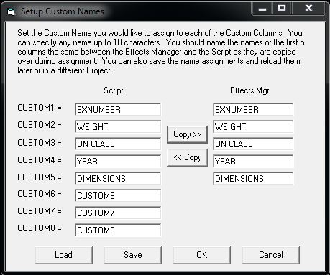

- AUTO-RESTORE (UNDO)
- New Auto Restore for Scripts and Effects Managers. This new function will keep a back up of your most recent Scripts or Effects Managers making a copy of the files every 5 minutes within 1 hour. There will be 12 copies that you can restore at any point on time. The feature is only active with a project open. The backup files are stored in a folder inside the directory where the project is saved.The function can be manually deactivated by changing On to Off in the file sd.ini in C:/Users/username/Appdata/Roaming/ShowDirector. You will never loose more than 5 minutes of work.

Create a New Effects File

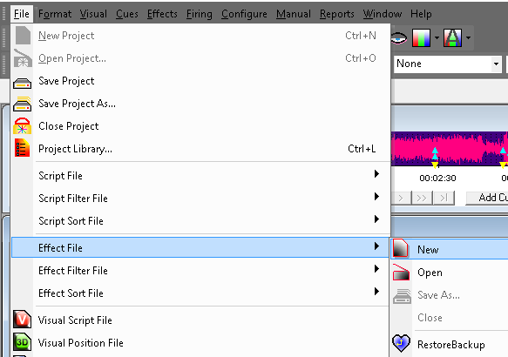
Creates a new Effects Manager File.
The user is prompted for a valid filename and, if the selected filename corresponds to an existing file, the software warns the user and prompts for overwrite.
It is safe to press [NO] if the user doesn't want to overwrite the existing file.

Create a new Effects Manager File from the Script

With a Script open you can create an Effects Manager file of all the individual effects present in the Script.
Go to Script Save As and choose .efx

Open an existing Effects File
Open an Effects Manager File
Opens an existing Effects Manager File.
If the file that is being opened is from a previous version of Show Director, the software will warn the user and will prompt for a filename for the imported version.
It auto-updates the file format.

Open and eff

Open and Save Effects Managers in .csv .xls .efx

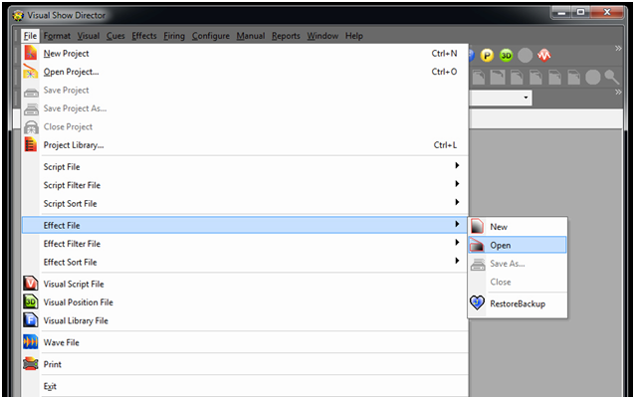
The importing of an Effects manager in .csv or .xls format is done from the File Menu / Effect File / Open Menu.
Imports a .csv or .xls file from Excel or any application supporting the file format.
The column formats must be the same as in Show Director Effects Manager. The order of the column does not matter.
The column names must be the same as in Show Director but not in the same order.
See the format of the Columns in The Effects Manager

Working with Effects
Show Director offers a wide number of functions, options and choices that work with the Effects Manager.
From the [EFFECTS] menu the following functions are available:

- 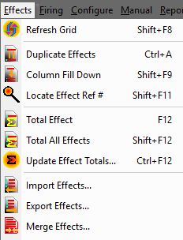

- Refresh Grid
- Duplicate Effects
- Column Fill Down
- Locate Effect Ref #
- Total Effect
- Total All Effects
- Update Effect Totals...
- Import Effects
- Export Effects
- Merge Effects

Refresh Grid (Shift+F8)
Refresh grid command updates the Effects Manager Grid.
Please refer to the analogue function of the Script Manager for more information.

Duplicate Effects

First: make a Selection.
If you don't know how to select multiple rows, please refer to Selection Strategies
Press Ctrl+A, select command from Effects Menu or click the related Icon in the tool-bar.
You can now also Copy, Cut and Paste text within cells or from other application. Highlight the text string and, clicking on it with the right button of the mouse, opens the edit Menu.

Column Fill Down
If you want to copy, repeat a value to following effects, you can use the Fill Down command.:
- Select the cell you want to fill down.
- While pressing the Shift key, select the last row of your fill. The selection is highlighted.
- Press Shift+F9, and the cell will be copied to the cells below the selection
Note: If you skip the point number 2, the cell will be copied until the end of the visible part of the effects file (sorted and filtered, in other words, it will fill until the end of the grid).

Locate Effect Ref#
Locate helps you to go to a certain effect based on reference #
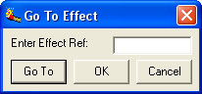
Total Effect (F12)
This is an inventory-tracking feature.
In order to operate properly you need to assign the Columns MAGAZINE in the Script Manager and Effects Manager to display the total quantities on hand or inventory for each product.
To know at any given moment of scripting the quantities of a particular product in the script :
- Select the product in the Script
- Select the command in the Effects Menu, Press F 12 or click the Icon.
If you have used more quantities than available in inventory the display in MAGAZINE /Script Manger will show negative numbers.

Total All Effects (F12)
This command extends the inventory account to all the products in the Script Manager.
Please refer to Total Effect function for more information.

Update Effect Total (CTRL+F12)
The Effect Manager can be updated by Subtracting all the product from the selected Script, which causes a NEW Effect File to be created.
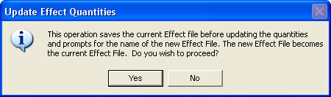

Import / Export Effects
Import and Export effects Show Director feature works together and in conjunction with the Effect Filter Manager option.
A Filter is a part of the Effects File.
It could be a large number of effects corresponding to a macro area such as outdoor or indoor, or several effects from a specific manufacturer.
You can filter by any entry in the Effects File.
EXPORT FILTERED EFFECTS:
- First create a Filter name in the Effects Filter Manager. Make the selection of values for every column.
- Select the Filter in the Drop down menu. The Effects Manager will show only the Filtered Effects.
- Select Export Effects in the Effects Menu or click in the Icon
- Follow direction in the Save Menu. A new Effects file will be created for the filtered effects.
Once you have exported the effects you have another effects file you can use and import in different projects.
IMPORT FILTERED EFFECTS:
- Select Import Effects in the Effects Menu or click in the Icon
- Choose the File to Import
Effects Merge

Merge an existing Effects Manager into the currently loaded one by selecting Effects->Merge Effects.

It will update the Effects Manger with the new information in the merging Effects Manager.

The Effects Filter File
This File contains all possible Filter combinations for all columns that you create.
This file can be opened in multiple Projects, saving your preferred filters once for future use.
This window or selection panel creates the new or partial Effect Files to be exported by selecting them in the Effect Filter view and Selecting Export. You can assign to every filter a new Effect Manager.
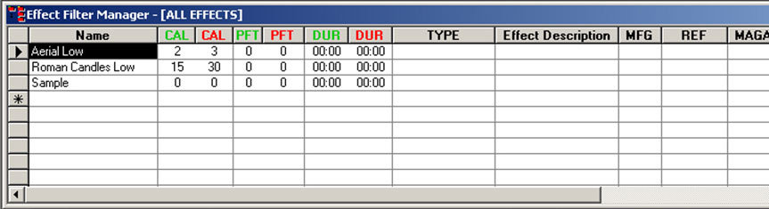
NAME: In this field you enter the name of the Filter. The names of the Filter will be displayed in the Drop-Down Tool-bar
When you select a name in the Drop-Down menu the Effect Manager will change accordingly to the settings of the Filter.
COLUMN FIELDS:
The Columns in Green or Red are Ranges:
- FIELD in Green corresponds to IN value.
- FIELD in Red corresponds to OUT Value.
If values remain at 0, the range is not taken into consideration.

Sorts and Filters Selection
You can select the Sort and Filter directly from the Script or Effects Sort & Filter Managers. Select the row and press enter will change the view of the Script or Effects Manager, and it will be reflected in the drop down boxes where you previously had to do the selections.

Script Effects Filter from Effects Manager
By selecting a row or rows in the Effects Manager it will filter all the same effects present in the Script. Do this by pressing ENTER on a row in the Effects Manager.
That will apply a filter on that Effects REF in the Script. The Filter is additive so more or multi-select of Effects rows will create more and more filtered Scripts.
Use the existing Reset Filter to clear this filter.

Effect Filter Manager AutoCreate

You can now automatically create a set of Effect Filters based on column data from Effect Manager. Select a column in Effect Manager then in Effect Filter Manager double-click the empty FilterName cell. You can also AutoCreate with two neighboring
Columns selected for a compound effect. A dialog will ask if you wish to AutoCreate the filters, select Yes.
A set of Filters will be created names based on the column or columns you selected and the column data that matches at least one row in your Effect Manager.

Filter Word based.
You can create a filter based in a single word or description. Name the Filter and Shift Double Click in a cell containing the description. A dialog will ask you if you want to add that description to the filter selected. Once included in the Filter you can delete the part of the Description that you don't need and leave just the word. You can also type the word directly in a Filter column.

Partial Match on Filters
For Script and Effect Sorts, all text fields now will match case-insensitive on a partial sort. If, for example, you have a Sort for Description that is "Yellow" it will find all Descriptions with the word "Crackling" or "crackling" or “CRACKLING".

Easy Add to Script- Effect Filter Manager
When you have a row selected in Script-Effect Filter Manager and you press Shift-Double Click in a cell in the Script- Effect Manager, you will be asked if you wish to add that cell data to the selected filter. Yes will add the data into the correct cell, No will go into normal Edit for the cell.
For the Columns VISUALREFERENCE, VIDEOLINK and PICTURELINK that have links to the Test Viewer, Video Player or Website, to view the linked effects, just double click to view. Other Show Director Changes

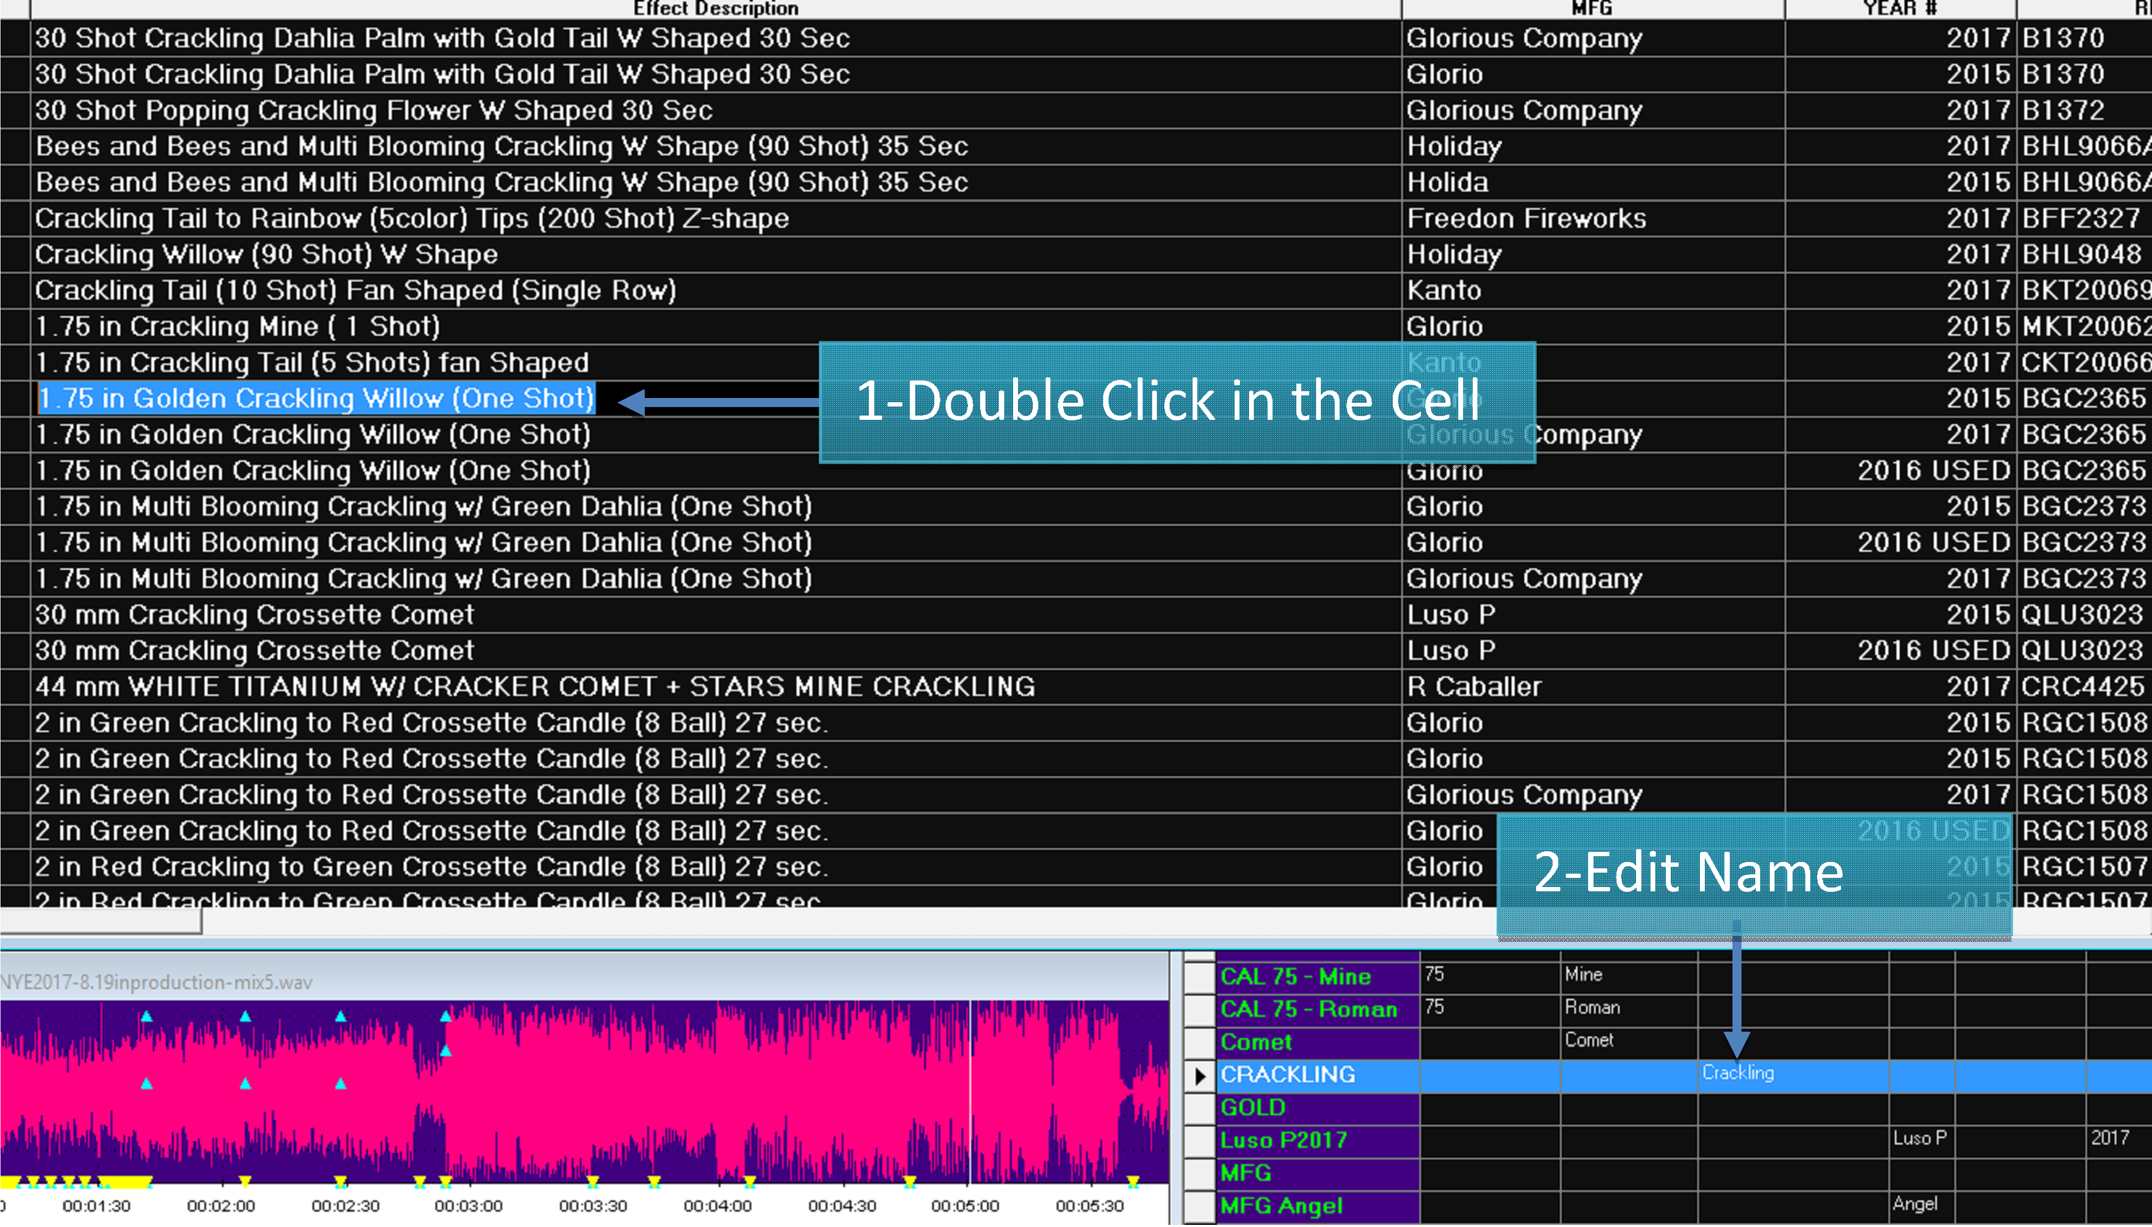

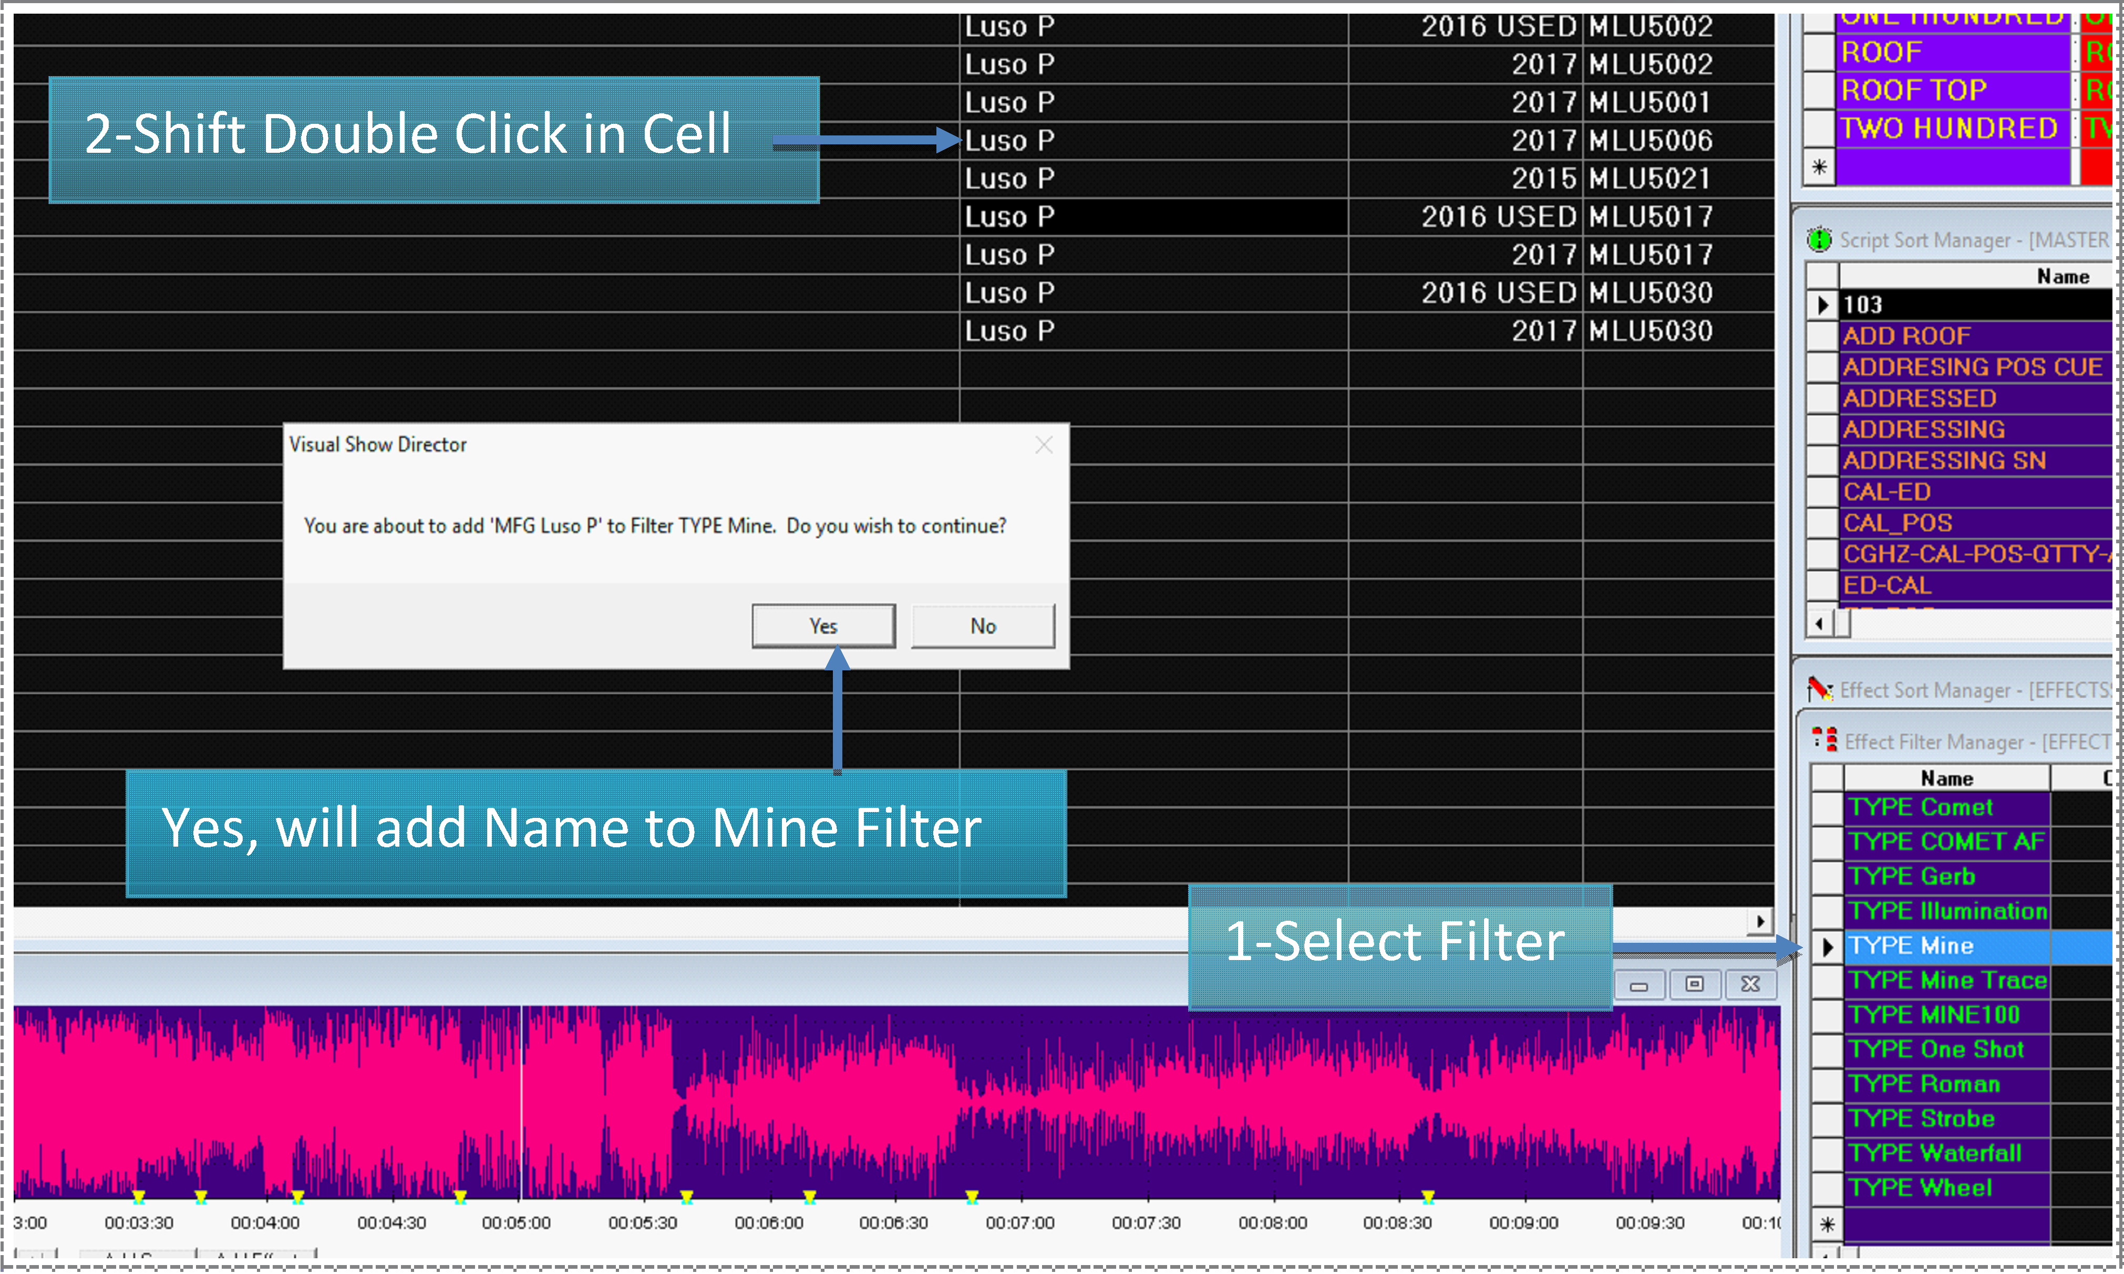

Effects Filter File Operations
From the File Menu, the following functions are accessible for the Effects Filter File
- NEW
Creates a new file (it prompts for overwriting if the selected file exists)
- OPEN
Opens an existing file
- SAVE AS...
Saves a copy of the open File. It is useful to frequently save backups of your file.
- CLOSE
Closes the opened file

The Effects Sort File
This file window contains all possible Sort combinations for all columns that you create.
This file can be opened in multiple Projects, saving your preferred sorts for future use.
All columns of the Script Manager are present in the Script Filter Manager.
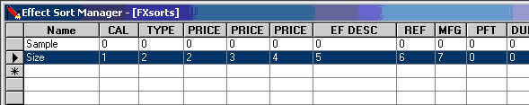
You need to give a name to the Sort and then proceed to insert the values of your Sort Order.
Value 1, will be the first column sorted, and so on. Positive values are sorting Ascending. Negative values are sorting Descending.
The display order of the columns in the Effect Sort Manager will change accordingly to the sort order, to help you visualize the Sort.
The Sort names will be displayed in the Script View tool bar:

Effects Sort File Operations
From the File Menu, the following functions are accessible for the Effects Sort File
- NEW
Creates a new file (it prompts for overwriting if the selected file exists)
- OPEN
Opens an existing file
- SAVE AS...
Saves a copy of the open File. It is useful to frequently save backups of your file.
- CLOSE
Closes the opened file
Quick and Additive Sort

- Quick Sort by using the three new tool-bar buttons, Sort Ascending, Sort Descending and Clear Sort. Select a column that you want to be your primary sort. Press either the Sort Ascending or the Sort Descending button
- If you select additional columns and presses either the Sort Ascending or Sort Descending buttons it will add additional levels of sorting. To clear the quick sort, press the Clear Quick Sort button.
- Apply multiple Script or Effects Filters
  - Selecting one or more Script Filters or Effects Filters and Right Clicking will apply all filters selected.

Effects Views
An Effect View is a combination of a Sort and a Filter.
You can name the View for quick access with the Drop-Down Menu in the Toolbar.
This is useful to view parts of the Script (Filters) sorted in a particular Order.
You will find many useful applications for this feature.
There is a limit of 32 names for Views in a Project.

Grid Printing and Formatting
In this section we are going to explore the printing and formatting features of the new Show Director grid.
Please take your time to explore this section because a well organized workspace really can speed up the creation process.
See also Custom Reports

Direct Print
Show Director prints all grids in WYSIWYG (What you see is what you get) format, as displayed on screen.

You can also use LAYOUTS to create a view of the Script to print.
The printout may be different depending on the screen resolution used and type of printer.
You should create Print Templates in different Projects with the particular settings for each printout. The settings will be saved in the Project and every time you open the project with the Script you want to print, it will appear showing the Columns and in the sort order you want them to appear.
In the creation of Print Project template you will use the following functions:

- Column order
- Hide
- Sort
- Font format
- Background Color
The Print Menu will allow you to adjust, margins, size and orientation of paper.
Each Print menu can be different depending on the type of printer used.

Reports
In this menu are the commands to create simple reports from Script File and Effects File.
Show Director includes a set of predefined reports. Those reports have been enhanced since version 5.1.
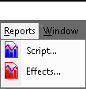
From the [REPORT] menu the following functions are available:
- Script...
- Effects...
Reports: Overview
Show Director creates various simple pre-defined Reports and Summaries.
Reports are Lists of all the data contained in the Script and Effects Manager, with the applied Filter, and with predetermined sorts, following the order of the columns from left to right.
Summaries are tables with computed information about Caliber use, by subtotals or for each individual item. In the lower tool bar there is a summary of Cost for each Price category, that you can update by pressing F8.
The Reports and Summaries open in a separate control window that you can leave open to check as you script the show, or send it to Windows toolbar. The window has navigational controls, page by page, zoom in and zoom out.
You may also save the report in a large variety of file formats, if you want to open it in another application like Excel, Word, etc., to edit the format, alter the order of the columns, sort it in a different way, apply other calculations or perform an enhanced printing.
If you require a more complete reporting, you can:
- Import the .scx or .efx files (a mdb format) into Microsoft's ACCESS database program.
- Export the whole Script or Effects Manager as a .csv file, open it with Microsot's EXCEL or other spreadsheet/database application.
Show Director exports to a variety of formats that can be treated in other third party applications.

For Custom Reports with the SD Tools Plugin go here
WATCH VIDEO CUSTOM REPORTS

Reports: Export and send by email
Event or Script Reports and Effects reports can be delivered via email service or exported to a variety of file formats for a more sophisticated printing layout.
To export a report:
Click on the export button (envelope icon) in the report window as shown in the next illustration
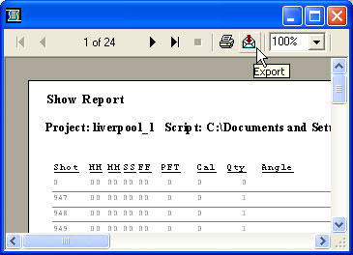
the following dialog appears with the all the available options.
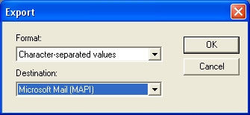

Custom Reports (SD Tools Plug in)
Custom Reports and Views with Show Director Tools: Overview

We have added the ability to save a named Custom View that includes the Visible Script Columns and their order plus whatever filters or sorts you may have in place. These Custom Views can be used in any project without having to load the original Script Filter or Sort files.
In addition to loading a Custom View, you have the ability to Print or Save the Script using that View.
Saving uses the Microsoft Excel format (.xls) and only saves the visible columns in order with the filter and sort.
This differs from normal Script Save as Excel which saves ALL columns and data.
Use this feature to create Custom Reports that can be applied to any Project.
A few commonly requested Custom Report Views have been included to get you started.

Reports: Direct Printing
Show Director reports support direct printing.
To print a report:
Click on the Print button (Printer icon) in the report window as shown
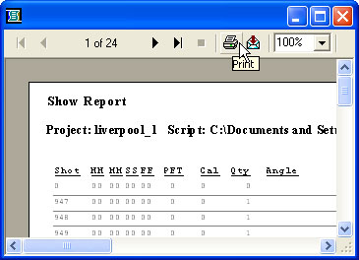

Script Reports
A set of predefined reports is available in the Script reports function.
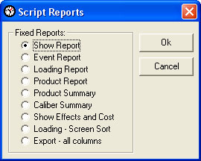
Show Report:
This contains Shot, HHMMSSFF, Caliber, quantity, Type, Effect Description, Position, Address, Caliber Group Hazard
Event Report:
This contains Shot, HHMMSSFF, next, Event description, Caliber, Quantity, Position, Angle, Custom 1, Custom 2
Loading Report:
This contains Cue, Position, Address, Caliber, Quantity, Type, Effect Description, Reference, Angle
Product Report:
This contains Reference, Caliber, Type, Effect Description, Magazine, Position, Quantity Total, Address
Loading -Screen Sort Report:
This contains Cue, Position, Address, Caliber, Quantity, Type, Effect Description, Reference, Angle
Set the sort order that you want in the Script with Cues Menu/Sort.
Select Loading-Screen Sort Report in the Reports Menu.
Product Summary:
his contains Reference, Caliber, Type, Effect Description, Magazine, Custom 1, Totals
Caliber Summary:
This contains Caliber and Quantities
Show Effects and Costs:
This contains Reference, Caliber, type, Effect Description, Quantity, Price 1,2 3 with Totals.

Effects Reports
A set of predefined reports is available in the Effects reports function.
Please remember that the reports are sensitive to the filters and sorts applied 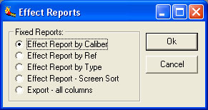
Effect Report by Caliber :
This contains Caliber, Type, PFT, Duration, Effect description, Reference, Manufacturer, Magazine, Price 1
Effect Report by Ref :
This contains Reference, Caliber, Type, PFT, Duration, Effect description, Manufacturer, Magazine, Price 1
Effect Report by Type :
This contains Type,Caliber, PFT, Duration, Effect description, Reference, Manufacturer, Magazine, Price 1
Effect Report Screen Sort :
his contains Caliber, Type, PFT, Duration, Effect description, Reference, Manufacturer, Magazine, Price 1
Export all Columns :
This Contains all the Columns of the Effect Manager

Configuration
In this menu we have the commands to customize and configure the Timecode and the Wave Display.

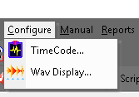
From the [CONFIGURE] menu the following functions are available:

- Time Code
- Wav Display...

Configure TimeCode

- External Pyrodigital modem (Pyrodigital Time Code)
You will select this option if you are using the Pyrodigital modem connected to the com port of your computer with an audio input from a tape with music and Time Code, or a wave file with music and Time Code playing from your computer.
You can play from the computer while Show Director is running. You will need to take a feed from the computer external audio L&R channels to one speaker and to the PD modem.
A two-channel (stereo) tape with a Soundtrack and Pyrodigital Time Code recorded.
Use this function if you are using a Tape Player, CD Audio with Music in the Left channel and Pyrodigital Time Code recorded in the Right Channel. You can play the CD from your computer CD ROM player. Connect the external audio stereo feed to the speaker and to the Pyrodigital Modem, respectively. To control the CD use the Microsoft CD player controls. Those include forward, rewind and a clock that matches the Time Code clock. This is the most reliable way to script the show as you have complete guarantee that there are no gaps due to the possible interference of other computer internal operations.
Internal CD ROM
If you have a CD player attached to the computer you can play CDs and capture cues directly from them. You will save these song scripts with different names. After, when you edit the music soundtrack from the same CDs, you will have to cue first the starting cues of each song, and with the command Import Cues insert the song files already cued to the starting cue of each song. We will demonstrate this later, in the Import Cues menu.
If you have your soundtrack burned into a CD-ROM or just scripting songs to a CD-Audio, you can also use the CD to capture cues. If you are preparing a show you can capture cues from songs on various CDs, and when your final soundtrack is edited import the scripts at the offset times.
IMPORTANT:
If you are using a CD ROM, with your soundtrack you have to be aware that some CD recording software requires a minimum of 2 seconds pause in the first track. When you play the CD you may observe that the music cues are offset by 2 seconds. To correct this you will need to offset all your cues in the Script by 2 seconds.
To do so:
- Select the first row and while pressing the Shift cue, select the last row.Go to Cues menu and select Export Cues. The save Export cues window will appear. Give a name to the Exported cues, ex: 'Script2sec'.Go back to the Script and select all the Rows, by selecting the first row, pressing Shift and selecting the last row, then press delete.Your Script is empty.Go to the Cues menu and select Import Cues. The Import cues window will appear.Select Insert Cue at time, and enter the offset, 2 sec= 00:00:02:00Click OK.
- The new cues will fill the Script with the 2 second offset.
You will observe that the music cues and Script cues now match while playing back.
If you are firing the show with a CD, with Music in the Left and Pyrodigital time code in the right channel, the CD recording software pause does not affect the synchronization, as both channels are playing simultaneously.
A Wave file (.wav):
Wave file configuration is automatically selected when you open a Wave File from the File Menu. (See Configuring Wave Display)
- SMPTE Time Code
Show Director supports Scripting directly with SMPTE Time Code. SMPTE Time Code is input through a new, optional external SMPTE Time Code Reader, in a manner similar to the Pyrodigital Time Code Modem.
This new SMPTE Modem is available from Pyrodigital Consultants or Infinity Visions.
Show Director and the new SMPTE Modem support 30fps, 29.97fps-Drop Frame, 25fps, and 24fps.
For more information about the use of SMPTE and the Modem, click here

- SMPTE Time Code
Enable Beep during cue capture.
If you want to hear a beep during cues playback you have to enable this function.
The beep is actually a. wave file, and you can make any beeps, sounds or words like Fire! sound at every cue.
If you want to change beeps go to Windows Settings-Control Panel-Sounds, Select Default Sound, Browse to Sound Director Folder, we have provided you with a collection. If you want you can create your own with Microsoft Sound Recorder.
If you can not hear any beeps, check that your multimedia controller for sound has the .wave listening enabled.
Depending on the Time Code option that you choose, you will have to change the Time Code Configuration. The default configuration is Pyrodigital Time Code /SMPTE 30fps, and Port1.
The TimeCode dialog has had additional ComPorts added, upping it from 4 to 16

- With Show Director Tools Plug-in it is possible to generate SMPTE timecode.
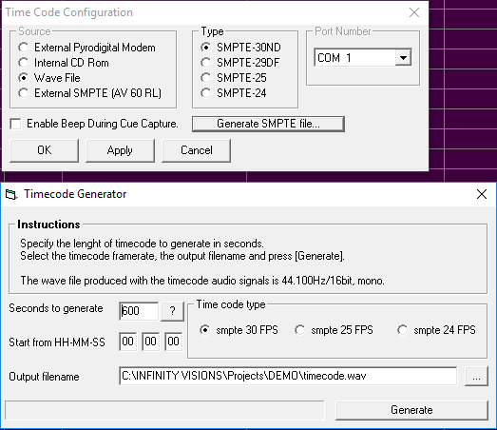

Configure Wave Display

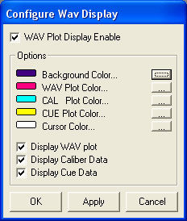

If you want to change the colors of
- the Wave Background
- the Wave foreground
- the Caliber plot color
- the Cue plot color
- the Cursor Color
or you want to display or not cues or caliber, you can open the Wave Configuration Display under the Configuration Menu, and make your selection.

Firing Tables Manager
FIRING TABLES MANAGER
Firing Table selection and Download
- All the Download operation is conducted with one single Control Panel in the Manager Window
- The Firing Table selection is done with the Script Filter Manager, as explained in the Script File Section.
- If no Filter is used, all cues are taken to make a unique Firing Table for Download.
- The number of selectable ports is 16. The port with the Field Controller connected, will show the mark <<

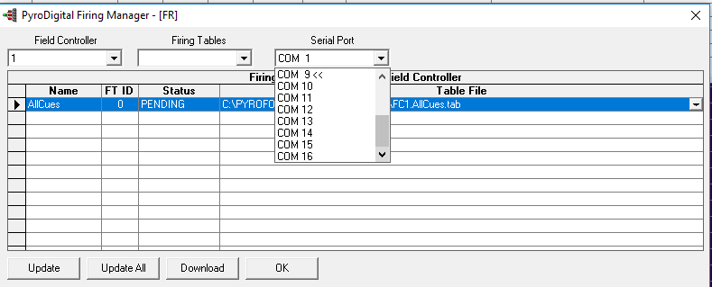
If you have used Filters to separate and specify each Firing Table, the Script Filter Manger will look like this:
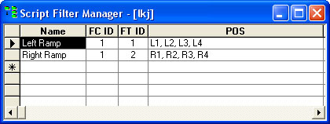
And the Firing Table Manager, like this:
Field Controller: Selects the Field Controller Number. Firing Tables: Selects the number of Tables in conjunction with The Field Controller Memory settings.
Serial Port: Chooses the serial port to send the data to the Field Controller.
Status: Shows the status of the Firing Table: Pending, Downloaded or Failed
If you make a change in the Script, make sure to click UPDATE or UPDATE ALL, to reflect the changes in the file downloaded to the Field Controller (.tab)
Click DOWNLOAD and follow the messages to download to the Field Controller.
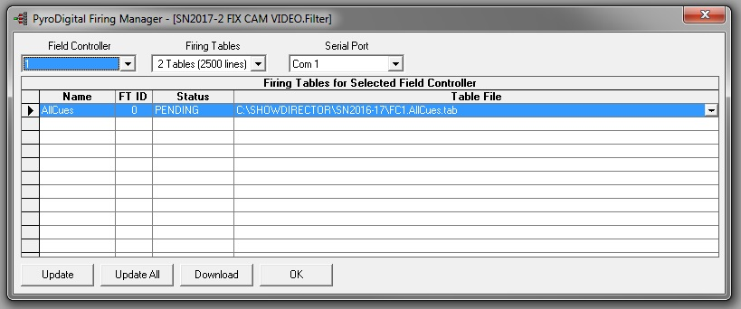

OK. Saves the settings and exits the Firing Table Manager.

PYROINFINITY FIRING MANAGER

This new firing table manager is used to create firing files for FireDirector control software and to program Monetti SQ3 sequencers.
You can download each SQ3 individually. Tables for each module are created automatically by Show Director.
For operation of the Monetti SQ3 refer to its user's guide.

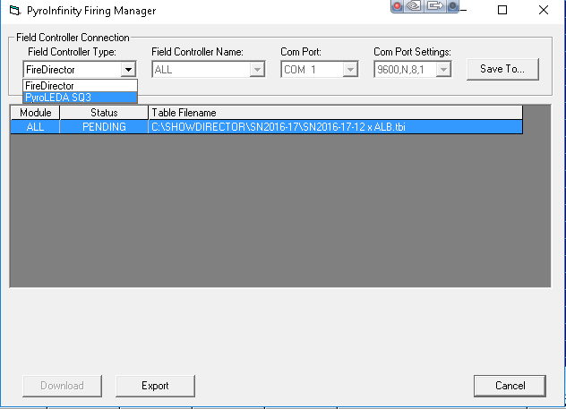

Visual Show Director Manual Mode
A new Manual Mode has been integrated in the program to allow the choreography of manually fired shows with electric panels.
Description of Manual Mode, when manual mode is entered:
- If the script window is on the screen, the PFT (PreFire Time/Delay) column is locked (i.e. edits not allowed) and the time (HMSF) is adjusted by the PFT. The time displayed is the Fire Time. The PFT column is locked, so that when manual mode is terminated, time is converted back to the original event time (Firing Time + PFT).
- If the script window in not on the screen, when the script is opened the script will be converted to the manual mode (i.e., the time will be adjusted to Fire Time).
When manual mode is active, the Manual Pull Down Menu is enabled. This Menu has the following functions:
- CountDown Display  - Configuration  - Renumber Cues  - Validate with Tolerance  - Add PFT  - Subtract PFT | 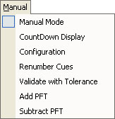
Configuration...
This screen contains all the Manual Mode parameters: The current set includes:
- Cue tolerance
Specifies how near cues can be to each other. The validate function will use this number to compare cue times (if cues are too close together, they are difficult to Fire on a manual panel, consolidate or adjust the script as required).
- Response Time
Sets the number of tenths of a second at which the "FIRE" wave file is to be played, to compensate for the Firing Operator's Delay in physically initiating the Firing button/probe on a manual Firing board.
- Cue Preview Time
Set the delay that you want the cue to be announced before it turns red in the display.
- Max Cue Number
Set the maximum number of cues of your firing panel per rail/slat before it restarts the cue count. If you have 25 cues per slat set it to 25.
CountDown Display
This window has a countdown HMSF/ Next Cue number /and Fire indicator. Everything is in big fonts for easy visibility.
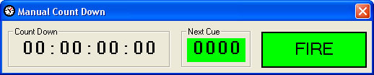
Renumber Cues
This function allows a quick and semi-automatic addressing of the number of Firing Positions per rail/slat on the manual firing system. It is possible to set the number of cues per rail/slat and automatically renumber all the script
Validate with Tolerance
This function flags occurrences of inter-cue times that do not meet the specified tolerance. The user specifies a tolerance and is able to select all, or selected cues for validation. It operates similar to the address validation in that the user is able to ignore/proceed past conditions that fail the check. This function insures that user has not specified cues too close together for actual operation of the manual firing system.
Add / Subtract PFT
This function gives the option to add or subtract the PFT.
USE OF THE WAVE DISPLAY WITH MANUAL MODE
With the new wave display it is possible to combine the Graphic display of the cues on the wave graphic with the Manual Countdown Panel. You will need to deselect wave display and caliber display in the Configure Wave-Options.
This way you will have a graphic plot of the cues only. While you play the music you will be able to see the cues coming while the cursor advances and looking at the Count Down announce the cue number.

