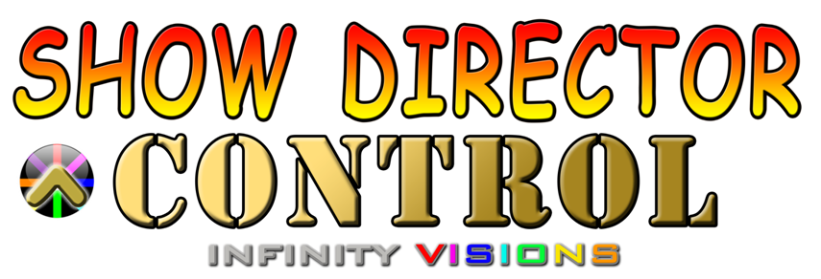

Table of contents
Introduction 3
ShowDirector Control User Interface 7
Connecting Show Director Control to Show Director 10
Loading a Show Director Script 14
Connecting a Midi keyboard device 17
Connection Show Director Control to a Field Controller 20
Arming the System 24
Show Control Buttons 28
The Show 32
Executing Script Macros 36
Safety Lock Outs 40
Scripting with Visual Show Director 8 46
How to program different DMX devices from Show Director 49
SimpleDMX 53
Galaxis G-Flame Flame Box 57
Le Maitre Salamander Flame Box 61
Explo X2 Wave Flame Box 65
SafeX Flame Jet Flame Box 69
CRGBLight 73
PanTiltWRGBCYMLight 77
Creating a Custom DMX Device 80

Introduction

- ShowDirectorControl is a PC application that can run stand alone and executes the Pyroinfinity firing table files (.tbi) generated by VisualShowDirector.
- ShowDirectorControl can be slaved to VisualShowDirector and act as an intermediary that gives VisualShowDirector the ability to be a fully functioning interface Master of Field Controllers.
- In addition to having VisualShowDirector run the show and WYSIWYG simulation, ShowDirectorControl can also act as a stand-alone Field Controller interface when used in conjunction with any of the supported Field Controllers.
- ShowDirectorControl is a complete and full featured field controller to run any show that Show Director can generate.
- ShowDirectorControl and Show Director when operating as Direct Firing are installed in a hardened Windows10 Intrinsically Safe Tablet with UL913,IECEx and ATEX, IP65 Certifications capable of acting as a reliable Field Controller.
- ShowDirectorControl can load, validate, convert and distribute the firing script to any of the supported field controllers. It can then go on to arm the system, and execute the show in either manual or auto-play modes.
- Scanning can also quickly generate a firing script for all found product in the physical system so that post show misfires can be quickly and safely re-fired.
- It can then go on to arm the system, and execute the show in either manual or auto-play modes. It has an over-ride to hold firing even as the show continues playing and has a hard stop command. It can also manually fire any module/pin at any time, even during a shows execution.
- ShowDirectorControl can also receive external timing syncs from VisualShowDirector so that it can sync the playback of a show to music time-codes or any other source of time sync that VisualShowDirector supports
- Firing script can be dynamically updated by ShowDirectorControl even while the show is executing so that lock outs or timing changes can be added while a show is in progress.
- It is also possible to execute only subsections of your script with just a click of a button (Macros) or lock out sections of show by position, module or other custom lock settings. Unlimited Macros.
- Macros can be mapped to MIDI keys in a keyboard or standard midi console.
- Unlimited Hazard Lock-Outs via Filters or Presets combinations. Any cues or group of cues can be turned off during show execution.
- The real time changes in design possibilities are easy and fast to use.
- New Columns were designed and added to contemplate different systems scenarios, 8 Custom columns re namable and 8 interactive Lockout columns added.

ShowDirector Control User Interface
- Multiple Tabs, for the different settings and stages of operation.
- The ShowDirectorControl interface can be set to any language required to allow better localized familiarity with the shooting operation.
- Dynamic Firing Buttons for each type of operation.
- Base status bar for activity status.
- Resizable window.
- Assistant wizard for guidance in every Tab operation.
- Error detection and message warning display.

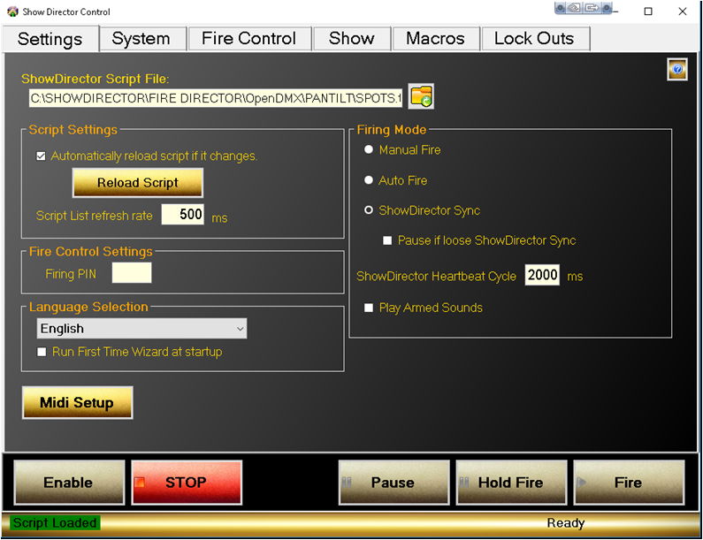
Figure 0- Main User Interface

Connecting Show Director Control to Show Director
Show Director Control can run stand-alone or connected to Show Director. When it is configured to run with Show Director it can be slaved so that actions you take in

Show Director such as Play, Pause or Stop will be immediately communicated down through Show Director Control to the connected Field Controllers. In this fashion you can use Show Director as the multi-media interface to Play or Pause your show as well as keep the show synchronized to the music or any external time sync devices supported by Show Director.

The three Firing Modes for Show Director Control are Manual Fire, Auto Fire and Show Director Sync.

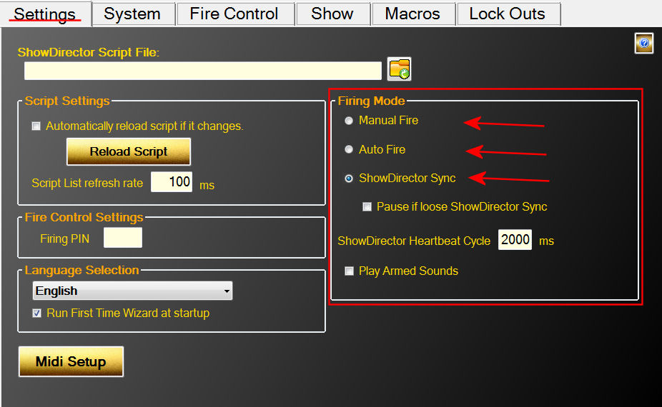
Figure 1- Settings Tab showing the Firing Modes

In Manual Fire, users must press the Fire button for each Cue that is to be executed. Pressing Fire will execute the Cue and advance to the next Cue so that it is ready to fire.

In Auto Fire, once the Auto Fire button has been pressed, the show's clock will begin and the show will execute Cues on their firing time.

In Show Director Sync, the Play and Pause buttons are disabled and the show is controlled via Show Directors Play, Pause and Stop buttons. There is also control over what happens if the connection is dropped. Selecting 'Pause if lose Show Director Sync' will pause the show after the second heartbeat from Show Director is detected. If this option is unselected, the show will continue on using the internal clock until such time as Show Director is reconnected. At that point the internal clock will sync with Show Director.

Loading a Show Director Script
From Show Director, use the Firing->PyroInfinity Manager dialog to save out the .tbi file. It will be saved using the project name and in the project folder. Then from Show Director Control's Settings tab, click the folder icon to browse to the project folder and open the .tbi file.

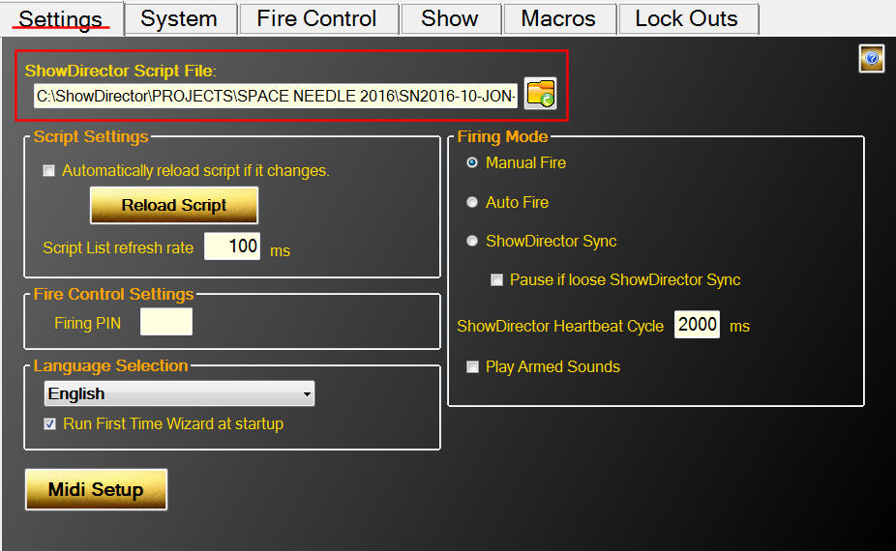
Figure 2- Click folder icon to load a new script file

Show Director Control can also be configured to monitor the loaded script for changes and reload script if it changes. If Automatic script reload is selected and the system is unarmed, the .tbi file will automatically reload and the show's script updated. Once the system is armed, if the script file changes the Settings tab will be highlighted yellow to signal the user of the change. The user must press the Reload Script button to load the updated script.

With the script loaded, the Show Tab displays the script and the important information related to it. The ShowDirectorControl application can be resized to fit the display and orientation of the computer or tablet it is running on. The following show displays the script information including the Macros and Lock Outs.

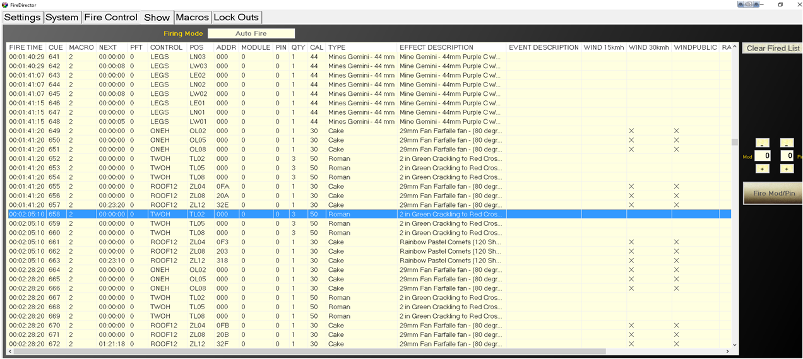
Figure 3- Script file

Connecting a Midi keyboard device
Show Director Control supports mapping some of its features to a Midi keyboard. On the Settings tab, press the 'Midi Setup' button. The Midi Setup dialog displays a list of the available Midi input and output devices.
Select your Midi input and Output device and press the 'Connect Midi' button. Now that you have your Midi device selected, you can map the six Control buttons by selecting the button and then pressing a key on your Midi device. The Channel and Key will be displayed. You can then save the map to any name you wish, but the Midi device name is suggested.

Each time you run Show Director Control, it will try to reload this device and this midi key map.

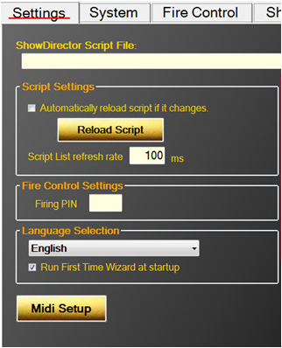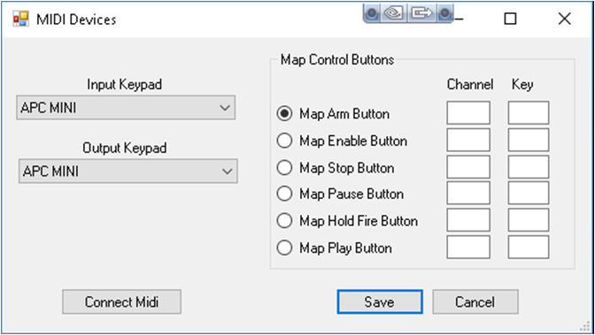
Figure 4- Midi Mapping Form

Connection Show Director Control to a Field Controller
Show Director Control is designed to be an extended user interface to any of the supported Field Controllers. When connected via a serial cable or optional wireless connection, Show Director Control communicates with the Field Controller to provide status and commands and control. The first step is connecting. For each of the Field Controllers, a serial communications connection needs to be made. Show Director Control can connect to virtually any serial port device via our System tab.
The Field Controller supported by Show Director Control at this time is OpenDMX. OpenDMX is one very common flavor of the popular DMX communications standard. Show Director Control can communicate with most USB connected DMX controllers that support the OpenDMX standard. When a DMX controller is detected, it will be displayed in the Add New Field Controller dropdown as the device number followed by 'DMX'.

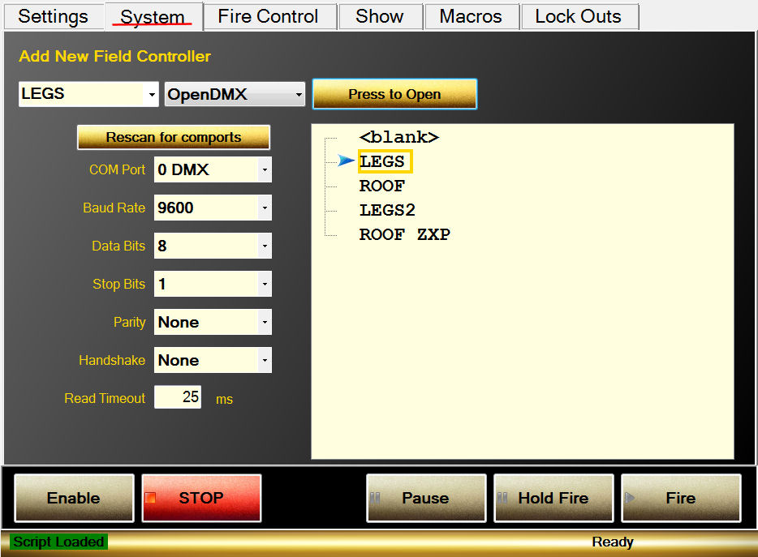
Figure 5- System Open Ports

With the script loaded, the values from the 'CONTROL' column are added to the system as suggested Field Controller values. The left most dropdown and the Field Controller list will both show these preloaded controller names. Select a name from the list, set the COM port connection values (see your devices specifications for these values) and press 'Press to Open'. This should connect Show Director Control to the device. If a good connection is established, the name will be highlighted green.

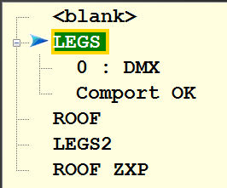
Figure 6- Controller 'LEGS' connected to DMX controller 0

If there are issues with the connection to a connected controller, the connection can be closed and reopened from the System tab.

Arming the System
Once you have a script loaded and a connection to a field controller established, the next stop would be to Arm the system. The Fire Control tab is where this is done. Select a field controller that is connected (green background) and press the 'Arm Ctrl' button. If the connected controller is already armed, the button will be red and read 'Disarm Ctrl' and pressing it will disarm that controller.

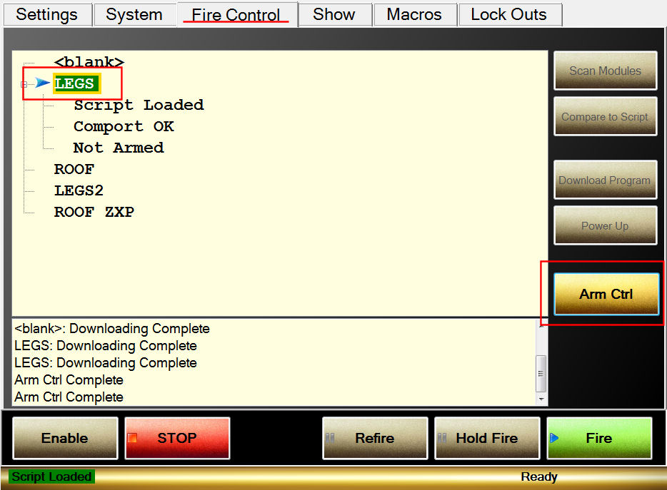
Figure 7- Fire Control screen ready to Arm controller LEGS

If the Arm System button is pressed, the user will be ask to (optionally) provide a arming PIN number and confirm arming the system. The arming PIN is set on the Settings screen under Fire Control Settings.

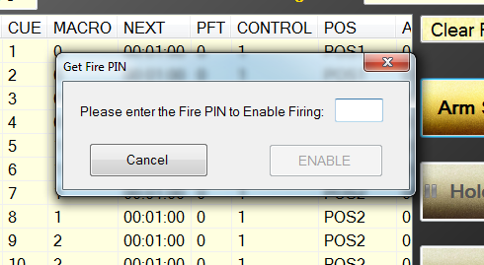
Figure 8- Arming confirmation dialog

With at least one controller armed, the system is ready to execute the loaded show.

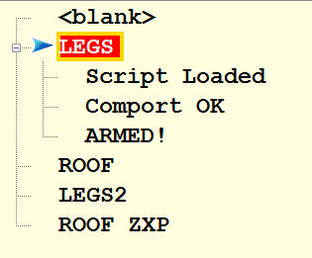
Figure 9- Controller LEGS armed and ready

With the system armed, the Fire Controls will enable allowing the show to be executed. Also enabled will be the ability to fire any pin on any module.

Show Control Buttons
Along the bottom of the screen are a panel of buttons that control the execution of the show.

The first two buttons from the left are 'Enable' and 'STOP'. The action of these two buttons remain the same for all Firing Modes.

Enable must be selected (highlighted green by clicking it or holding down the Ctrl key) for the show, macros or firing of module/pin execute buttons to operate. This is meant to add a layer of security that s show not be accidentally started or a pin fired without the user enabling of the system.

The 'STOP' button is a All Halt action that stops the show or macro and disarms the system.

Figure 10- Control buttons for Manual Mode

Figure 11- Control Buttons for AutoFire Mode

Figure 12- Control Buttons for Show Director Sync Mode

The control buttons change in display and action based on what Firing Mode we are in.

In Manual Firing Mode the button 'Fire' will execute the current cue and advance to the next cue.

' Refire' will execute the previously fired cue.

'Hold Fire' will allow the user to 'Fire' cues and advance without actually executing the fire command. If you are in AutoFire Mode, the 'Auto Fire' button starts the execution of the show from the beginning or from wherever you may have paused the show.

'Pause' allows a executing show to be paused. 'Hold Fire' allows the show to continue running but none of the cues will execute.

In Show Director Sync Mode the 'Play' and 'Pause' buttons are disabled as we are slaved to the Show Director Play and Pause buttons. However the 'Hold Fire' button will still keep cues from executing even though Show Director plays on.

The Show
The Show tab displays the currently loaded script along with the Firing Mode, Show Clock and countdown timer to next cue. Initially the script is shown with a gray background to indicate that the controller for that cue has not been connected and armed. This is to help the user to visually see what cues would fire if the show would be run at that time. Once the controller listed in the cues CONTROL column is armed, those cues will light up with the golden background.

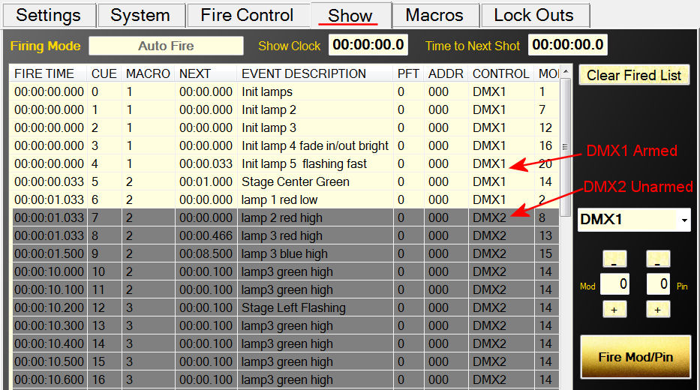
Figure 23- Show tab with one controller armed and another unarmed

The script contains a FIRE TIME column which is the Show Director TIME column minus the Prefire Time (PFT). The PFT column is also include, but only as reference. Also note, that while some of the Show Director columns display in Show Director in Seconds:Frames, in Show Director Control you will always have clock time and/or milliseconds.

Once a cue has been executed the first time, the background color of the cue will turn light blue. This helps the user understand what parts of the show have been fired and what cues have not. This list can be cleared anytime by pressing the 'Clear Fired List' button in the upper right of the Show screen.

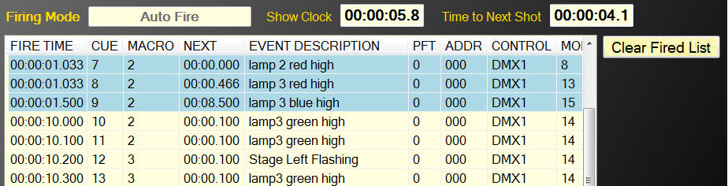
Figure 14- Script showing some cues as fired

Executing Script Macros
ShowDirectorControl can execute unlimited Macro scripts created with Show Director.

Macros are defined numerically and have an Event Description for identification.

Content of the Macros can be seen from ShowDirector or ShowDirectorControl “Show” tab

Subsections of a loaded script can be executed by marking them with a MACRO value in Show Director.

All the cues with the same MACRO value can be fired together. In addition, they are executed by their own internal clock and can be played over the top of an executing Show script.

Playing, Pausing or Stopping a macro has no effect on the currently executing Show. While only one macro may be playing at a time, a paused macro will resume where it left off when played again.

A macro that has been stopped will reset back to its original unplayed state.

The columns in the Macros display show you the Macro Name (the Event Description of the first line of the Macro), the Duration of the macro, its Status (Play, Pause, Stop), the number of times this macro has been fully Played, the Total number of cues in this macro and the current number of Live cues left to play.
For example, in the Figure below, Macro 2, Stage Center Green, is currently paused with 8.7 seconds left to play and 3 out of 7 cues left to execute.

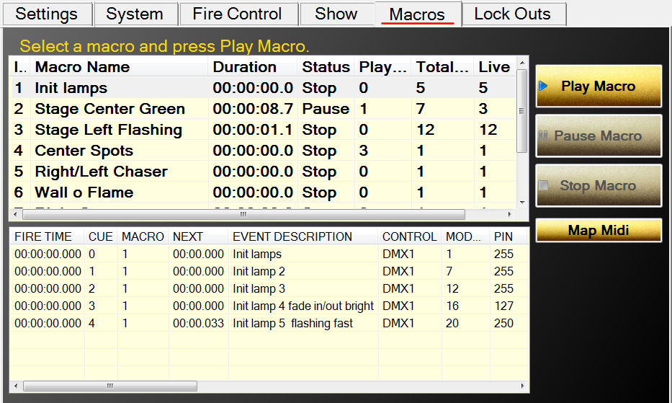
Figure35- The Macro tab

Midi mapping of macros

When you select a macro from the list, the macro script will be show in the lower display. This display, like the script display on the Show tab, will display the cues either gray, golden, light blue or pink.

If you are using a Midi keyboard, you can map midi keys to macro Indexes from the Map Midi dialog. Simply type in the index of a macro and press the midi key and the two are mapped together. When you save this map, it will load each time you startup. While you can save the map to any filename, the name of the input Midi device is suggested.

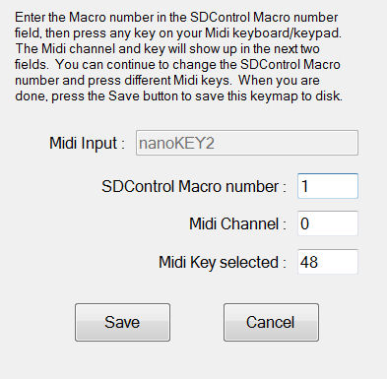
Figure 16- The Mapping form

Safety Lock Outs
ShowDirector allows to set up automatically Lock Outs by default for all the positions plus combinations of 8 Lock Out Hazard conditions, such as wind, fog, rain, fallout, etc.

ShowDirectorControl unique Lock Out screen offers a simple, accessible and complete view of Lock Outs.
In addition any changes in the original script can be automatically and instantly update in the firing table of ShowDirectorControl , allowing to cancel or change any given shot.

Show Director and Show Director Control support Module, Position and Custom lock outs.

With Module and Position lock outs you can control the safe shutdown of product firing by physical locations.

With our new Custom lock outs you can set up to eight logical lock outs that overlap with the physical positions.

Show Director allows the user to setup custom lock outs for each script in a fashion that makes sense to the user.

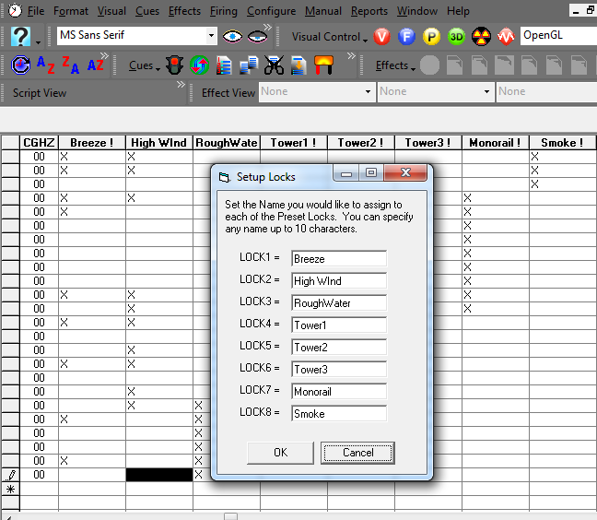
Figure:17 The Lock Naming fom in VSD8

Each of these custom lock outs can overlap so some cues may have more than one condition associated with it. In the Figure: below we have locked out cues that have custom locks for Breeze or Monorail.

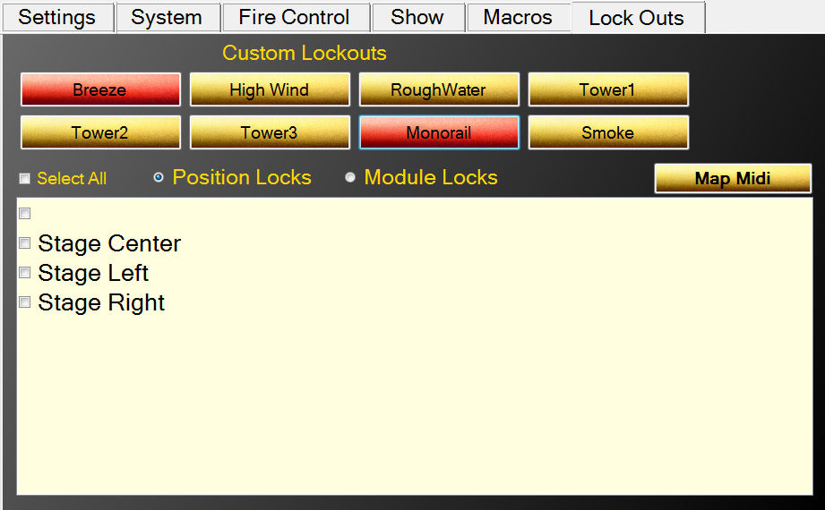
Figure:18/ Locked out for Breeze or Monorail

We can also lock out cues based on Position or Module. In the Figure: below we have locked out all cues for Position 'Stage Center'.

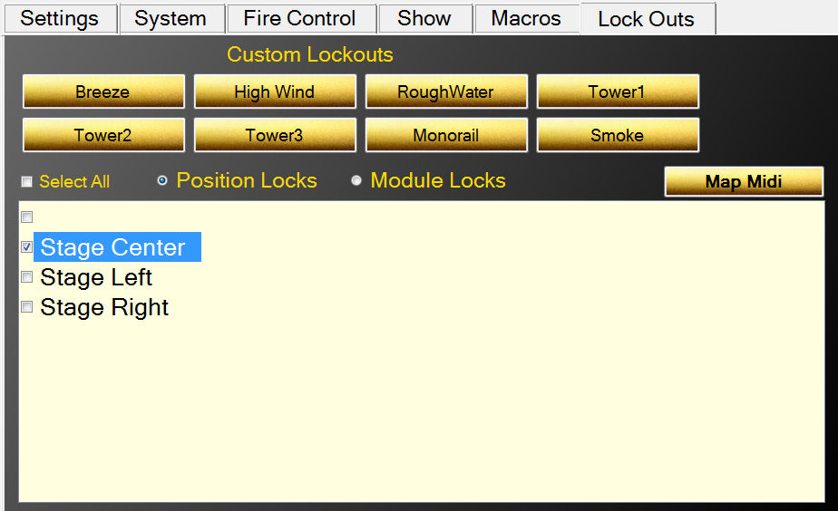
Figure:19/ Locking cues for Position 'Stage Center'

When cues have been locked out, their background color turns pink as seen below for Position 'Stage Center':
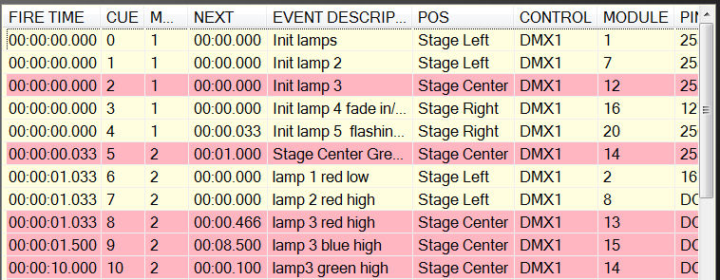
Figure:20/ Cues for position 'Stage Center' are locked out

Like Position, Modules can be locked out. Select the Module Locks radio button and the lower panel displays all the Modules for this script. Selecting one locks out all cues for that Module.
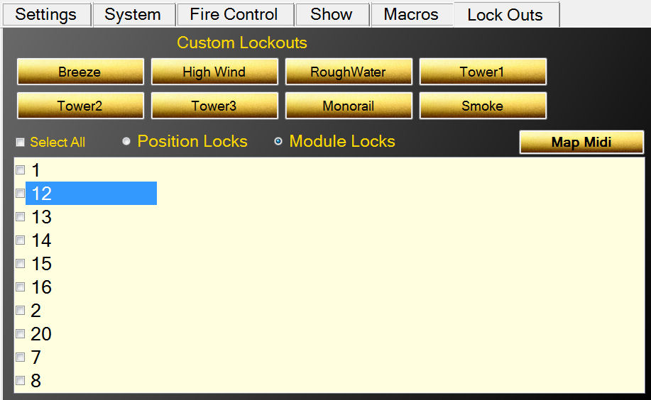
Figure:21/ Locking cues by Module

It is important to remember that a cue may have several overlapping locks. It can have any number of the eight custom locks, a position and a module. If ANY of these locks overlap a cue, it is locked out and only when ALL locks have been removed that overlap that cue does it become unlocked.

Cues that are locked out will not execute in either the Show script or any Macro.

Midi Keyboard Lock Outs

If you are using a Midi keyboard, you can map midi keys to eight Custom Locks from the Map Midi dialog.
Simply type in the lock number (1 for upper left to 8 for bottom right) and press the midi key and the two are mapped together.
When you save this map, it will load each time you startup.
While you can save the map to any filename, the name of the input Midi device is suggested.

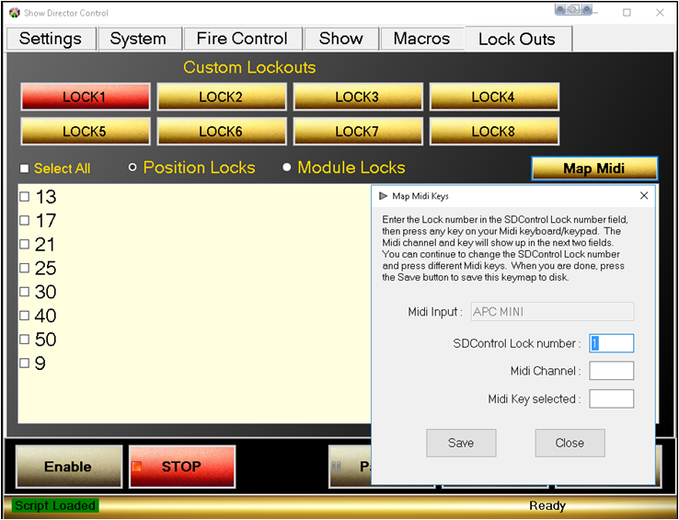
Figure:42/ The Midi key assignemt form

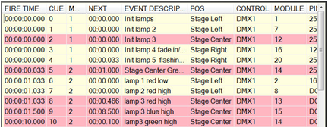
Figure: 23/ The Script with locked cues

Scripting with Visual Show Director 8
VisualShowDirector 8 can be customized with the new Custom Layouts to transform the scripting environment to match the DMX or any other system shape and needs.

New Columns were designed and added to contemplate different systems scenarios, 8 Custom columns re namable and 8 interactive Lockout columns added.

With ShowDirector Sync selected in SD Control you will be running the show or sequences from here.

Fo more informationon Sriting See VSD8 User'sGuide here

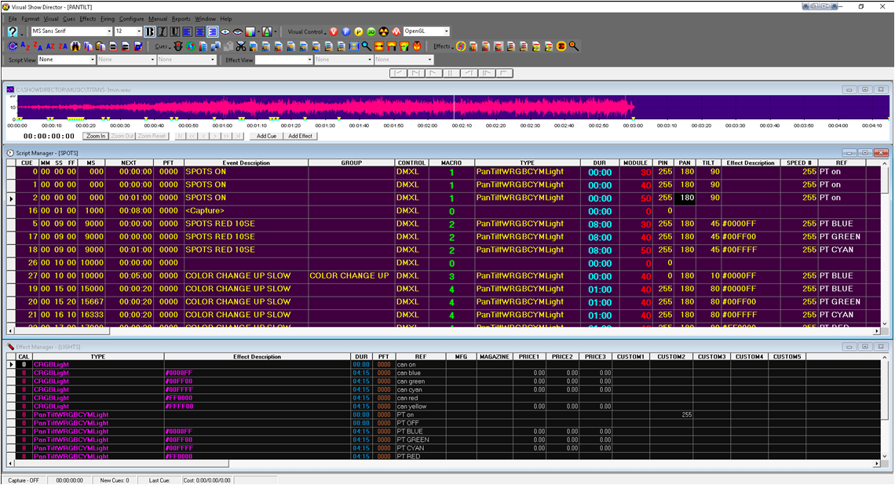
Figure 24- The VSD8 Script Layout for DMX scripting

How to program different DMX devices from Show Director
Show Director supports DMX devices in two ways. First by providing a simple way to address a DMX controller, channel and value for that channel. The second is by providing specific devices where multiple channels are used. Below we will provide example of how each can be used.

Show Director allows for DMX devices to be added to any show script. Different actions can be specified using the existing columns in your script. One requirement for the DMX devices is that the TYPE column in your script must be exactly one of the supported DMX types.

For example, the SimpleDMX type must be specified in the TYPE column as "SimpleDMX". Case and spelling do count. Other columns will contain the additional information based on the DMX command.

SimpleDMX
The most basic of the DMX commands is a generic simple command. This will set one of the 512 channels to a specified value. We allow for CUSTOM1 column to be used to over-ride the PIN column. This is so that you can create Effects Manager entries to control the intensity value set to the PIN column. If you put a numerical value in CUSTOM1, it will over-ride the value in PIN. Otherwise, use the PIN column.

SD Column Name | DMX | Note
TYPE |  | Must be "SimpleDMX"
CONTROL | Controller | One DMX controller universe per serial USB connection
MODULE | Channel | Values 1 to 512 are allowed
DUR | The duration that this channel will have this value before returning to zero | If duration is zero (00:00) then the channel is set to value permanently, otherwise max duration is 99 seconds
PIN or CUSTOM1 | Value to place on the Channel | Values 0 to 255 are allowed.

Here is an example of what a SD script might look like using SimpleDMX commands:

CUE | HH MM SS FF | TYPE | CONTROL | MODULE | DUR | PIN | Event Description
1 | 00 00 00 00 | SimpleDMX | C1 | 12 | 01:15 | 255 | Turn channel 12 on for 1 and a half sec
2 | 00 00 05 00 | SimpleDMX | C1 | 7 | 00:00 | 127 | Set channel 7 to 127
3 | 00 00 10 15 | SimpleDMX | C1 | 7 | 00:00 | 0 | Set channel 7 to 0

When the DUR column is zero, then the value place on the channel is permanent until changed again by another cue. However, if a duration is provided, then the channel is set to the value in the PIN column for the specified time and then the channel is returned to zero. The limit on duration is 99 seconds.

Galaxis G-Flame Flame Box
One of the specifically supported DMX devices is the G-Flame by Galaxis. Like most flame boxes, the G-Flame has a safety channel as well as a trigger channel. In order for the G-Flame to operate, the safety channel must first be turned on and later, for safety, must be turned off. The G-Flame therefore has three command: GFlameSafetyOn, GFlameTrigger and GFlameSafetyOff. These can be called multiple times during the show as long as the safety channel is on before any event triggers. Note that multiple G-Flame devices can share a single safety channel. Here are the SD columns and an example script:

SD Column Name | DMX | Note
TYPE |  | One of the GFlame commands listed below
CONTROL | Controller | One DMX controller universe per serial USB connection
MODULE | Channel | Values 1 to 512 are allowed
DUR | The duration of this flame | Must be a value between 00:01 and 25:00 (maximum duration)

Assuming two G-Flame boxes are configured with safety channel 33 and trigger channel 2 and 17 respectively:
CUE | HH MM SS FF | TYPE | CONTROL | MODULE | DUR | Event Description
1 | 00 00 00 00 | GFlameSafetyOn | G2 | 33 | 00:00 | Set channel 33 to GFlame safety value
2 | 00 00 05 00 | GFlameTrigger | G2 | 2 | 00:15 | Flame on device 2 for half sec
3 | 00 00 05 00 | GFlameTrigger | G2 | 17 | 00:15 | Also start device 17 for same
4 | 00 01 00 00 | GFlameTrigger | G2 | 2 | 05:00 | Flame on device 2 for 5 sec
5 | 00 05 00 00 | GFlameSafetyOff | G2 | 33 | 00:00 | Disable both 2 and 17

You should always turn the G-Flame safety on for at least 1 second before any trigger events in order to give the flame box time to get activated.

Le Maitre Salamander Flame Box
The Salamander Flame Box is a specifically supported DMX device. Like all flame boxes it has a safety channel and a trigger channel. In order for the flame box to operate, the safety channel must be turned on before any trigger commands will activate. For safety reasons we must also turn the safety channel back off at the end of the script. The safety and triggers may be turned on or off any number of times as long as the safety is on before any trigger cues are executed. The Salamander has three commands for this: SalamanderSafetyOn, SalamanderTrigger and SalamanderSafetyOff. Note that multiple Salamander devices may use the same safety channel.

SD Column Name | DMX | Note
TYPE |  | One of the Salamander commands listed below
CONTROL | Controller | One DMX controller universe per serial USB connection
MODULE | Channel | Values 1 to 512 are allowed
DUR | The duration of this flame | Must be a value between 00:01 and 25:00 (maximum duration)

Here is an example SD script using two Salamander flame boxes with separate safety channels. One has the safety channel on 1 and trigger on 2, the other safety is 3 and trigger 4.

CUE | HH MM SS FF | TYPE | CONTROL | MODULE | DUR | Event Description
1 | 00 00 00 00 | SalamanderSafetyOn | C1 | 1 | 00:00 | Set channel 1 to Salamander safety value for device 2
2 | 00 00 00 00 | SalamanderSafetyOn | C1 | 3 | 00:00 | Set channel 3 to Salamander safety value for device 4
3 | 00 00 10 00 | SalamanderTrigger | C1 | 2 | 00:15 | Flame on device 2 for half sec
4 | 00 00 10 00 | SalamanderTrigger | C1 | 4 | 00:15 | Also start device 4 for same
5 | 00 01 00 00 | SalamanderTrigger | C1 | 2 | 05:00 | Flame on device 2 for 5 sec
6 | 00 05 00 00 | SalamanderSafetyOff | C1 | 1 | 00:00 | Disable channel 1 for 2
7 | 00 05 00 00 | SalamanderSafetyOff | C1 | 3 | 00:00 | Disable channel 3 for 4

You should always allow for 10 seconds after turning the Salamander safety channel on before any trigger events.

Explo X2 Wave Flame Box
The Explo X2 Wave flame box is specifically supported by SD. This DMX device sports a moving flame head and is a little more complex the some other flame boxes. SD takes care of this complexity through four commands: X2WaveSafetyOn, X2WaveTrigger, X2WaveSeq and S2WaveSafetyOff. The X2 Wave device has a safety channel for each device and they cannot be shared. A unique feature of the X2 Wave is that you only need to set the first channel of the device.

All other features are an offset from that first channel and therefore not required to be specified in the SD script. There are 6 channels in use, so the base addresses for any other device must be 6 greater than the base address of the X2 Wave. If the base channel of a X2 Wave flame box is 6, then the next DMX device on the controller must be set to 12 or higher otherwise you will have channel conflicts and errors.

SD Column Name | DMX | Note
TYPE |  | One of the GFlame commands listed below
CONTROL | Controller | One DMX controller universe per serial USB connection
MODULE | Channel | Values 1 to 512 are allowed
DUR | The duration of this flame | Must be a value between 00:01 and 02:15 (maximum duration)
TILT | Angle of the flame head | 0 degrees is horizontal right, 90 is up and 180 is horizontal left. Negative values may be used between 0 and -180 to represent down (-90 is down).  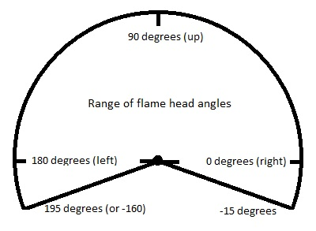
CUSTOM2 | Speed of flame head | When the flame head changes positions, the speed at which if moves may be specified. 0 is stationary, 1 (slowest) to 255 (fastest). Default movement is fastest.
REF | Built-in X2 Wave sequences | There are 70 built in sequences programmed into the X2 Wave. See the X2 Wave user's manual for a full explanation of these sequences.

Here is an example SD script using the X2 Wave. Assume we have two devices set to base channel 10 and 16 respectively.

CUE | HH MM SS FF | TYPE | CONTROL | MODULE | DUR | REF | TILT | CUSTOM2 | Event Description
1 | 00 00 00 00 | X2WaveSafetyOn | DD1 | 10 | 00:00 |  |  |  | Set safety on for device 10
2 | 00 00 00 00 | X2WaveSafetyOn | DD1 | 16 | 00:00 |  |  |  | Set safety on for device 16
3 | 00 00 10 00 | X2WaveTrigger | DD1 | 10 | 00:15 |  |  |  | Flame on device 10 for half sec
4 | 00 00 10 00 | X2WaveTrigger | DD1 | 16 | 00:15 |  |  |  | Also start device 16 for same
5 | 00 01 00 00 | X2WaveTrigger | DD1 | 10 | 02:00 |  |  |  | Flame on device 10 for 2 sec
6 | 00 01 30 00 | X2WaveTrigger | DD1 | 10 | 00:00 |  | 135 | 255 | Flame off, move head to 45 left
7 | 00 01 00 00 | X2WaveTrigger | DD1 | 10 | 02:15 |  | 45 | 127 | Flame on med wave to 45 right
8 | 00 01 00 00 | X2WaveTrigger | DD1 | 10 | 00:00 |  | 90 | 255 | Flame off move to up
9 | 00 01 00 00 | X2WaveTrigger | DD1 | 10 | 02:00 |  |  |  | Flame on device 10 for 2 sec
10 | 00 01 00 00 | X2WaveSeq | DD1 | 10 | 00:00 | 51 |  |  | Seq med wave 45 left to 45 right
11 | 00 01 00 00 | X2WaveSeq | DD1 | 16 | 00:00 | 52 |  |  | Seq med wave 45 right to 45 left
12 | 00 05 00 00 | X2WaveSafetyOn | DD1 | 10 | 00:00 |  |  |  | Disable device 10
13 | 00 05 00 00 | X2WaveSafetyOn | DD1 | 16 | 00:00 |  |  |  | Disable device 16

The build in sequences in the X2 Wave are nice in that cue 10 does the same thing as cues 6,7 and the duration of the flame is regulated by the sequence, not by the script writers estimation.

SafeX Flame Jet Flame Box
The SafeX Flame Jet flame box is another SD supported DMX device. Like all flame boxes it has a safety channel and a trigger channel. In order for the flame box to operate, the safety channel must be turned on before any trigger commands will activate. For safety reasons we must also turn the safety channel back off at the end of the script. The safety and triggers may be turned on or off any number of times as long as the safety is on before any trigger cues are executed. The Flame Jet has three commands for this: FlameJetSafetyOn, FlameJetTrigger and FlameJetSafetyOff. Note that multiple Flame Jet devices may use the same safety channel.

SD Column Name | DMX | Note
TYPE |  | One of the Flame Jet commands listed below
CONTROL | Controller | One DMX controller universe per serial USB connection
MODULE | Channel | Values 1 to 512 are allowed
DUR | The duration of this flame | Must be a value between 00:01 and 10:00 (maximum duration)

Assuming two Flame Jet boxes are configured with safety channel 33 and trigger channel 2 and 17 respectively:
CUE | HH MM SS FF | TYPE | CONTROL |  | MODULE | DUR | Event Description
1 | 00 00 00 00 | FlameJetSafetyOn | G2 | 33 |  | 00:00 | Set channel 33 to FlameJet safety
2 | 00 00 05 00 | FlameJetTrigger | G2 | 2 |  | 00:15 | Flame on device 2 for half sec
3 | 00 00 05 00 | FlameJetTrigger | G2 | 17 |  | 00:15 | Also start device 17 for same
4 | 00 01 00 00 | FlameJetTrigger | G2 | 2 |  | 05:00 | Flame on device 2 for 5 sec
5 | 00 05 00 00 | FlameJetSafetyOff | G2 | 33 |  | 00:00 | Disable both 2 and 17

You should always turn the Flame Jet safety on for at least 1 second before any trigger events in order to give the flame box time to get activated.

CRGBLight
A very common DMX controlled light is one with four channels that does Red, Green and Blue colors. Show Director Control has provided a TYPE for this light. The Control for the light is in the PIN (or CUSTOM1) column and is light specific as to how values control the light. Typically 0 turns the light off and 255 will use the values of Red, Green and Blue to set color and intensity. Your lamp may have other features that are controlled using the PIN column. Consult your manual. To specify a color, you need to have the start of the Effect Description have a '#RRGGBB' hexadecimal value. These values are two hex characters each for red, green and blue. So, for example, #FF0000 would be full red. #00FF00 would be full Blue, etc. #7F0000 would be half intensity red. #00FFFF would be bright cyan. If you provide a duration, the light will turn on for than amount of time and then turn itself off.

SD Column Name | DMX | Note
TYPE |  | Must be "CRGBLight"
CONTROL | Controller | One DMX controller universe per serial USB connection
MODULE | Channel | Values 1 to 512 are allowed. Each CRGBLight uses 4 contiguous channels. Next device must be 4 higher than the value used here.
DUR | The duration that this channel will have this value before returning to zero | If duration is zero (00:00) then the channel is set to value permanently, otherwise max duration is 99 seconds
PIN or CUSTOM1 | Control value to place on the Channel | Values 0 to 255 are allowed. Typically 0 is off and 255 uses the color and intensity provided. Other values are light specific features like blinking and fade.
Effect Description | Color and Intensity of the light | Values #000000 to #FFFFFF are allowed

Here is an example of what a SD script might look like using CRGBLight commands:

CUE | HH MM SS FF | TYPE | CONTROL | MODULE | DUR | PIN | Event Description
1 | 00 00 00 00 | CRGBLight | C1 | 1 | 01:15 | 255 | #FFFFFF bright white for 1.5 seconds
2 | 00 00 05 00 | CRGBLight | C1 | 1 | 00:00 | 255 | #FF0000 full red on
3 | 00 00 10 15 | CRGBLight | C1 | 1 | 00:00 | 255 | #A5184C switch to custom color
4 | 00 00 12 15 | CRGBLight | C1 | 1 | 00:00 | 0 | Turn light off

PanTiltWRGBCYMLight
Another common DMX controlled light is one with 10 channels that does Pan, Tilt, colors. Show Director Control has provided a TYPE for this light. In this light, the color is determined by an internal color wheel that has 7 colors: White, Red, Green, Blue, Cyan, Yellow and Magenta. To specify a color, you need to have the start of the Effect Description have a '#RRGGBB' hexadecimal value. These values are two hex characters each for red, green and blue. So, for example, #FF0000 would be full red. #00FF00 would be full Blue, #00FFFF would be bright cyan, etc. If you provide a duration, the light will turn on for than amount of time and then turn itself off. In addition the light has a swivel head and can be panned or tilted. You can pan through 360 degrees and tilt from 0 to 180. The light can be pan/tilted while the light is off or on.

SD Column Name | DMX | Note
TYPE |  | Must be "PanTiltWRGBCYMLight"
CONTROL | Controller | One DMX controller universe per serial USB connection
MODULE | Channel | Values 1 to 512 are allowed. Each PanTiltWRGBCYMLight uses 8 contiguous channels. Next device must be 8 higher than the value used here.
DUR | The duration that this channel will have this value before returning to zero | If duration is zero (00:00) then the channel is set to value permanently, otherwise max duration is 99 seconds
PIN or CUSTOM1 | The intensity of the light | Values 0 to 255 are allowed. 0 is off through 255 being full intensity.
Effect Description | Color of the light | Values #000000 to #FFFFFF are allowed.
PAN | Pan angle of the light | Values 0-360.
TILT | Tilt angle of the light | Values 0-180.
CUSTOM2 | Speed of the pan and tilt | Values 1-255. 1 is slow, 255 is fast. Zero or blank is fast.

Here is an example of what a SD script might look like using PanTiltWRGBCYMLight commands:

CUE | HH MM SS FF | TYPE | CONTROL | MOD | DUR | PIN | PAN | TILT | CUSTOM2 | Event Description
1 | 00 00 00 00 | PanTiltWRGBCYMLight | C1 | 7 | 01:15 | 255 |  |  |  | #FFFFFF bright white for 1.5 seconds
2 | 00 00 05 00 | PanTiltWRGBCYMLight | C1 | 7 | 00:00 | 255 | 90 | 45 | 127 | #FF0000 full red on, pan 90 and tilt up 45, medium speed
3 | 00 00 10 15 | PanTiltWRGBCYMLight | C1 | 7 | 00:00 | 255 |  | 135 | 255 | #A5184C switch to custom color and tilt over to 135, fast speed
3 | 00 00 12 15 | PanTiltWRGBCYMLight | C1 | 7 | 00:00 | 0 | 0 | 0 |  | Turn light off and return to center pan and tilt, fast speed

Creating a Custom DMX Device
It is also possible to create a custom DMX device mapping to cover any type of DMX device you may have. To create a custom device, start on the System tab. Clicking the "DMX Devices" button will bring up the Create DMX Devices dialog. This Dialog allows the user to Name and map some of the Show Director column data onto channels of a DMX device.
First you need to name your device in the name dropdown. This dropdown will show you any previously created DMX devices. You can delete a previous DMX device by selecting its name in the dropdown and pressing the 'Delete' key. The name of your device must not be one of the previously defined or internally defined names. See the Show Director Control User Guide for a list of these names.

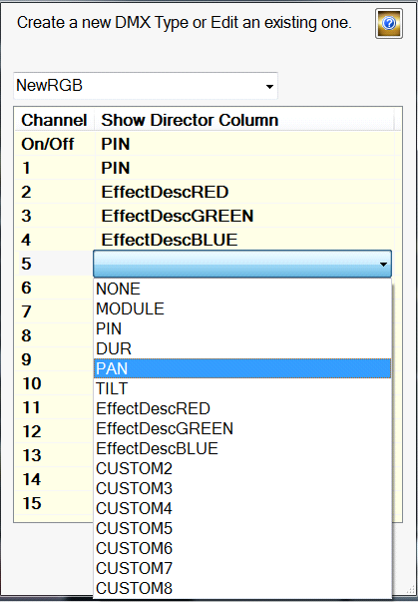
Figure 25- DMX create custom mapping

Now you need to specify what column of data in Show Director reflects the turning this device on or off. That is, when the value of this column is zero, the device will turn off. It is used in conjunction with the DUR column to turn a device on and turn the device off by setting this channel to zero. In the example above, we use the PIN column to be the on/off and have mapped PIN to channel 1. Thus channel one is the channel that will be turning this device off when set to zero.

We support up to 15 channel devices and 15 different Show Director columns. For each channel you wish to map data to, click the "Show Director Column" area next to it to open the dropdown for columns. In our example, we see that channel 1 is mapped to Show Director column PIN. Channel 2 is mapped to the RED component of a hex color value in the EffectDescription column. See CRGBLight chapter listed above to a detailed description of how to use the EffectDescription column for colors.

If you do not wish to use a channel, just leave it blank or set it to NONE. To remember that the user is responsible for the format of the data in Show Director matching the expected values of the DMX Device. Generally, that format is a number between 0 and 255 so if you want to map PAN angle you need to convert that angle to the DMX value in your PAN column in Show Director. If you expect a PAN from 0 to 180 you need to create values from 0 to 255.

When you are finished with a new device, press the "Save" button. This device will not get reloaded at startup each time you run Show Director Control. The file that saves this data is in your AppData/Roaming/ShowDirector folder and is called "dmx_devices.dmxd". You can now put this devices name in the TYPE column in Show Director and use it like any of the other build-in device types.

