Show Director Control | Infinity Visions, LLC  Bellevue, WA 98004  sales@infinityvisions.com

Show Director Control
Show Director Control is a Windows PC application that runs stand alone and executes on the Show Directors PyroInfinity firing table files (.tbi). Show Director Control is an extension of Show Director and it is assumed that the reader is familiar with Show Director, its scripts and running a simulation. Show Director Control can be slaved to Show Director and act as an intermediary that gives Show Director the ability to be a fully functioning field controller interface. In addition to having Show Director run the show, Show Director Control can also act as a stand-alone field controller interface when used in conjunction with any of the supported field controllers.
Show Director Control is a complete and full featured field controller to run any show that Show Director can generate. Show Director Control can load, validate, convert and distribute the firing script to any of the supported field controllers. It can then go on to arm the system, and execute the show in either manual or auto-play modes. It has an over-ride to hold firing even as the show continues playing and has a hard stop command. It can also manually fire any module/pin at any time, even during a shows execution. Show Director Control can also receive external timing syncs from Show Director so that it can sync the playback of a show to music time-codes or any other source of time sync that Show Director supports.
Firing script can be dynamically updated by Show Director Control even while the show is executing so that lock outs or timing changes can be added while a show is in progress. It is also possible to execute only subsections of your script with just a click of a button (Macros) or lock out sections of show by position, module or other custom lock settings.

Connecting Show Director Control to Show Director
Show Director Control can run stand-alone or connected to Show Director. When it is configured to run with Show Director it can be slaved so that actions you take in Show Director such as Play, Pause or Stop will be immediately communicated down through Show Director Control to the connected Field Controllers. In this fashion you can use Show Director as the multi-media interface to Play or Pause your show as well as keep the show synchronized to the music or any external time sync devices supported by Show Director.
The three Firing Modes for Show Director Control are Manual Fire, Auto Fire and Show Director Sync.
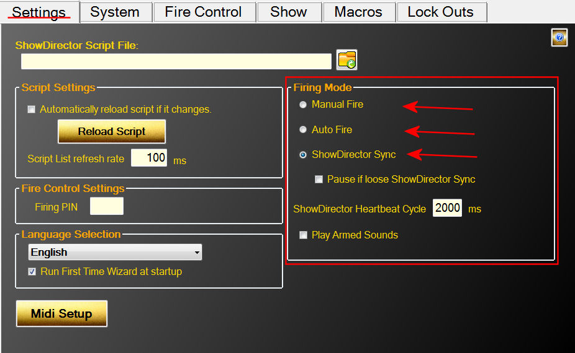
Figure 1- Settings Tab showing the Firing Modes
In Manual Fire, users must press the Fire button for each Cue that is to be executed. Pressing Fire will execute the Cue and advance to the next Cue so that it is ready to fire.
In Auto Fire, once the Auto Fire button has been pressed, the show's clock will begin and the show will execute Cues on their firing time.
In Show Director Sync, the Play and Pause buttons are disabled and the show is controlled via Show Directors Play, Pause and Stop buttons. There is also control over what happens if the connection is dropped. Selecting 'Pause if lose Show Director Sync' will pause the show after the second heartbeat from Show Director is detected. If this option is unselected, the show will continue on using the internal clock until such time as Show Director is reconnected. At that point the internal clock will sync with Show Director.

Loading a Show Director script
From Show Director, use the Firing->PyroInfinity Manager dialog to save out the .tbi file. It will be saved using the project name and in the project folder. Then from Show Director Control's Settings tab, click the folder icon to browse to the project folder and open the .tbi file.
Figure 2- Click folder icon to load a new script file
Show Director Control can also be configured to monitor the loaded script for changes and reload script if it changes. If Automatic script reload is selected and the system is unarmed, the .tbi file will automatically reload and the show's script updated. Once the system is armed, if the script file changes the Settings tab will be highlighted yellow to signal the user of the change. The user must press the Reload Script button to load the updated script.

Connecting a Midi keyboard device
Show Director Control supports mapping some of its features to a Midi keyboard. On the Settings tab, press the 'Midi Setup' button. The Midi Setup dialog displays a list of the available Midi input and output devices. Select your Midi input and Output device and press the 'Connect Midi' button. Now that you have your Midi device selected, you can map the six Control buttons by selecting the button and then pressing a key on your Midi device. The Channel and Key will be displayed. You can then save the map to any name you wish, but the Midi device name is suggested. Each time you run Show Director Control, it will try to reload this device and this midi key map.

Connection Show Director Control to a Field Controller
Show Director Control is designed to be an extended user interface to any of the supported Field Controllers. When connected via a serial cable or optional wireless connection, Show Director Control communicates with the Field Controller to provide status and commands and control. The first step is connecting. For each of the Field Controllers, a serial communications connection needs to be made. Show Director Control can connect to virtually any serial port device via our System tab.
The Field Controller supported by Show Director Control at this time is OpenDMX. OpenDMX is one very common flavor of the popular DMX communications standard. Show Director Control can communicate with most USB connected DMX controllers that support the OpenDMX standard. When a DMX controller is detected, it will be displayed in the Add New Field Controller dropdown as the device number followed by 'DMX'.
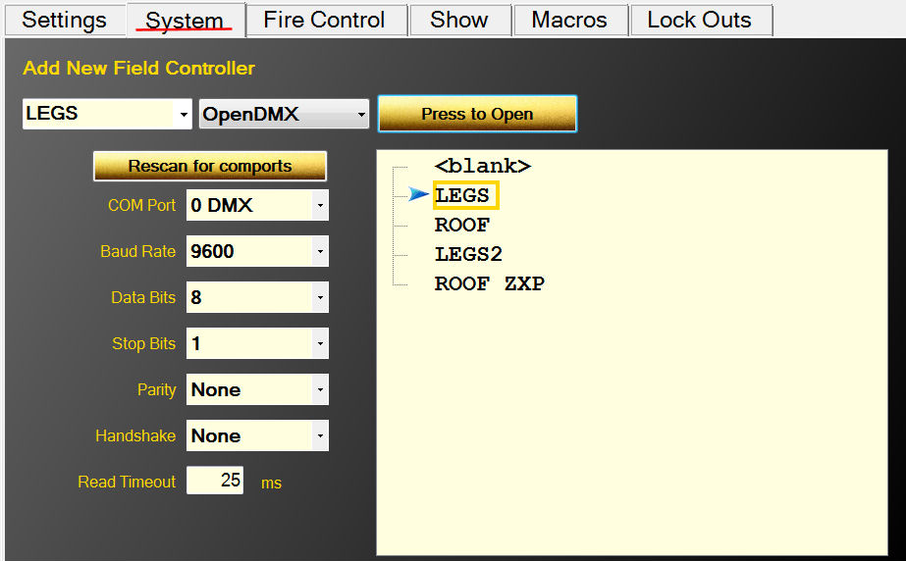
With the script loaded, the values from the 'CONTROL' column are added to the system as suggested Field Controller values. The left most dropdown and the Field Controller list will both show these preloaded controller names. Select a name from the list, set the COM port connection values (see your devices specifications for these values) and press 'Press to Open'. This should connect Show Director Control to the device. If a good connection is established, the name will be highlighted green.
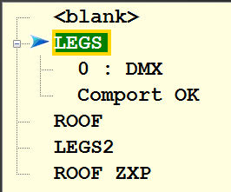
Figure 3- Controller 'LEGS' connected to DMX controller 0
If there are issues with the connection to a connected controller, the connection can be closed and reopened from the System tab.

Arming the System
Once you have a script loaded and a connection to a field controller established, the next stop would be to Arm the system. The Fire Control tab is where this is done. Select a field controller that is connected (green background) and press the 'Arm Ctrl' button. If the connected controller is already armed, the button will be red and read 'Disarm Ctrl' and pressing it will disarm that controller.
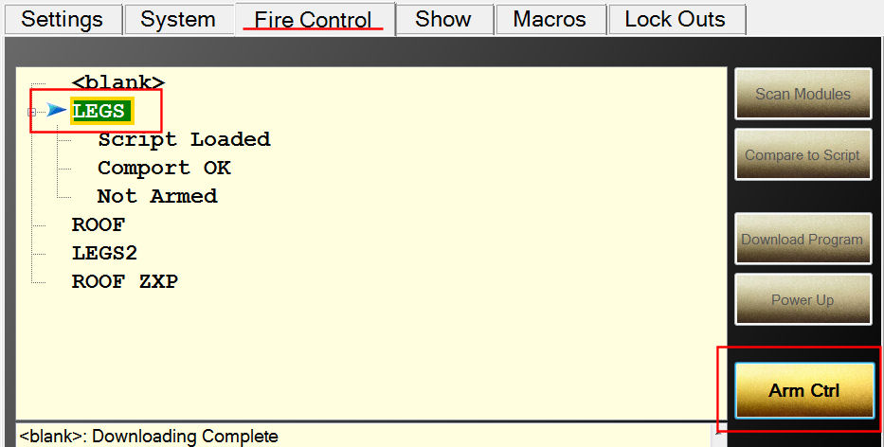
Figure 4- Fire Control screen ready to Arm controller LEGS

If the Arm System button is pressed, the user will be ask to (optionally) provide a arming PIN number and confirm arming the system. The arming PIN is set on the Settings screen under Fire Control Settings.
Figure 5- Arming confirmation dialog
With at least one controller armed, the system is ready to execute the loaded show.
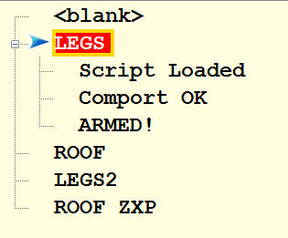
Figure 6- Controller LEGS armed and ready
With the system armed, the Fire Controls will enable allowing the show to be executed. Also enabled will be the ability to fire any pin on any module.

Show Control Buttons
Along the bottom of the screen are a panel of buttons that control the execution of the show. The first two buttons from the left are 'Enable' and 'STOP'. The action of these two buttons remain the same for all Firing Modes. Enable must be selected (highlighted green by clicking it or holding down the Ctrl key) for the show, macros or firing of module/pin execute buttons to operate. This is meant to add a layer of security that s show not be accidentally started or a pin fired without the user enabling of the system. The 'STOP' button is a All Halt action that stops the show or macro and disarms the system.
Figure 7- Control buttons for Manual Mode
Figure 8- Control Buttons for AutoFire Mode
Figure 9- Control Buttons for Show Director Sync Mode
The control buttons change in display and action based on what Firing Mode we are in. In Manual Firing Mode the button 'Fire' will execute the current cue and advance to the next cue. ' Refire' will execute the previously fired cue. 'Hold Fire' will allow the user to 'Fire' cues and advance without actually executing the fire command. If you are in AutoFire Mode, the 'Auto Fire' button starts the execution of the show from the beginning or from wherever you may have paused the show. 'Pause' allows a executing show to be paused. 'Hold Fire' allows the show to continue running but none of the cues will execute. In Show Director Sync Mode the 'Play' and 'Pause' buttons are disabled as we are slaved to the Show Director Play and Pause buttons. However the 'Hold Fire' button will still keep cues from executing even though Show Director plays on.

The Show
The Show tab displays the currently loaded script along with the Firing Mode, Show Clock and countdown timer to next cue. Initially the script is shown with a gray background to indicate that the controller for that cue has not been connected and armed. This is to help the user to visually see what cues would fire if the show would be run at that time. Once the controller listed in the cues CONTROL column is armed, those cues will light up with the golden background.
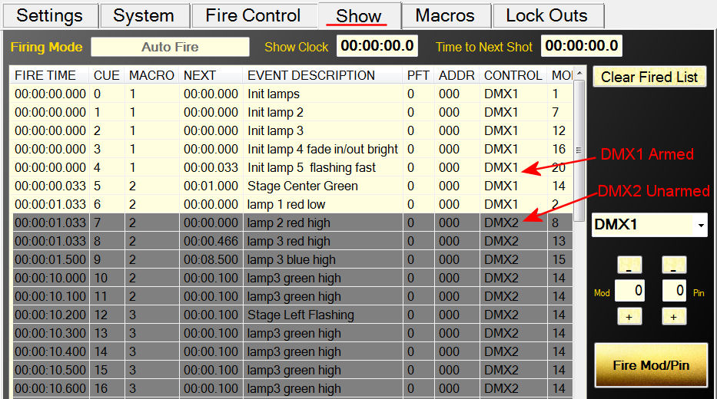
Figure 10- Show tab with one controller armed and another unarmed
The script contains a FIRE TIME column which is the Show Director TIME column minus the Prefire Time (PFT). The PFT column is also include, but only as reference. Also note, that while some of the Show Director columns display in Show Director in Seconds:Frames, in Show Director Control you will always have clock time and/or milliseconds.
Once a cue has been executed the first time, the background color of the cue will turn light blue. This helps the user understand what parts of the show have been fired and what cues have not. This list can be cleared anytime by pressing the 'Clear Fired List' button in the upper right of the Show screen.
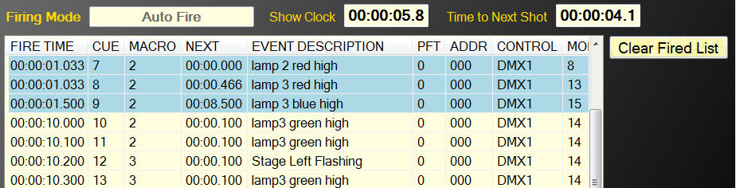
Figure 11- Script showing some cues as fired

Executing Script Macros
Subsections of a loaded script can be executed by marking them with a MACRO value in Show Director. All the cues with the same MACRO value can be fired together. In addition, they are executed by their own internal clock and can be played over the top of an executing Show script. Playing, Pausing or Stopping a macro has no effect on the currently executing Show. While only one macro may be playing at a time, a paused macro will resume where it left off when played again. A macro that has been stopped will reset back to its original unplayed state. The columns in the Macros display show you the Macro Name (the Event Description of the first line of the Macro), the Duration of the macro, its Status (Play, Pause, Stop), the number of times this macro has been fully Played, the Total number of cues in this macro and the current number of Live cues left to play. For example, in the Figure below, Macro 2, Stage Center Green, is currently paused with 8.7 seconds left to play and 3 out of 7 cues left to execute.
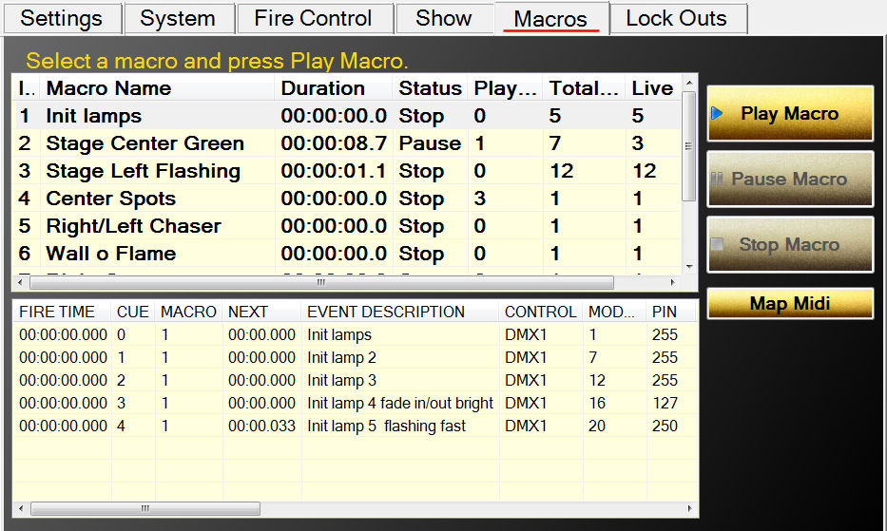
Figure 12- The Macro tab
When you select a macro from the list, the macro script will be show in the lower display. This display, like the script display on the Show tab, will display the cues either gray, golden, light blue or pink.
If you are using a Midi keyboard, you can map midi keys to macro Indexes from the Map Midi dialog. Simply type in the index of a macro and press the midi key and the two are mapped together. When you save this map, it will load each time you startup. While you can save the map to any filename, the name of the input Midi device is suggested.
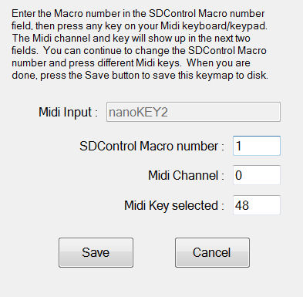

Safety Lock Outs
Show Director and Show Director Control support Module, Position and Custom lock outs. With Module and Position lock outs you can control the safe shutdown of product firing by physical locations. With our new Custom lock outs you can set up to eight logical lock outs that overlap with the physical positions. Show Director allows the user to setup custom lock outs for each script in a fashion that makes sense to the user.
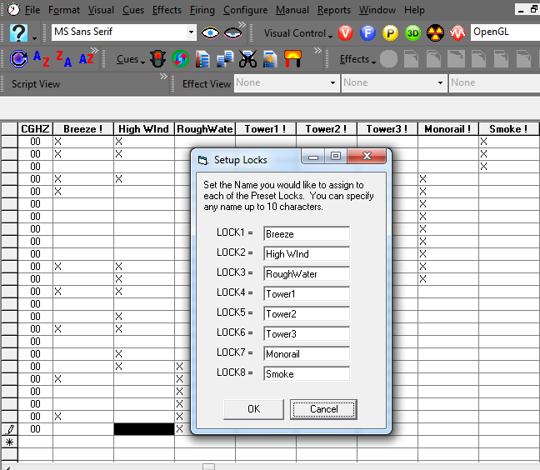
Each of these custom lock outs can overlap so some cues may have more than one condition associated with it. In the Figure below we have locked out cues that have custom locks for Breeze or Monorail.
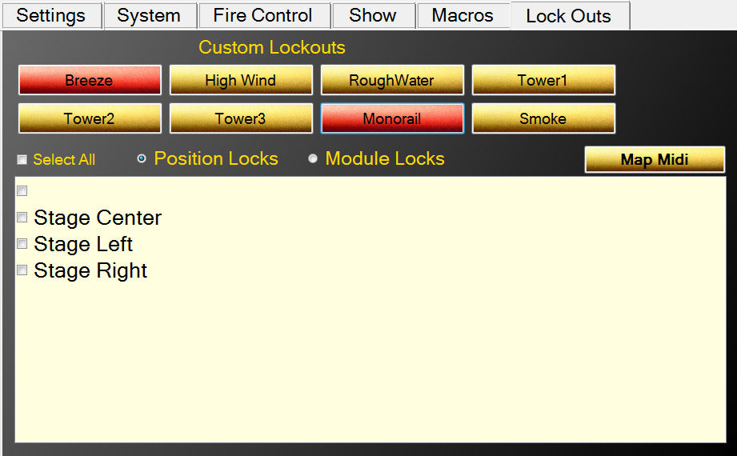
Figure 13- Locked out for Breeze or Monorail
We can also lock out cues based on Position or Module. In the Figure below we have locked out all cues for Position 'Stage Center'.
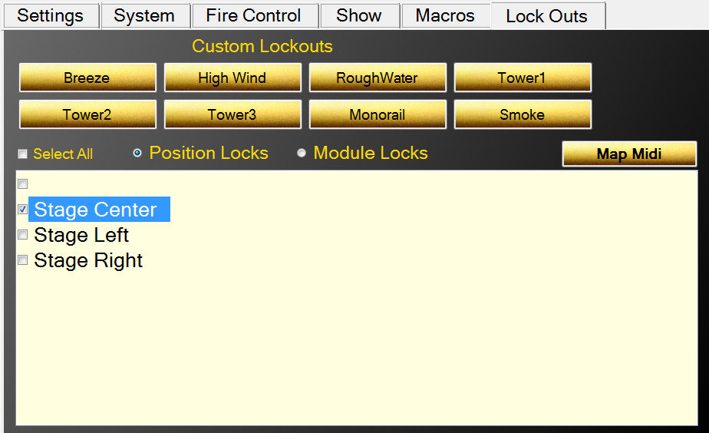
Figure 14- Locking cues for Position 'Stage Center'
When cues have been locked out, their background color turns pink as seen below for Position 'Stage Center':
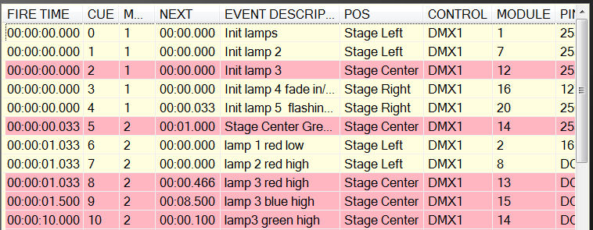
Figure 15- Cues for position 'Stage Center' are locked out
Like Position, Modules can be locked out. Select the Module Locks radio button and the lower panel displays all the Modules for this script. Selecting one locks out all cues for that Module.
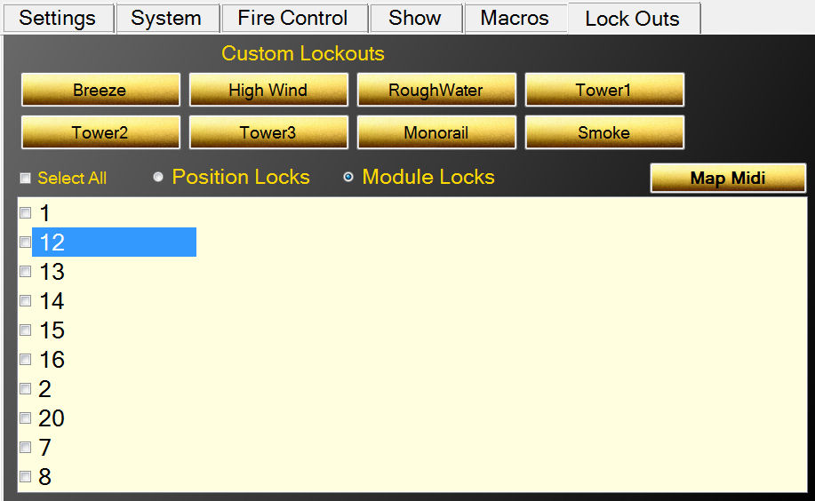
Figure 16- Locking cues by Module
It is important to remember that a cue may have several overlapping locks. It can have any number of the eight custom locks, a position and a module. If ANY of these locks overlap a cue, it is locked out and only when ALL locks have been removed that overlap that cue does it become unlocked.
Cues that are locked out will not execute in either the Show script or any Macro.
If you are using a Midi keyboard, you can map midi keys to eight Custom Locks from the Map Midi dialog. Simply type in the lock number (1 for upper left to 8 for bottom right) and press the midi key and the two are mapped together. When you save this map, it will load each time you startup. While you can save the map to any filename, the name of the input Midi device is suggested.

